醫用超音波原理

Chapter 1: Overview of Diagnostic Ultrasonic Imaging Systems

- The main purpose of all imaging systems is to provide a visual representation of a real object. For medical ultrasonic imaging systems, high frequency sound waves are used to interact with the human body so that anatomical structures, blood flow velocity and other diagnostic information can be obtained.

- A typical ultrasonic imaging system is shown below on the left and an ultrasound image with both anatomical structure of the umbilical cord and associated flow information is shown on the right. (Both are from Acuson corporation, Mountain View, CA.)

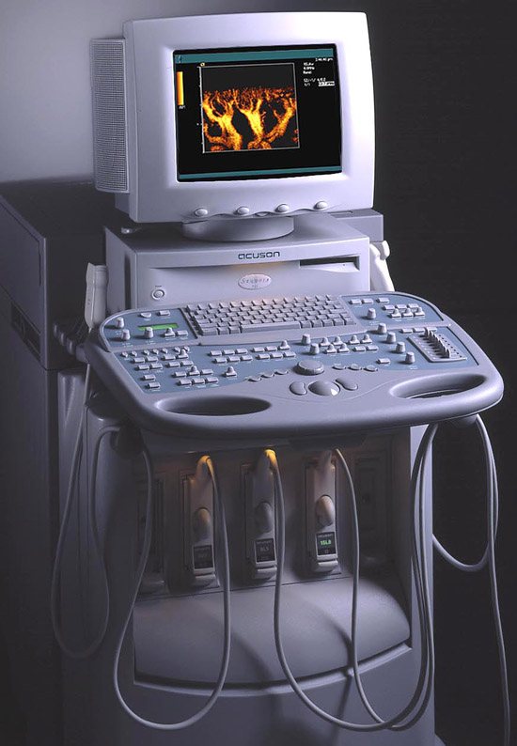
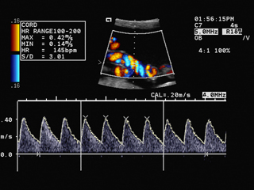

- Ultrasound is the second most widely used diagnostic imaging modality (next to X-ray). Gray scale (B-mode) ultrasound became popular in 1970s. Color Doppler became clinically useful in 1980s. In 1990s, all high-end systems are fully digital. The next generation systems will continue to take advantage of advanced signal processing techniques, faster clock rate, larger memory capacity and higher circuit density.

- The advantages of ultrasonic imaging systems include non-invasive image formation of anatomical structures, non-invasive detection of moving objects, real-time acquisition, portability and cost.

- Current clinical applications include OB/GYN, vascular, cardiac, transcranial, abdominal, musculosckeletal, endo-vaginal, endo-rectal, ocular, intra-vascular, intra-operative...etc. With the recent advancement of electronic technologies and more understanding of the imaging mechanism, the clinical capabilities have been expanding rapidly. Generally, new features are being released to the market approximately every six months.

- World’s largest markets are U.S., Japan and Europe. Emerging markets include China, Southeast Asia and Latin America. The cost of a system ranges from below US$10,000 to above US$250,000. The market has been growing steadily.

- Characteristics of ultrasonic imaging:
- Non-invasive.
- Safe (under regulations).
- Direct acquisition of 3D information.
- Reflection mode, similar to RADAR.
- Real-time (frame rate is high enough to allow direct interaction between the user and the patient).
- Velocity estimation of moving targets (such as blood) using Doppler. Information can be displayed either by video or audio.
- Relatively cost-effective.
- Access (cannot effectively penetrate air pockets and bone).
- Resolution determined by diffraction (as in Optics).
- Modest resolution, but continues to improve.
- Image quality strongly dependent on “body type”.

- A very simple model of ultrasonic imaging (A-scan, one-dimensional)

display
receive signal processing
T/R switch
pulser
transducer

received signal

- A transducer is used to convert an electrical signal to an ultrasonic pulse on transmit, and vice versa on receive (acting as an antenna). The following is a picture of a phased array transducer (Acuson corporation, Mountain View, California).
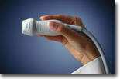

- The ultrasonic pulse propagates into the body and reflected by tissue inhomogeneities. The reflection is caused by the differences in acoustic impedance which is in turns determined by the propagation velocity and density. Therefore, the returned signal (echo) carries information of the mechanical properties of the image object. The echo is then received by the same transducer and converted into an electrical signal. Due to the round-trip nature of acoustic propagation, the total propagation time for an echo reflected from a depth of R is troudtrip=2*R/c, where c is sound velocity. The propagation time for a typical imaging condition is at the order of a few hundred micro-seconds.

- B-mode (Brightness mode): A two-dimensional image consists of many one-dimensional A-scans (described previously). In other words, a two-dimensional image is acquired by simply moving the directions of the ultrasound beam (i.e., scanning). This is similar to a radar system. The scanning can be done manually, mechanically or electronically. A full view two-dimensional image typically consists of 100-200 lines. Therefore, it is possible to acquire 30 image frames in a second for continuous (real-time) display.

- Current digital systems all use arrays transducers to perform electronic scanning. Such transducers typically consist of 64 to 256 individual transducer elements. The process of using arrays to direct acoustic beams to a particular point in space is called beam formation. Array transducers allow dynamic beam formation (i.e., independent control of individual transducer element) which is not possible with single crystal transducers. However, system complexity, size and cost also dramatically increase.

- Commonly seen scan formats:

linear sector curved linear

easy access limited access easy access
limited field of view large field of view large field of view

- Scan format variations:

steered linear vector curved vector

These variations can be used to extend the field of view or to obtain a better angle for flow estimation using Doppler.

- Doppler effects have also been used to acoustically detect moving objects in the body (e.g., blood and cardiac muscle). The motion information can be presented by audio speakers, or displayed as Doppler spectra and two-dimensional color images.

- There are two types of three-dimensional ultrasonic imaging. One is to construct three-dimensional object information by using a set of two-dimensional images. The three-dimensional data is then projected to a pre-specified two-dimensional plane for display. This is not real-time.

- A real-time three-dimensional ultrasonic imaging system using two-dimensional arrays has recently been commercialized with limited imaging capabilities. Its clinical potential is yet to be realized.

- A fully digital system using arrays:

high voltage amplifier
digital transmit beamformer
DAC

array
body
system control
keyboard
beamformer control
T/R switch

B, M, Doppler image processing
digital receive beamformer
ADC
variable gain

display
Doppler processing

all digital

- A fully digital system is indeed a special purpose computer with powerful signal processing capacity, plus transducer arrays and analog front-end.

- The main purpose of this course is to cover major aspects of ultrasonic imaging systems, including underlying physics, imaging techniques, resolution, inherent limitations and bioeffects.

- The field of ultrasonic imaging is multi-disciplinary, full of challenges and with great potential. WELCOME ABOARD !!

