Chapter 9 Transient Response

9.1 First-order transients

- First order circuits: Circuits contain only one inductor or one capacitor, governed by first-order differential equations.
- Zero-input response: the circuit has no applied source after a certain time. It is determined by natural response and the initial condition.
- Characteristic equation and time constant (an RC circuit):

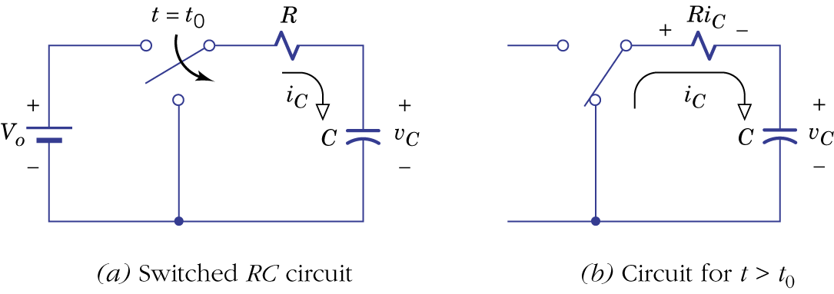Figure 9.1.

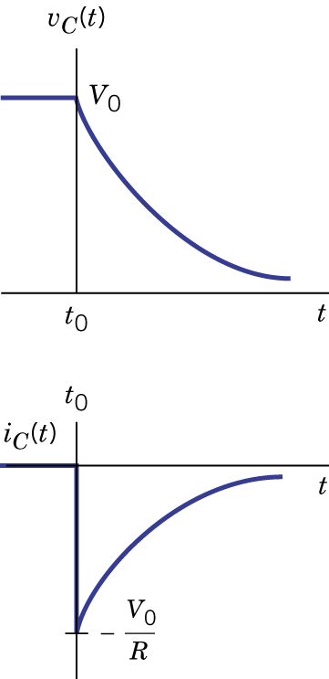Figure 9.2.
- An RL circuit:
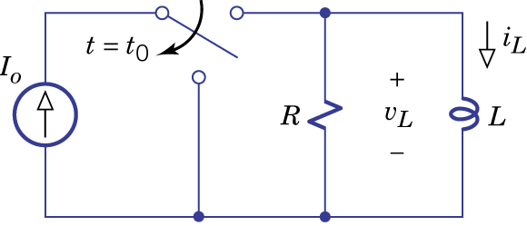Figure 9.3.

- General first-order circuits:

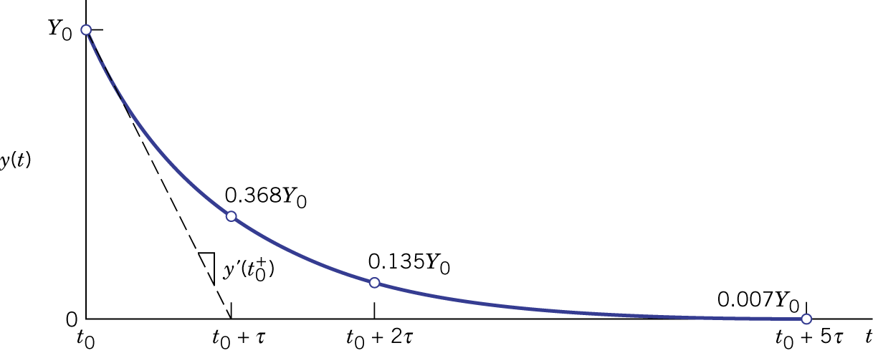Figure 9.4.

Example 9.1: Zero-Input Response of an RL Circuit
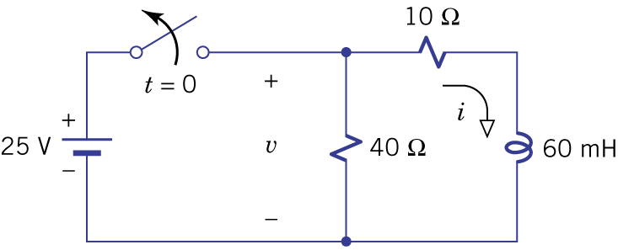Figure 9.5.

- Step response: response to a step input (OFF to ON) with zero initial conditions.

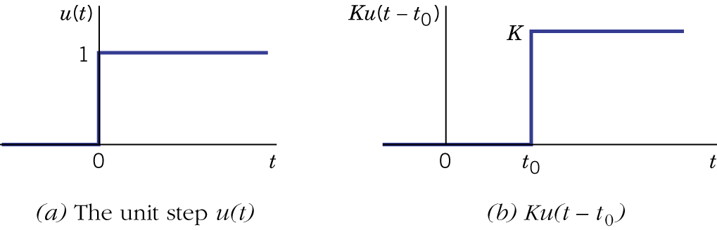Figure 9.6.

- First order RC circuit:
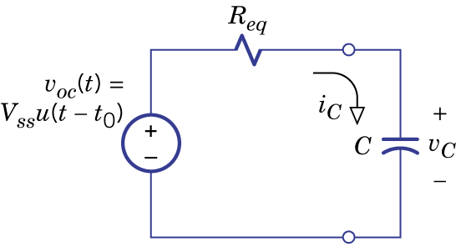Figure 9.7.

- First order RL circuit:
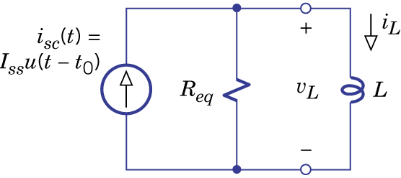

- General first order circuits:

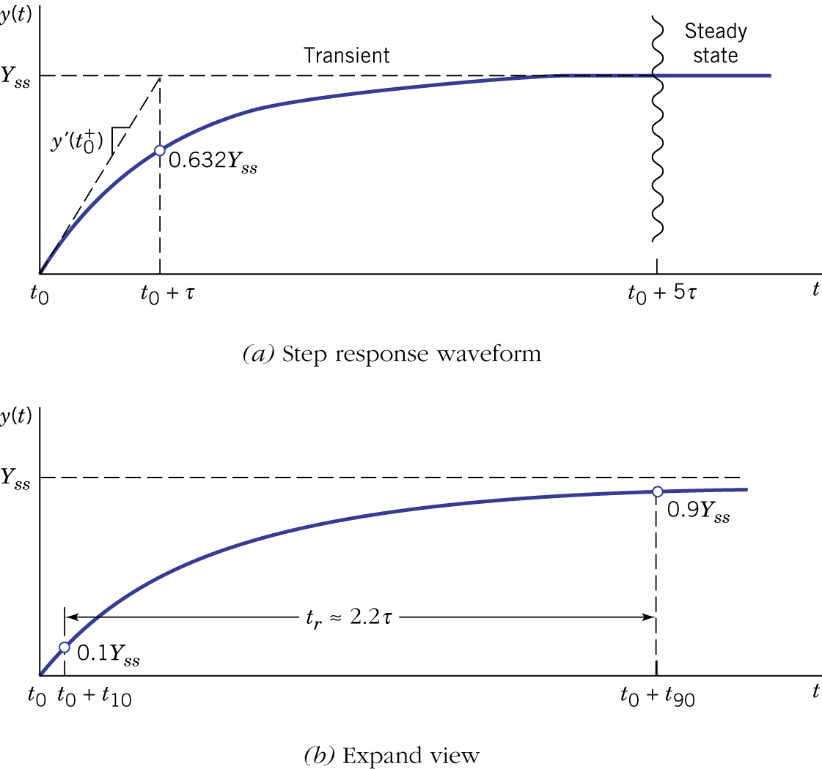Figure 9.9.

Example: Step Response of an RC Circuit

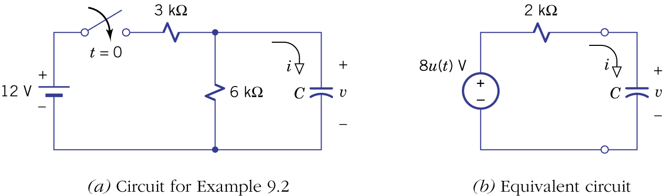Figure 9.10.

- Pulse response: zero-sate response with a rectangular pulse excitation.

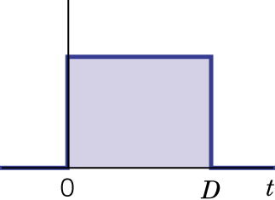Figure 9.11.

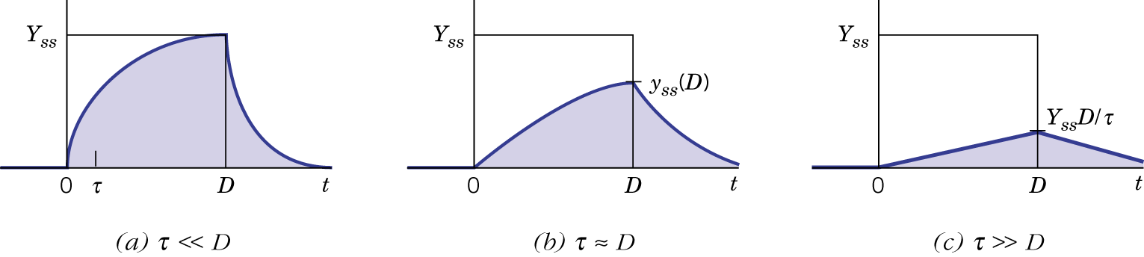
Figure 9.12.

Example 9.3: Analysis of a Relay Driver

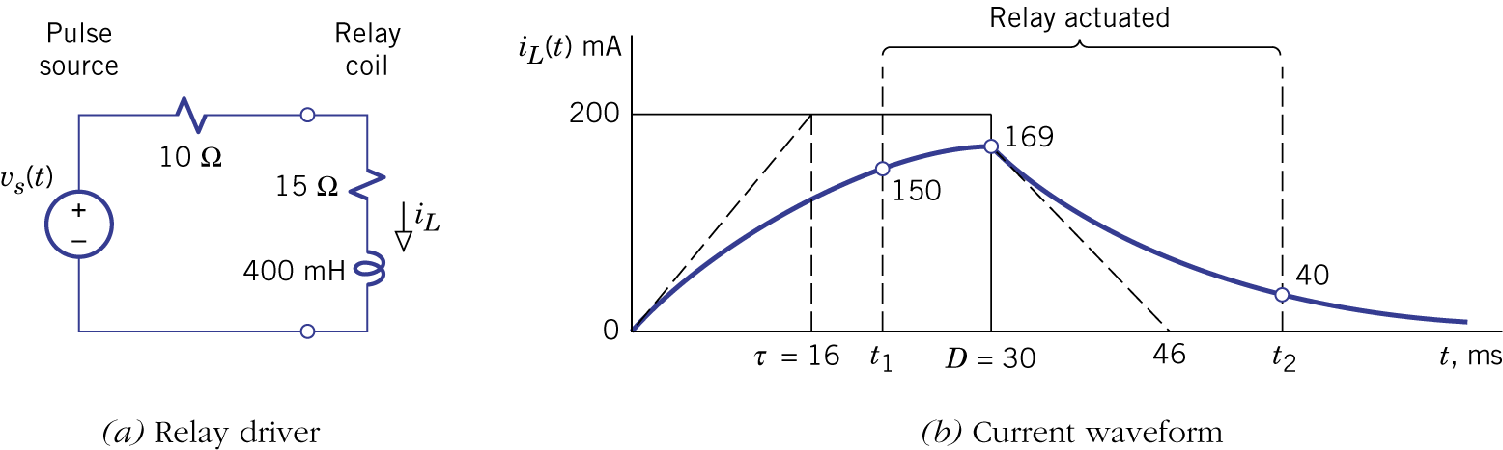
Figure 9.13.

- Switched DC transients: the source switches from one constant to another constant.

Example 9.4: Sequential Switched Transients
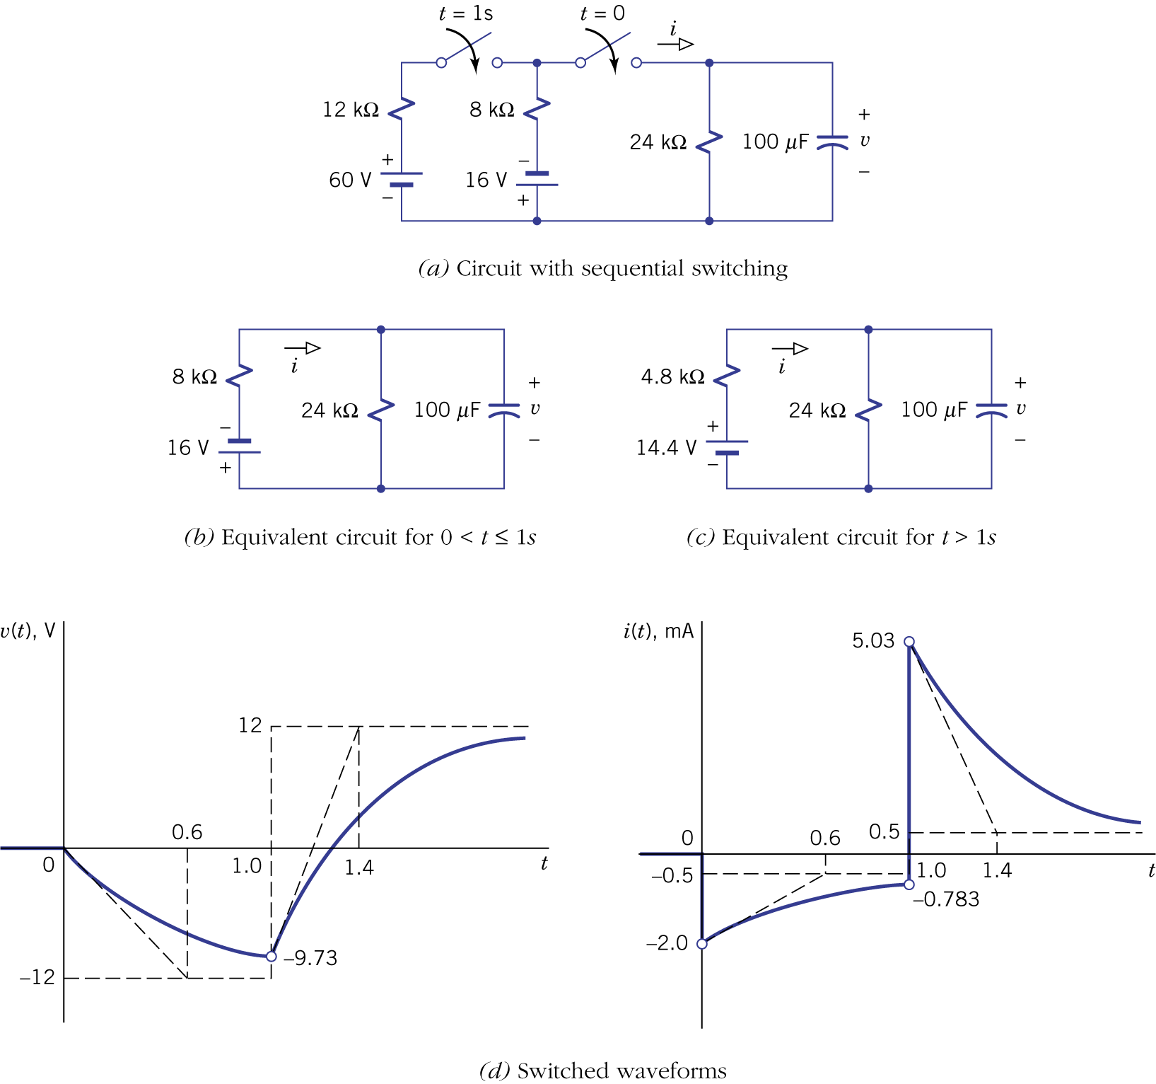
Figure 9.14.

9.2. Switched AC transients

- The parameter of an ac source undergoes an abrupt change.
- Analysis is the same as switched dc transients, except that the force response is different.

Example 9.5: Transients in an AM (amplitude modulation) Radio Signal

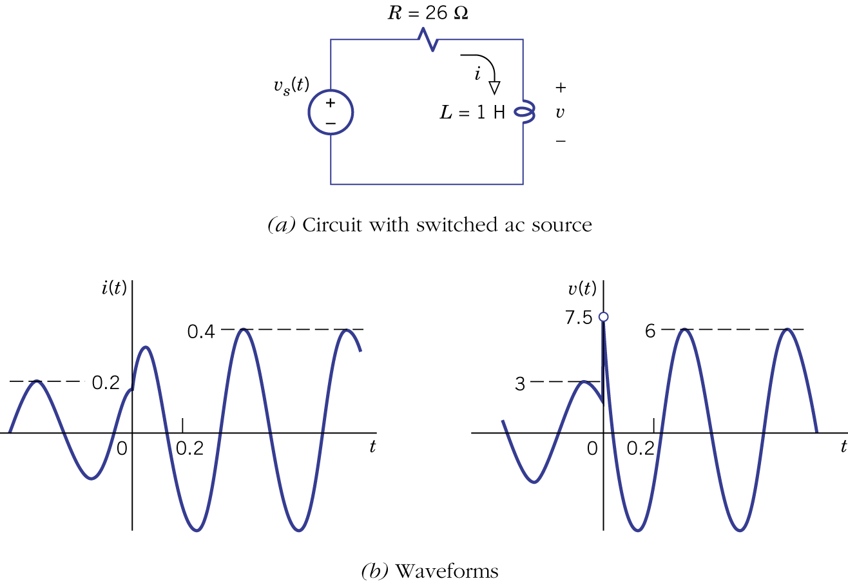Figure 9.16.

9.3 Second-order natural response

- A second-order circuit contains two independent energy storage elements (i.e., inductors or capacitors).
- First-order transient is characterized by decaying exponentials. Second order natural response includes overdamped, underdamped and critically damped behaviors.
- Capacitor voltages and inductor currents are state variables.
- Series LRC circuit:
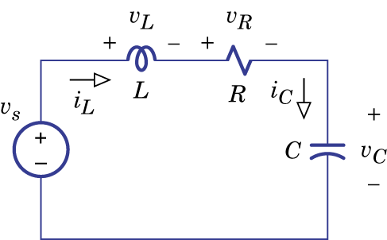Figure 9.17.

- Parallel CRL circuit (dual of series LRC circuit):
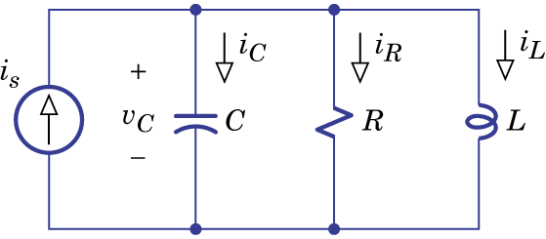Figure 9.18.

- General form of second order circuits:

Example 9.6: Second-Order Circuit with Two Inductors

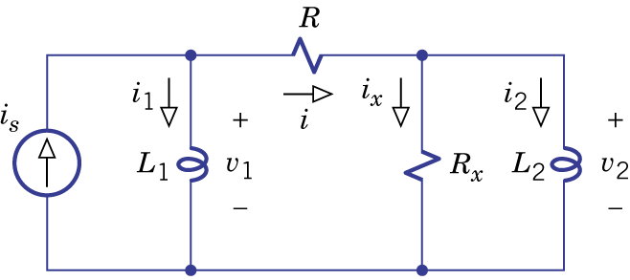Figure 9.19.

Example 9.7: Second-Order with a Controlled Source (Phase-Shift Oscillator)
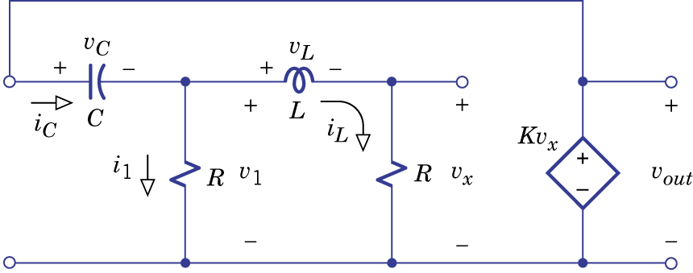Figure 9.20.

- Overdamped response: determined by the roots (characteristic values, eigenvalues) of the second-order characteristic equation.

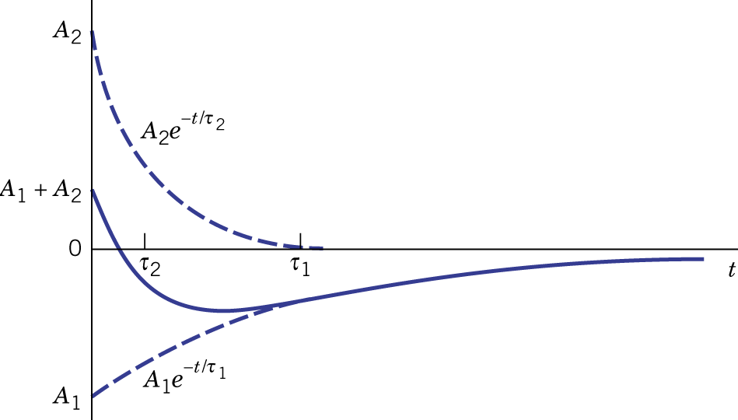Figure 9.22.

Example 9.8: Natural Response of a Series LRC Circuit

- Underdamped Response:

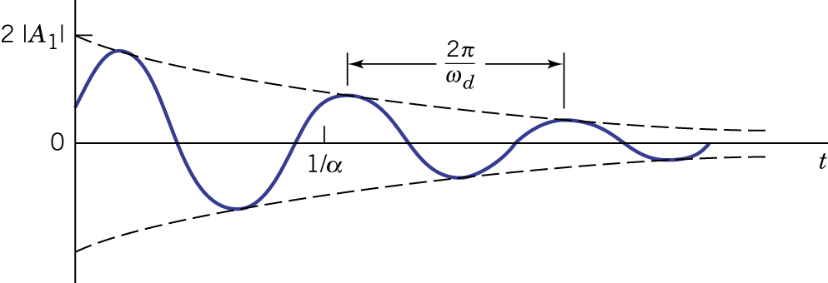Figure 9.23.
Example 9.9: Natural Response of a Phase-Shift Oscillator

- Critically damped response (repeated roots):

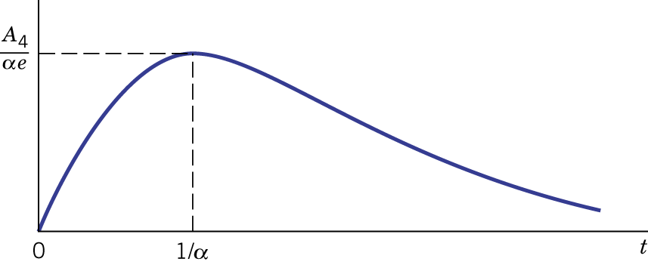Figure 9.24.

9.4 Second-order transients

- Two initial conditions are required for second-order circuits.

Example 9.10 Calculating Initial Conditions
Figure 9.25.

- Switched DC transients for the three types of second-order circuits (overdamped, underdamped and critically damped).

Example 9.11: Underdamped Zero-Input Response
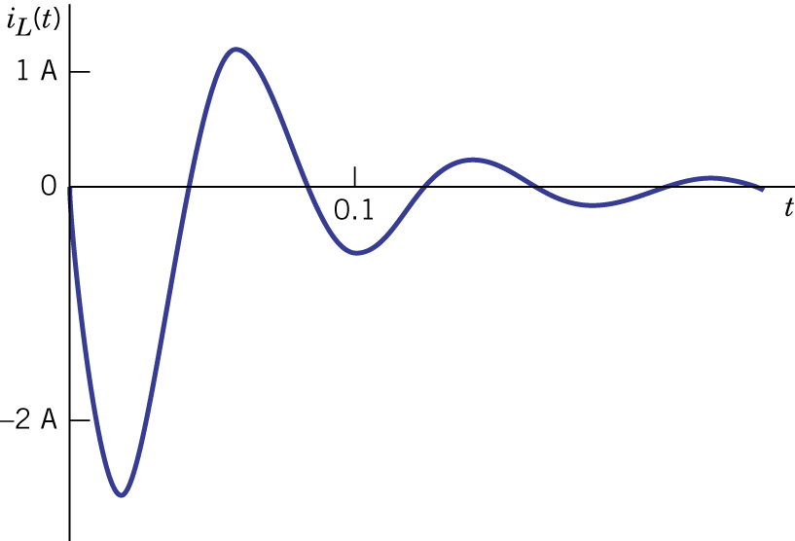Figure 9.27.

Example 9.12: Step Response with Variable Damping

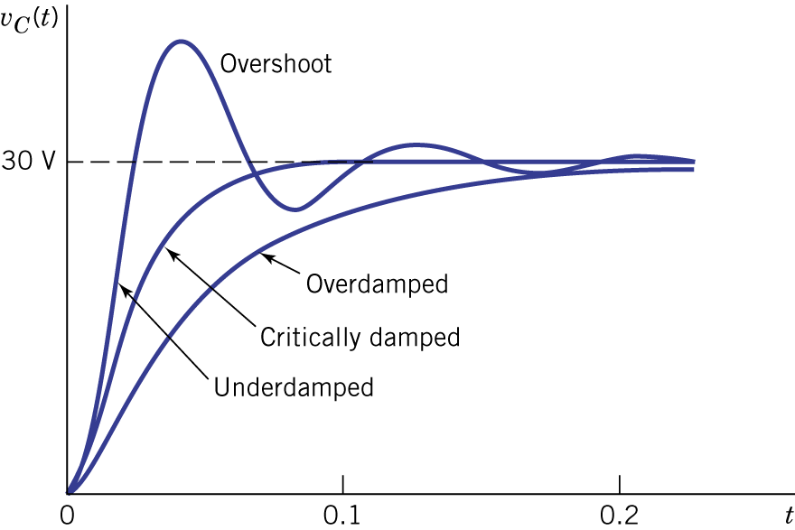Figure 9.28.

