Chapter 8 Transformers and Mutual Inductance

8.1 Ideal Transformers

- Transformers consist of magnetically coupled coils the respond only when driven by time-varying excitations.
- Ideal transformers vs. real transformers.
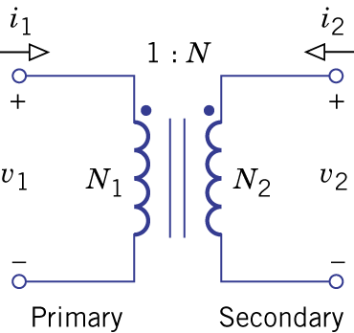 Figure 8.1.
- N₁: primary winding, N₂: secondary winding.
- Reference direction: both currents into the upper terminals.
- Dot convention: polarity is the same at both windings.
- Coils have zero resistance and are short circuits at dc steady state.
- Time varying excitation activates magnetic coupling and induces voltage at the other winding.
- Turns ratio: $N≡{N_{2}}/{N_{1}}$.
- $v_{2}(t)={\text{Nv}}_{1}(t)$, $i_{2}(t)=−i_{1}(t)/N$.
- With $N=1$, a transformer becomes an isolation transformer that decouples the dc potential levels without affecting the time-varying quantities.
- An ideal transformer does not dissipate power ($p=v_{1}i_{1}+v_{2}i_{2}=0$).
- Controlled source models (VCVS and CCCS)
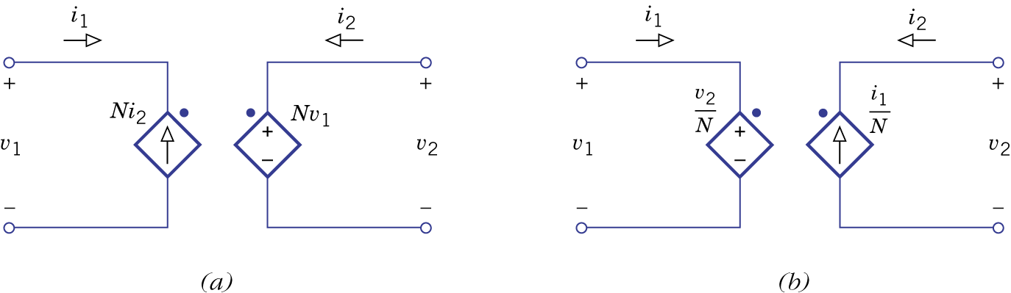 Figure 8.2.
- Transformers with three or more windings:
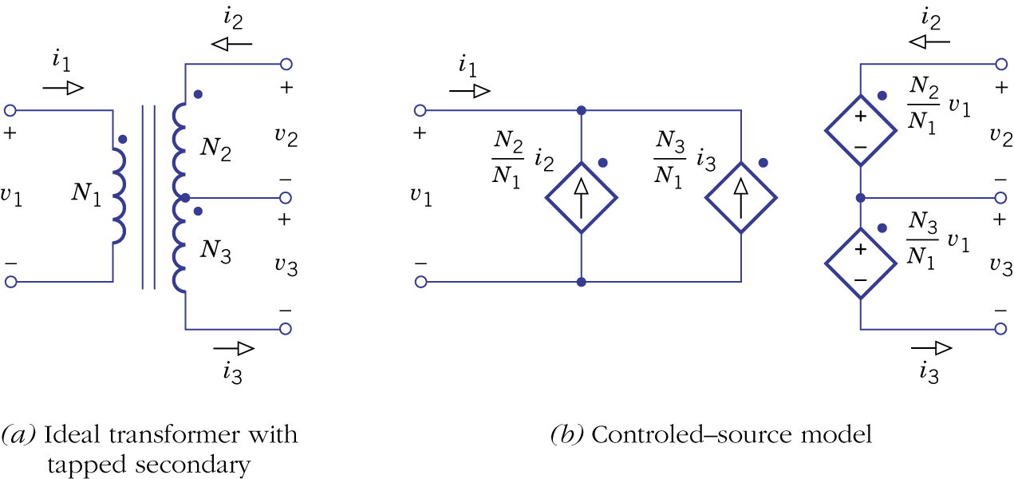Figure 8.3.

Example 8.1: Analysis of a Transformer Circuit

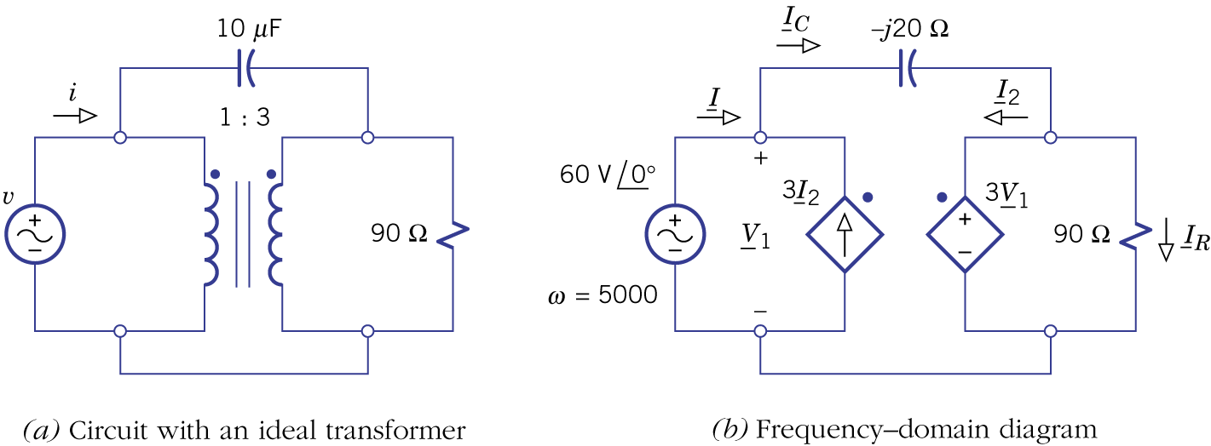Figure 8.4.

- Referred networks:
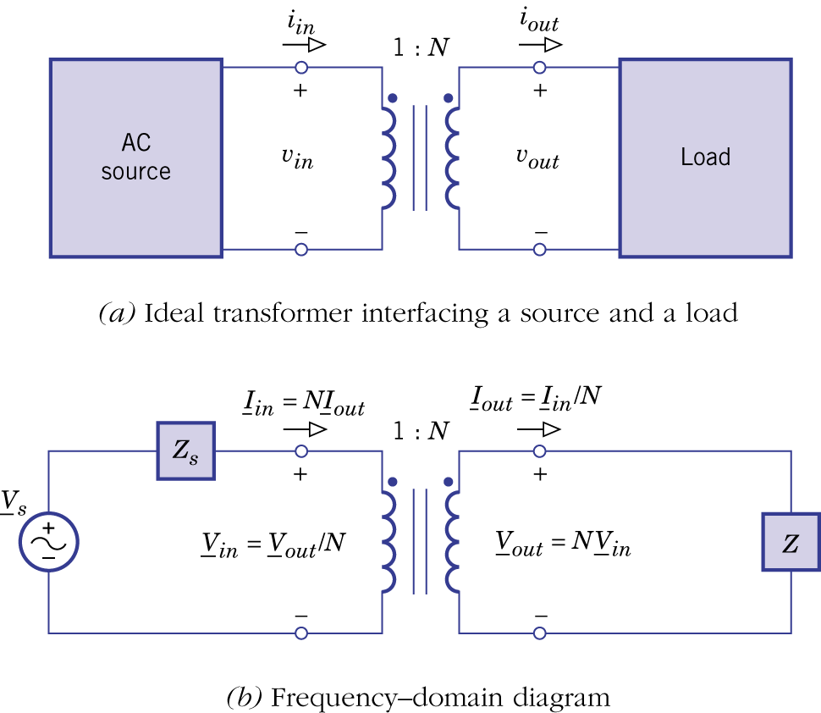Figure 8.6.
- Referred load network and referred source network.

- Referred load network: R and L divided by N² and C multiplied by N².
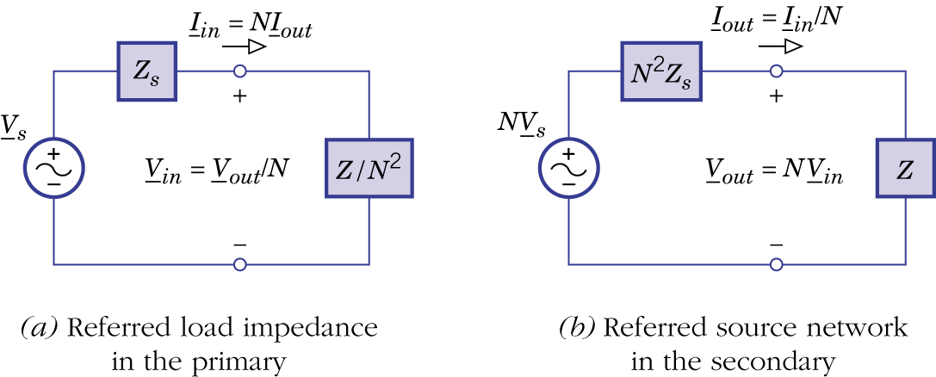Figure 8.7.

- Referred source network: voltage multiplied by N, impedance multiplied by N² and current divided by N.

Example 8.2 Power Transmission with Transformers
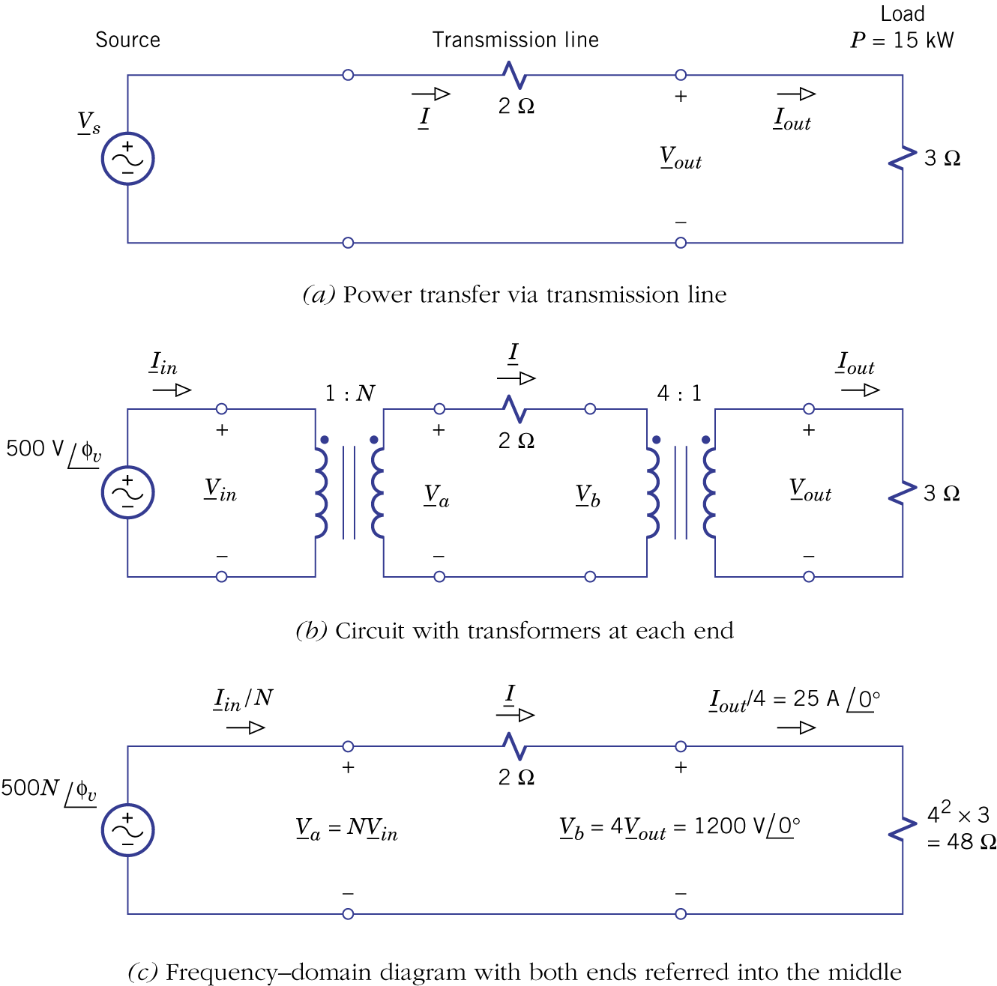Figure 8.8.

Example 8.3 Transformer-Coupled Oscillator
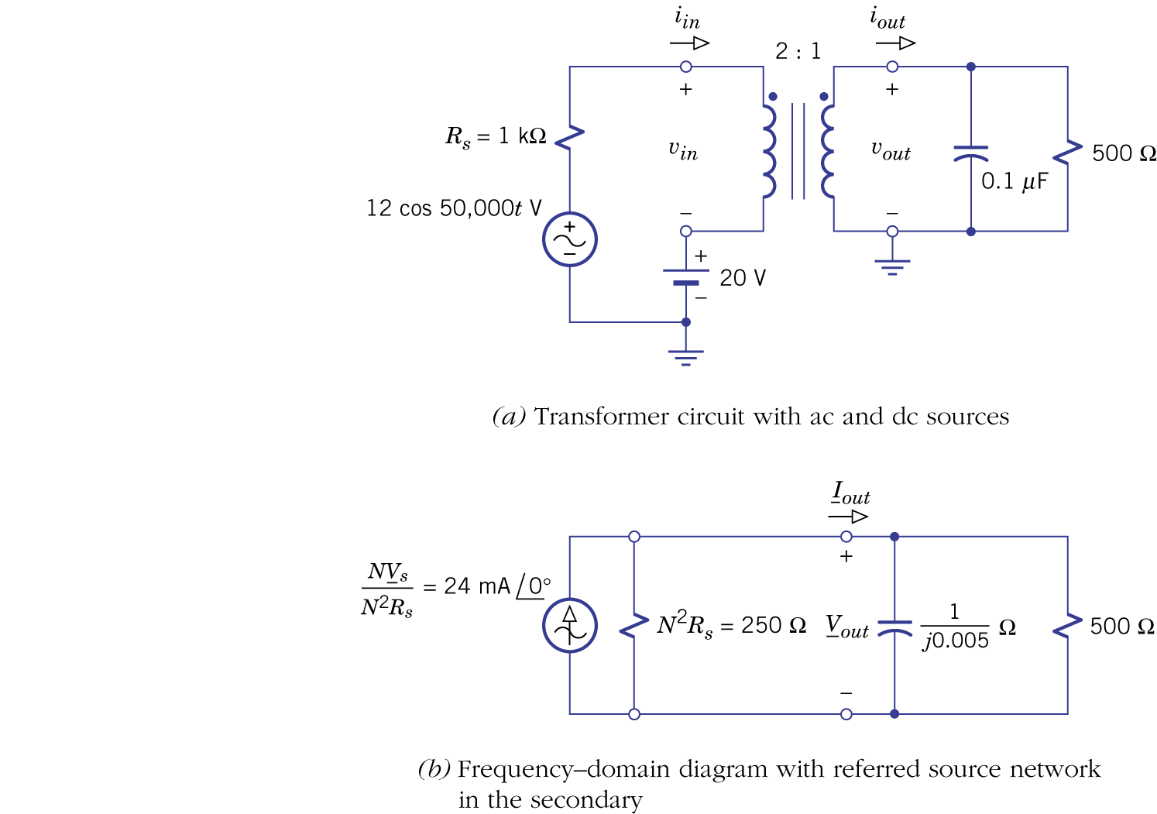Figure 8.9.

- Impedance matching (refer to Figure 8.6b).

Example 8.4 Impedance Matching with a Transformer
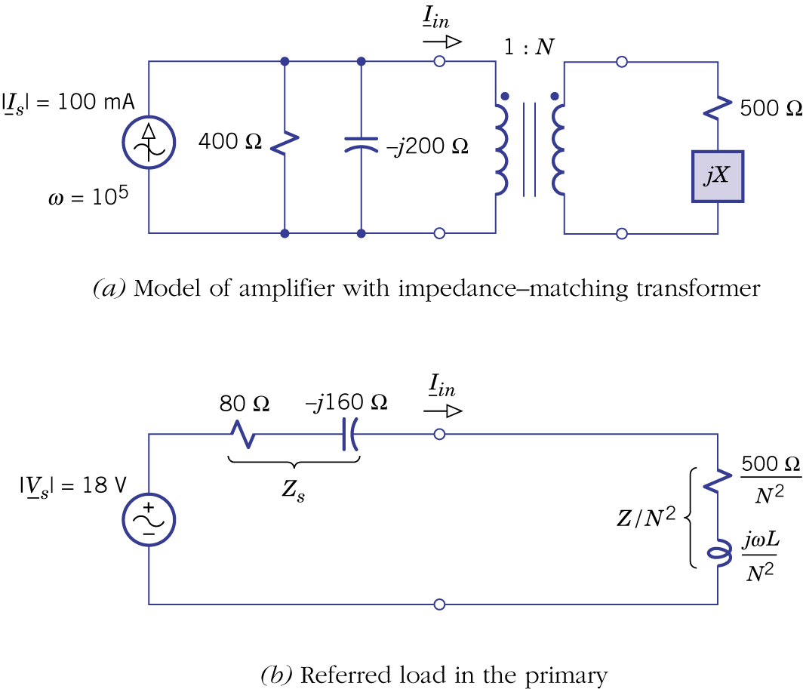 Figure 8.10.
8.2 Magnetic Coupling and Mutual Inductance

- Magnetic circuits: N turns, magnetic flux $φ$ and current i (with right-hand rule).
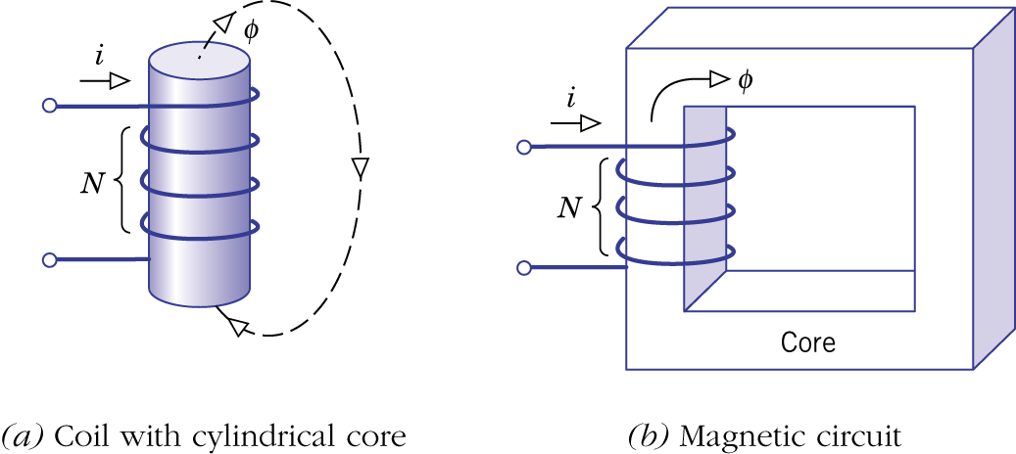Figure 8.11.

- Magnetomotive force (mmf): F=Ni.
- Reluctance: R=l/μ_{r}μ₀A.
- F=Rφ.
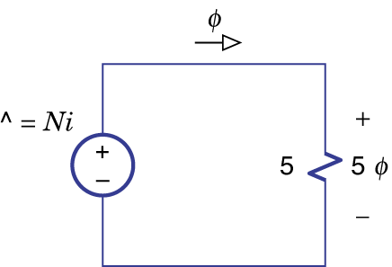Figure 8.12.

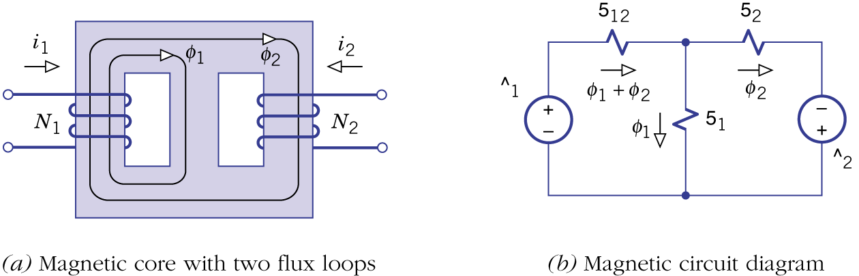Figure 8.13.

- Self-inductance and mutual inductance.

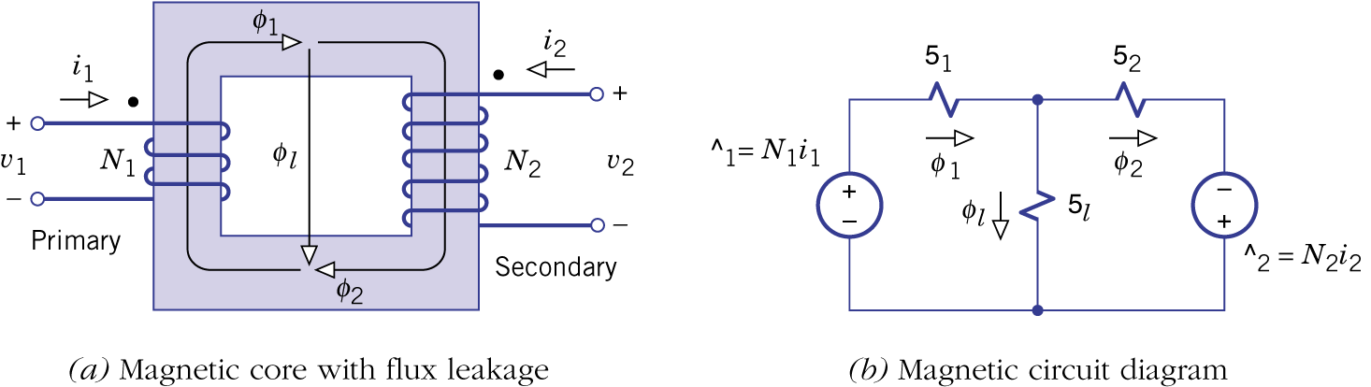Figure 8.14.

- Currents entering the dotted ends of both windings produce flux in the same direction.
- Leakage flux, self-inductance, mutual inductance and coupling coefficient.

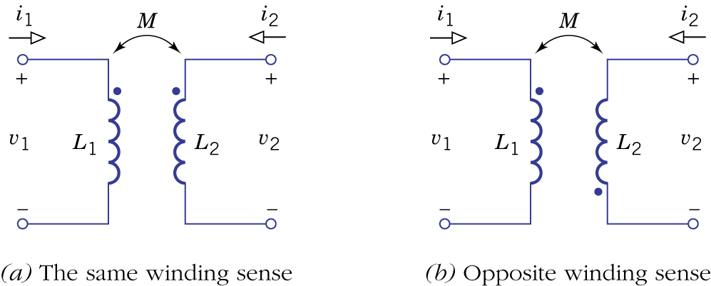 Figure 8.15.
Example 8.5: Series Equivalent Inductance
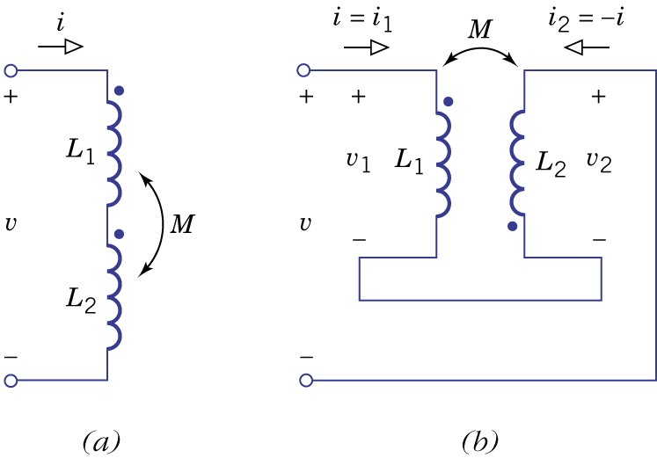Figure 8.16.

- Stored energy:

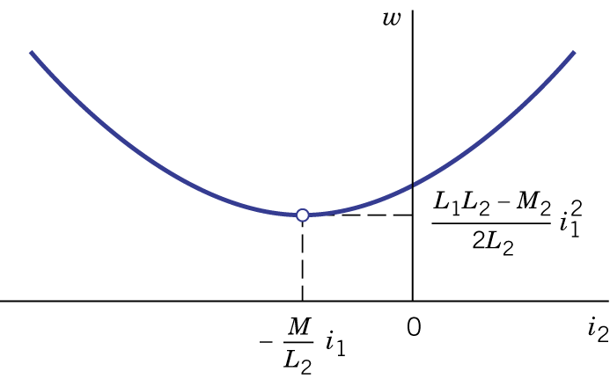 Figure 8.18.
- Unity coupling:

8.3 Circuits with Mutual Inductance

- Mutual inductance represented by controlled sources:
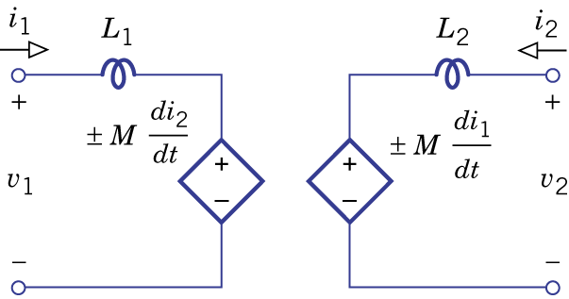Figure 8.19.

- Frequency domain model of self- and mutual inductances:
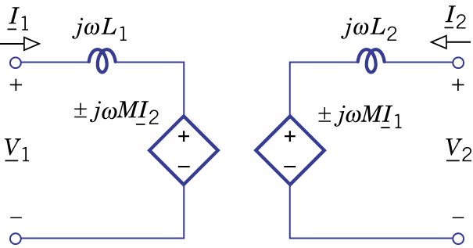Figure 8.20.

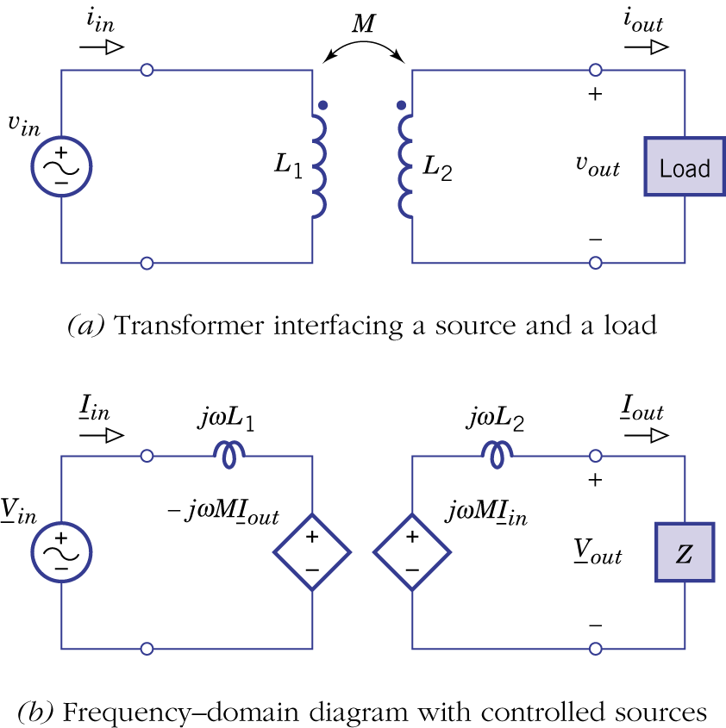Figure 8.21.

Example 8.6: Comparison of a real and ideal transformer

- Equivalent tee (T) networks:
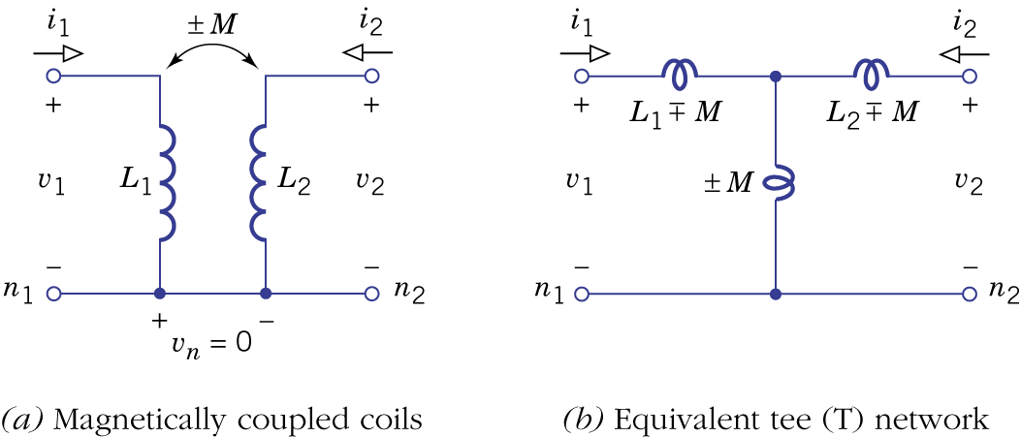Figure 8.23.

- Equivalent pi (Π) networks:
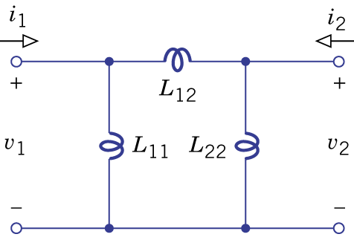Figure 8.24.

Example 8.7: Transformer circuit analysis with a tee network
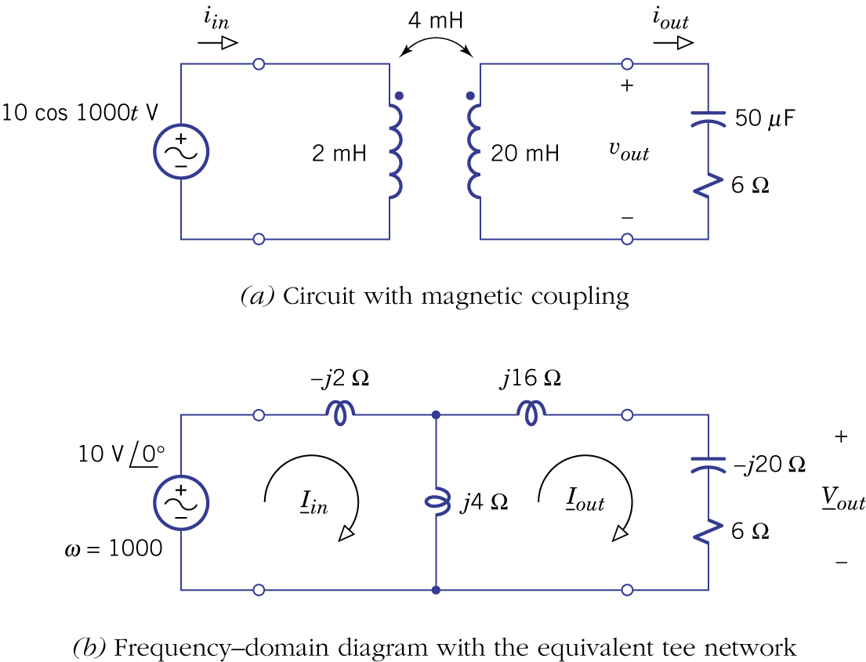Figure 8.25.
Example 8.8: Step-Up Autotransformer
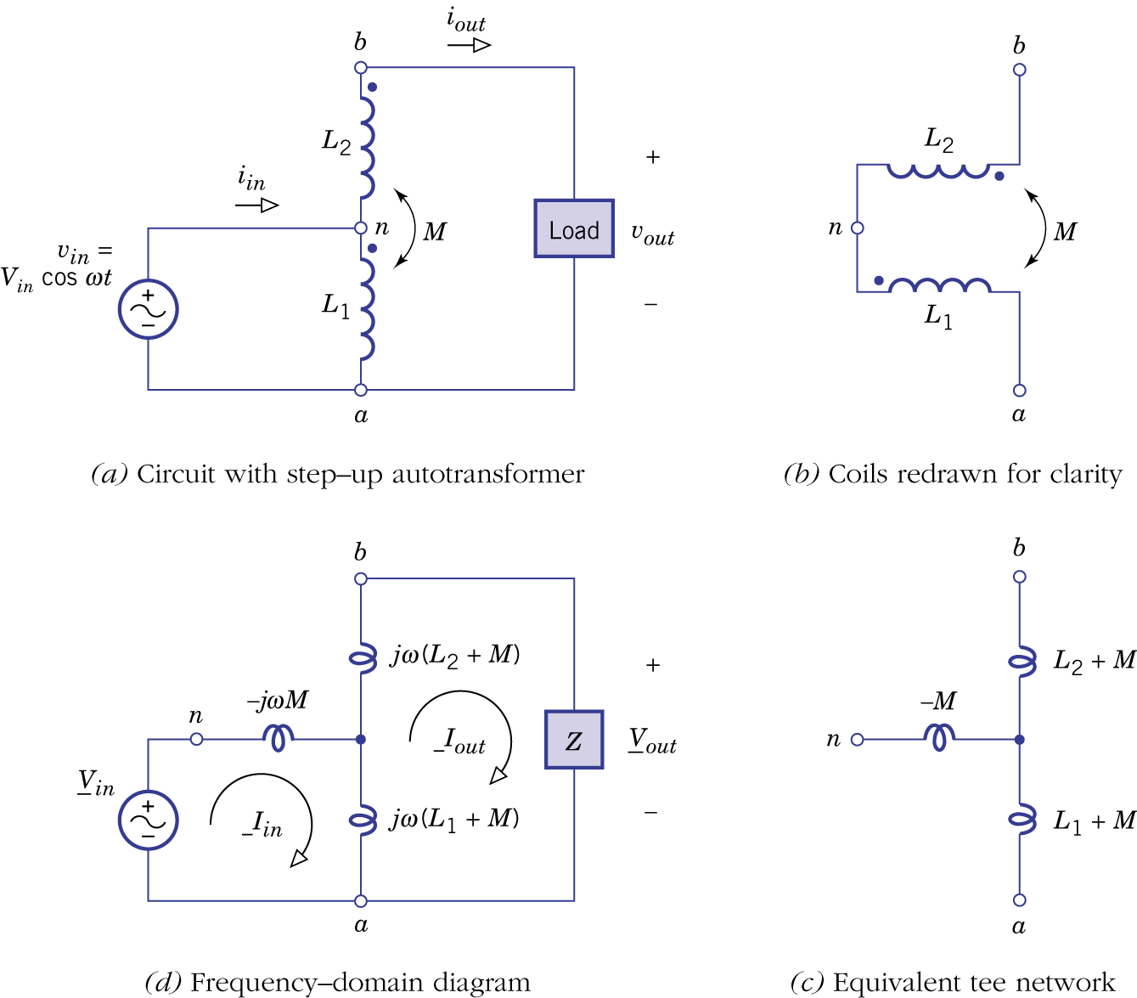Figure 8.26.

- Equivalent networks with an ideal transformer to represent mutual inductance.
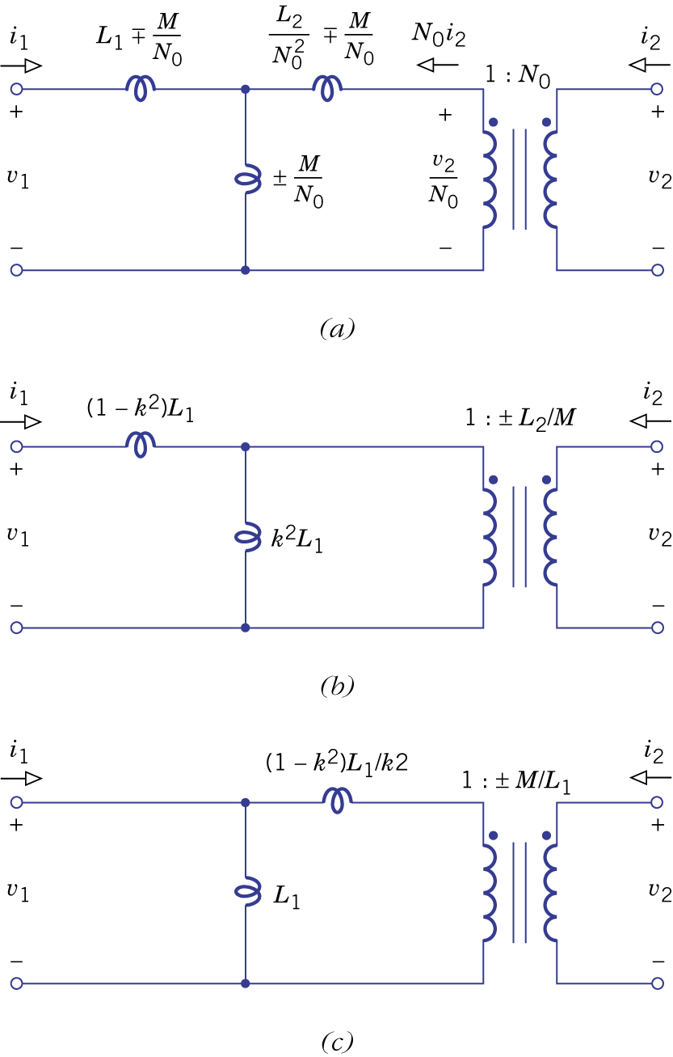Figure 8.27.
Example 8.9: Design of a Tuned Amplifier
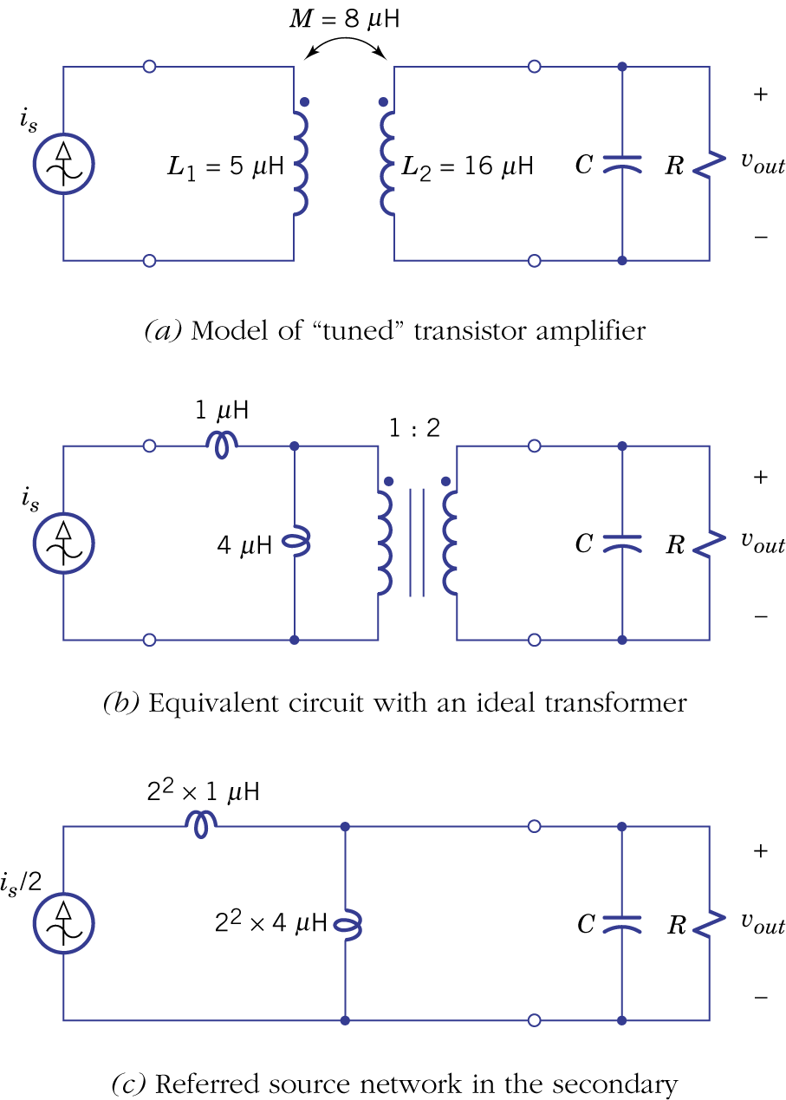Figure 8.28.

