Chapter 14 Two-Port Networks

14.1 Two-ports and impedance parameters

- Two-port networks:

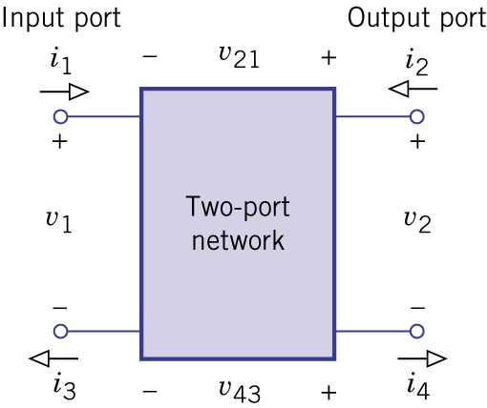Figure 14.1.

- It is assumed that a two-port network contains no independent sources but may include controlled sources.

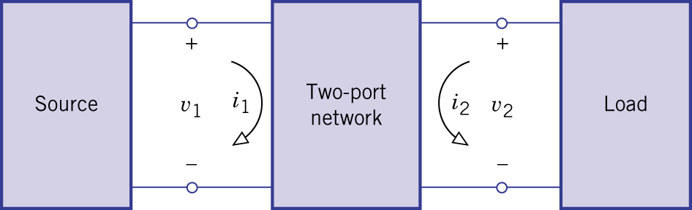Figure 14.2.

- Three-terminal networks (with a common ground):

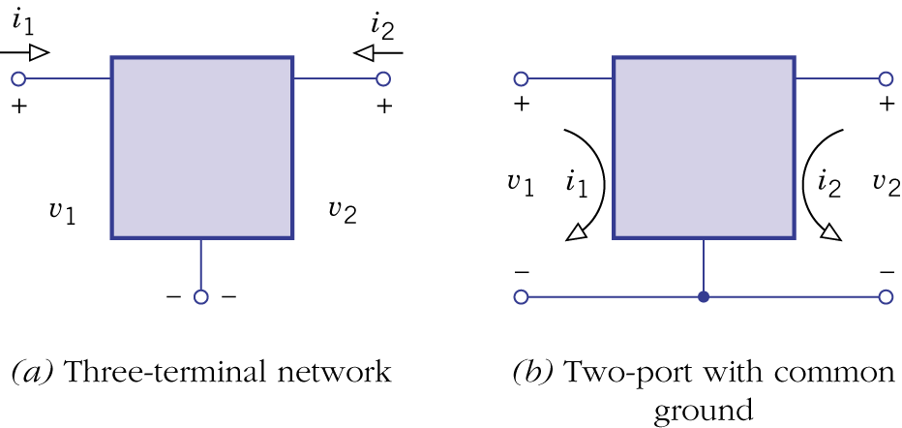Figure 14.3.
- Two-port in the s-domain:
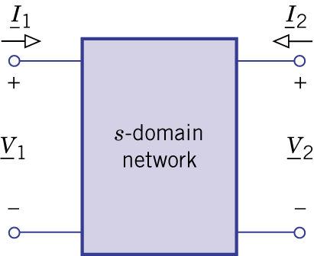Figure 14.4.

- Impedance parameters: common ground two-port with current sources.

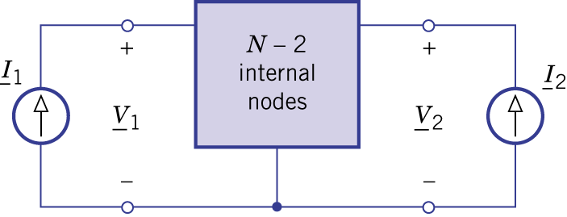Figure 14.5.

$$\left[\begin{matrix}{\underline{V}}_{1} \\ {\underline{V}}_{2}\end{matrix}\right]=\left[\begin{matrix}z_{\text{11}} & z_{\text{12}} \\ z_{\text{21}} & z_{\text{22}}\end{matrix}\right]\left[\begin{matrix}{\underline{I}}_{1} \\ {\underline{I}}_{2}\end{matrix}\right]$$

- Open circuit impedance parameters:
- $z_{\text{11}}={{\underline{V}}_{1}}/{{\underline{I}}_{1}}|{\underline{I}}_{2}=0$: input impedance with open output.
- $z_{\text{12}}={{\underline{V}}_{1}}/{{\underline{I}}_{2}}|{\underline{I}}_{1}=0$: reverse transfer impedance with open output.
- $z_{\text{21}}={{\underline{V}}_{2}}/{{\underline{I}}_{1}}|{\underline{I}}_{2}=0$: forward transfer impedance with open output.
- $z_{\text{22}}={{\underline{V}}_{2}}/{{\underline{I}}_{2}}|{\underline{I}}_{1}=0$: output impedance with open input.

- Equivalent s-domain diagram:
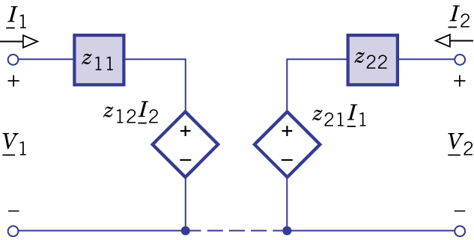Figure 14.6.
- Indirect method for finding z parameters: Treat ${\underline{I}}_{1}$ and ${\underline{I}}_{2}$ as source currents and use standard analysis techniques.
- Direct method for finding z parameters: open circuit techniques.
- Existence test: independent current sources may be connected to the input and output ports without violating KCL.

Example 14.1: z Parameters by the Indirect Method

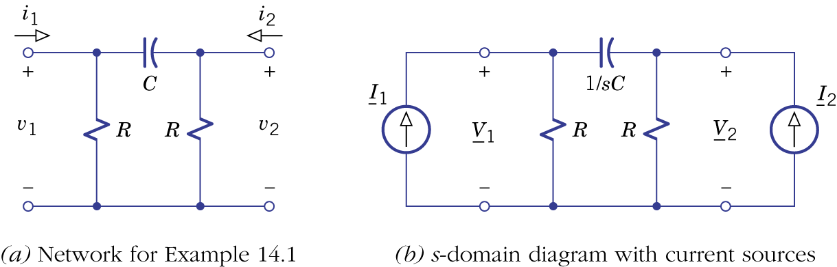Figure 14.7.

Example 14.2: z Parameters by the Direct Method
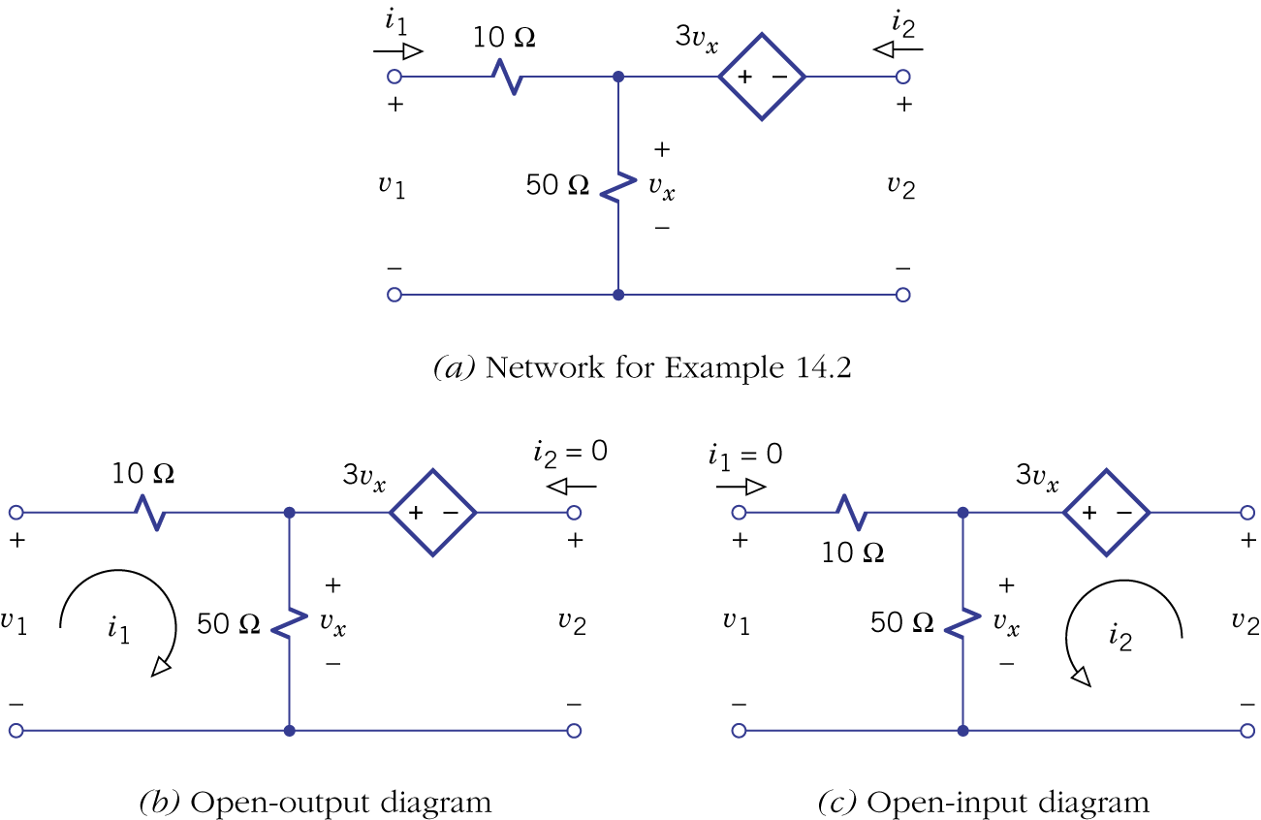Figure 14.8.

- Reciprocal networks: $z_{\text{12}}=z_{\text{21}}$.
- Reciprocal theorem:
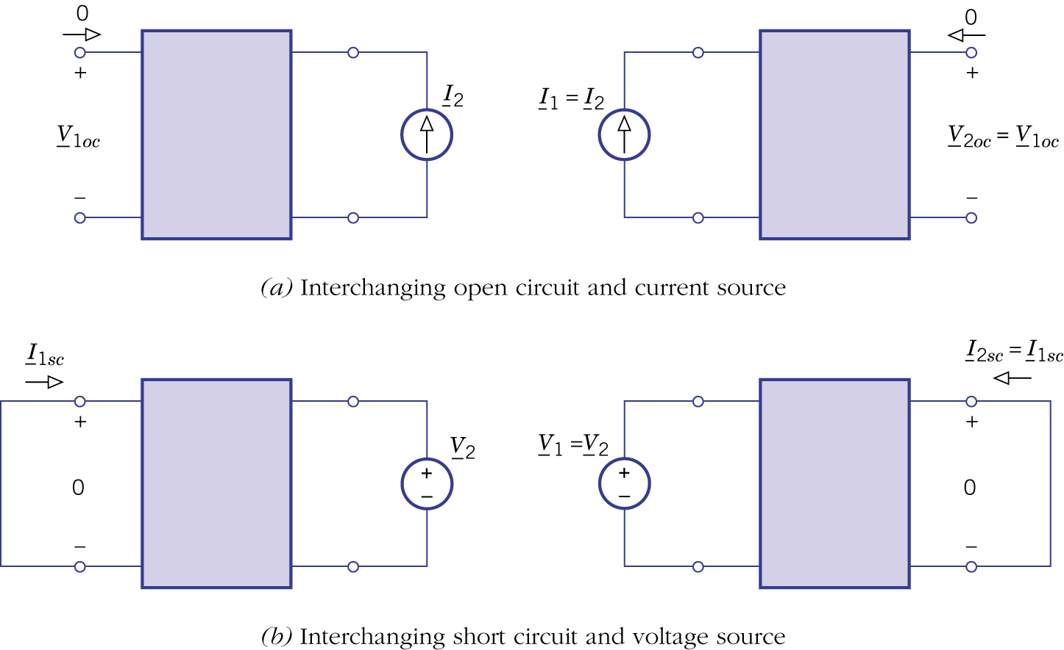Figure 14.10.

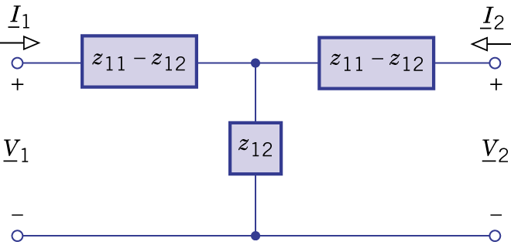Figure 14.11.
- A linear circuit that contains no controlled sources will be reciprocal.

Example 14.3: z Parameters of a Tee Network

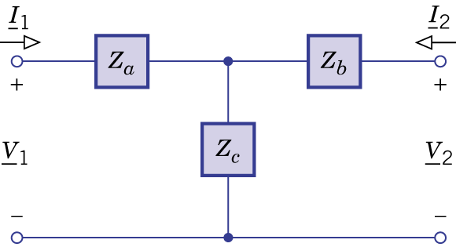Figure 14.12.
14.2 Admittance, hybrid, and transmission parameters,

- Admittance parameters (y parameters): dual of the impedance parameters.
$$\left[\begin{matrix}{\underline{I}}_{1} \\ {\underline{I}}_{2}\end{matrix}\right]=\left[\begin{matrix}y_{\text{11}} & y_{\text{12}} \\ y_{\text{21}} & y_{\text{22}}\end{matrix}\right]\left[\begin{matrix}{\underline{V}}_{1} \\ {\underline{V}}_{2}\end{matrix}\right]$$
- Short circuit admittance parameters:
- $y_{\text{11}}={{\underline{I}}_{1}}/{{\underline{V}}_{1}}|{\underline{V}}_{2}=0$: input admittance with shorted output.
- $y_{\text{12}}={{\underline{I}}_{1}}/{{\underline{V}}_{2}}|{\underline{V}}_{1}=0$: reverse transfer admittance with shorted output.
- $y_{\text{21}}={{\underline{I}}_{2}}/{{\underline{V}}_{1}}|{\underline{V}}_{2}=0$: forward transfer admittance with shorted output.
- $y_{\text{22}}={{\underline{I}}_{2}}/{{\underline{V}}_{2}}|{\underline{V}}_{1}=0$: output admittance with shorted input.
- Existence test: independent current sources may be connected to the input and output ports without violating KVL.

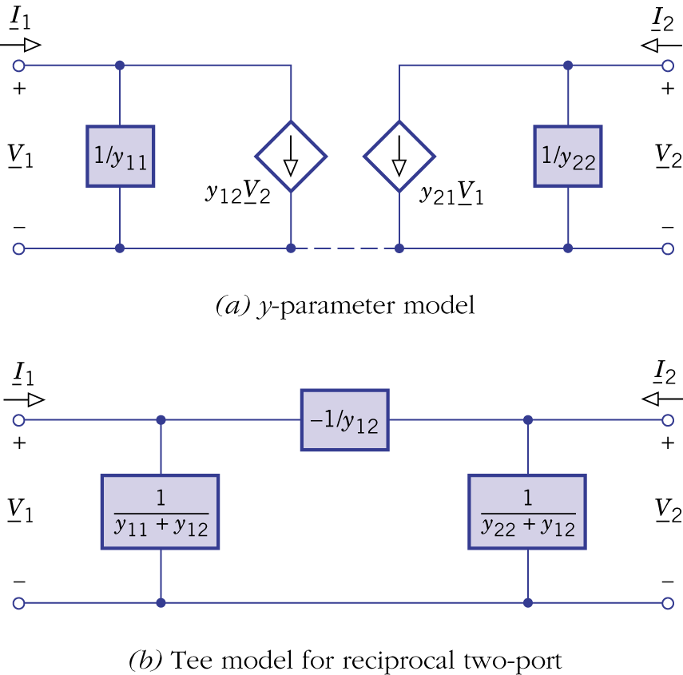Figure 14.14.
- The y parameters can be found by the indirect and the direct method.

Example 14.4 y Parameters by the Indirect Method

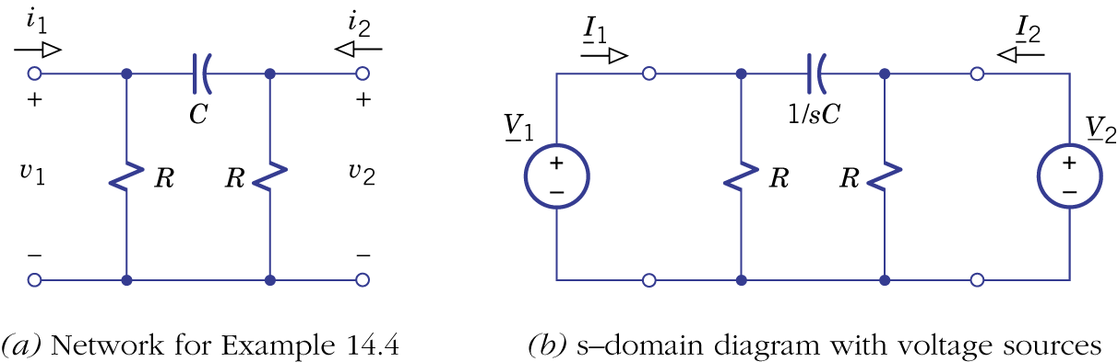Figure 14.15

Example 14.5 y Parameters by the Direct Method

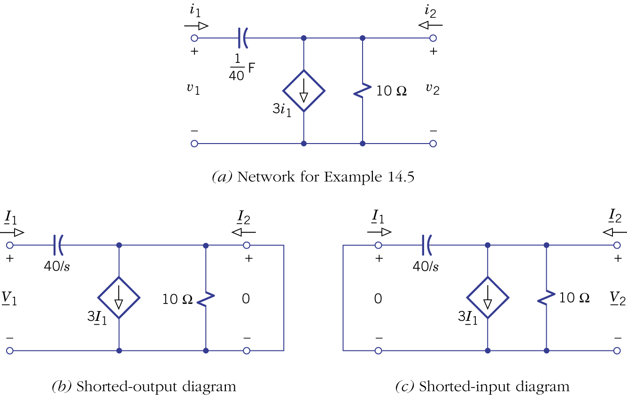Figure 14.16

- Hybrid parameters (h parameters):
$$\left[\begin{matrix}{\underline{V}}_{1} \\ {\underline{I}}_{2}\end{matrix}\right]=\left[\begin{matrix}h_{\text{11}} & h_{\text{12}} \\ h_{\text{21}} & h_{\text{22}}\end{matrix}\right]\left[\begin{matrix}{\underline{I}}_{1} \\ {\underline{V}}_{2}\end{matrix}\right]$$
- Hybrid parameters:
- $h_{\text{11}}={{\underline{V}}_{1}}/{{\underline{I}}_{1}}|{\underline{V}}_{2}=0$: input impedance with shorted output.
- $h_{\text{12}}={{\underline{V}}_{1}}/{{\underline{V}}_{2}}|{\underline{I}}_{1}=0$: reverse voltage ratio with open input.
- $h_{\text{21}}={{\underline{I}}_{2}}/{{\underline{I}}_{1}}|{\underline{V}}_{2}=0$: forward current ratio with shorted output.
- $h_{\text{22}}={{\underline{I}}_{2}}/{{\underline{V}}_{2}}|{\underline{I}}_{1}=0$: output admittance with open input.
- Existence test: an independent current sources may be connected to the input port and an independent voltage source may be connected to the output port without violating KCL and KVL.

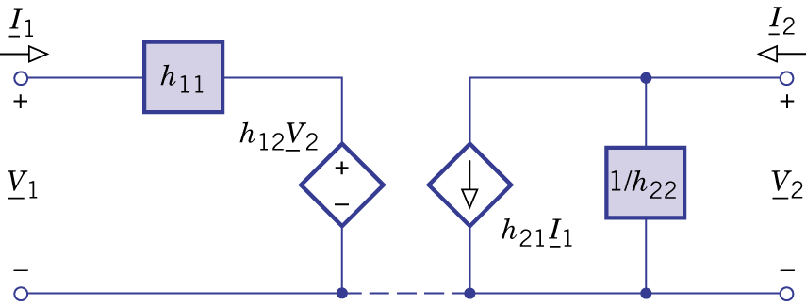Figure 14.17.

Example 14.6 Calculating h parameters
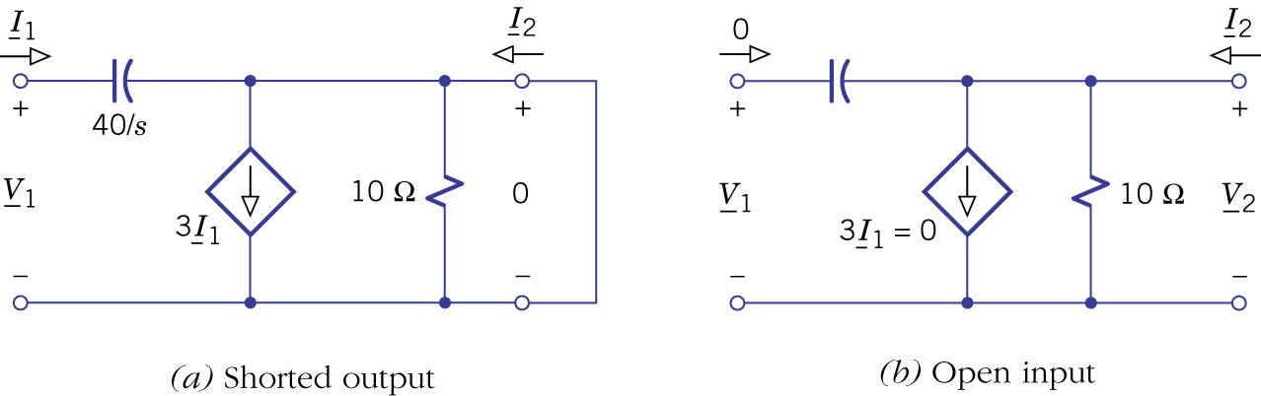Figure 14.18.

- Transmission parameters (ABCD parameters):
$$\left[\begin{matrix}{\underline{V}}_{1} \\ {\underline{I}}_{1}\end{matrix}\right]=\left[\begin{matrix}A & B \\ C & D\end{matrix}\right]\left[\begin{matrix}{\underline{V}}_{2} \\ −{\underline{I}}_{2}\end{matrix}\right]$$
- Transmission parameters:
- $A={{\underline{V}}_{1}}/{{\underline{V}}_{2}}|{\underline{I}}_{2}=0$.
- $B={−{\underline{V}}_{1}}/{{\underline{I}}_{2}}|{\underline{V}}_{2}=0$.
- $C={{\underline{I}}_{1}}/{{\underline{V}}_{2}}|{\underline{I}}_{2}=0$.
- $D={−{\underline{I}}_{1}}/{{\underline{I}}_{2}}|{\underline{V}}_{2}=0$.
- A: reverse voltage ratio with open output.
- -B: reverse transfer impedance with shorted output.
- C: reverse transfer admittance with open output.
- -D: reverse current ratio with shorted output.
- Existence test: the ABCD parameters exist only if ${\underline{V}}_{2\text{oc}}≠0$ and ${\underline{I}}_{2\text{sc}}≠0$.

Example 14.7 Calculating ABCD Parameters
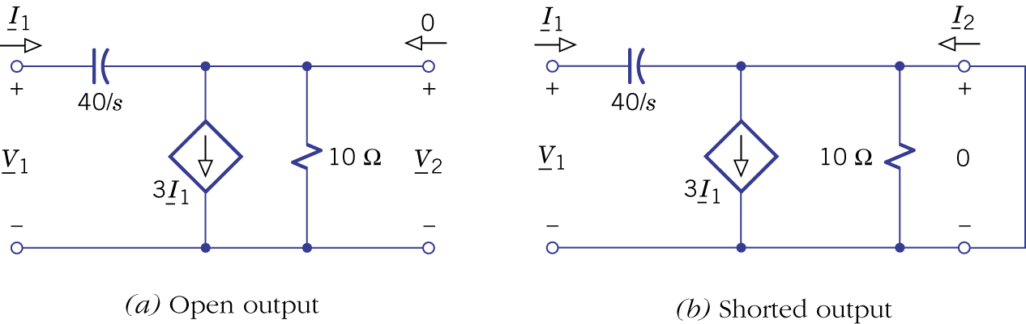Figure 14.19.

- Parameter conversion: with one set of parameters for a particular two-port, other sets of parameters can be obtained if they exist.

(Table 14.1 Two-port equations)

- The conversion between z and y can be done by matrix inversion.
- Conversions involving hybrid or transmission parameters need to be done by algebraic manipulation.

(Table 14.2 Parameter conversions)

Example 14.8 Parameters of a Tee Network
figure 14.20.

14.3 Circuit analysis with two-ports

- Terminated two-ports: A two-port is terminated with a source and a load. The source may be replaced by a Thevenin or Norton model and the load may be replaced by an equivalent impedance.
- Typical network functions:
  - Voltage transfer function: $H_{v}(s)≡{{\underline{V}}_{2}}/{{\underline{V}}_{1}}$.
  - Current transfer function: $H_{i}(s)≡{{\underline{I}}_{2}}/{{\underline{I}}_{1}}$.
  - Equivalent input impedance: $Z_{i}(s)≡{{\underline{V}}_{1}}/{{\underline{I}}_{1}}$.
  - Equivalent output impedance: $Z_{o}(s)≡{{\underline{V}}_{2}}/{{\underline{I}}_{2}}|_{{\underline{V}}_{s}=0}$.
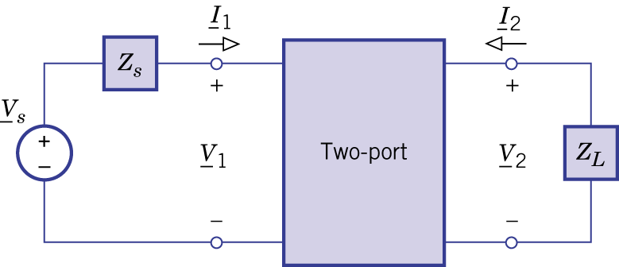Figure 14.21.

(Table 14.3 Relations for Terminated Two-Ports)

Example 14.9 Calculating a Transfer Function

Example 14.10 A Mid-Frequency Transistor Amplifier

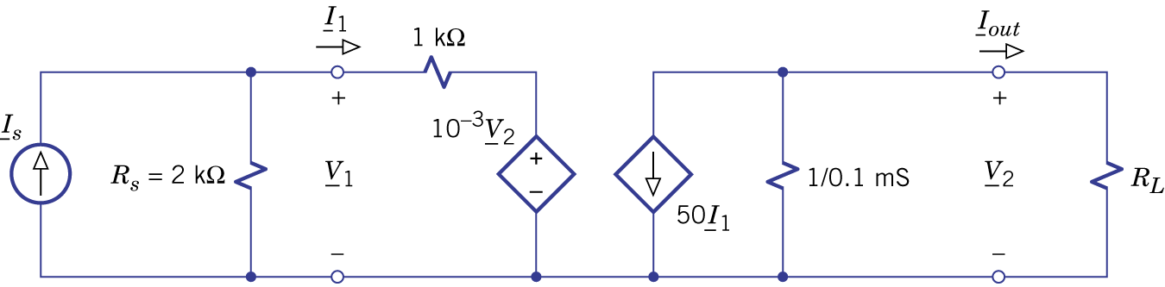Figure 14.22.

- Interconnected two-ports (assuming the interconnection does not change the properties of individual two-ports).
- Cascade connection:
${\underline{V}}_{1b}={\underline{V}}_{2a}$, ${\underline{I}}_{1b}=−{\underline{I}}_{2a}$.
${\left[T\right]}_{\text{cas}}={\left[T\right]}_{a}{\left[T\right]}_{b}$.

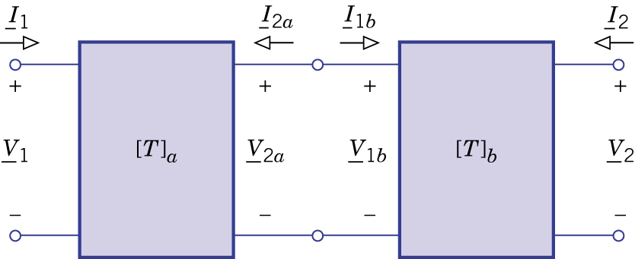Figure 14.24.
Example 14.11 A Cascade Amplifier
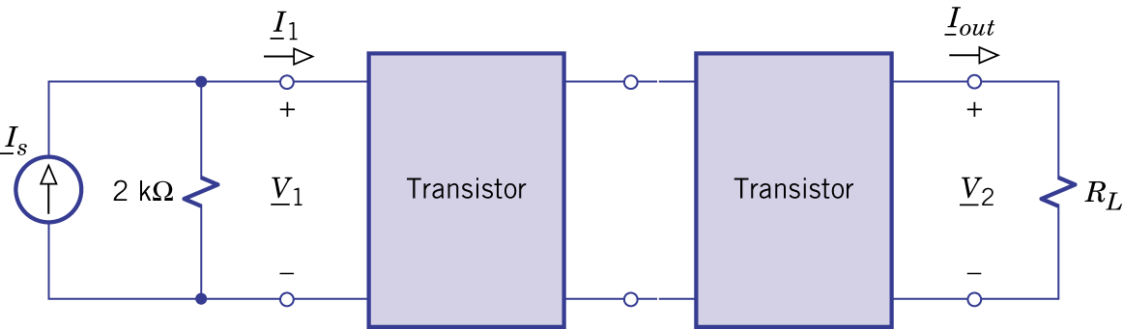Figure 14.25.

- Series and parallel connections
$${\left[z\right]}_{\text{ser}}={\left[z\right]}_{a}+{\left[z\right]}_{b}$$
$${\left[y\right]}_{\text{par}}={\left[y\right]}_{a}+{\left[y\right]}_{b}$$

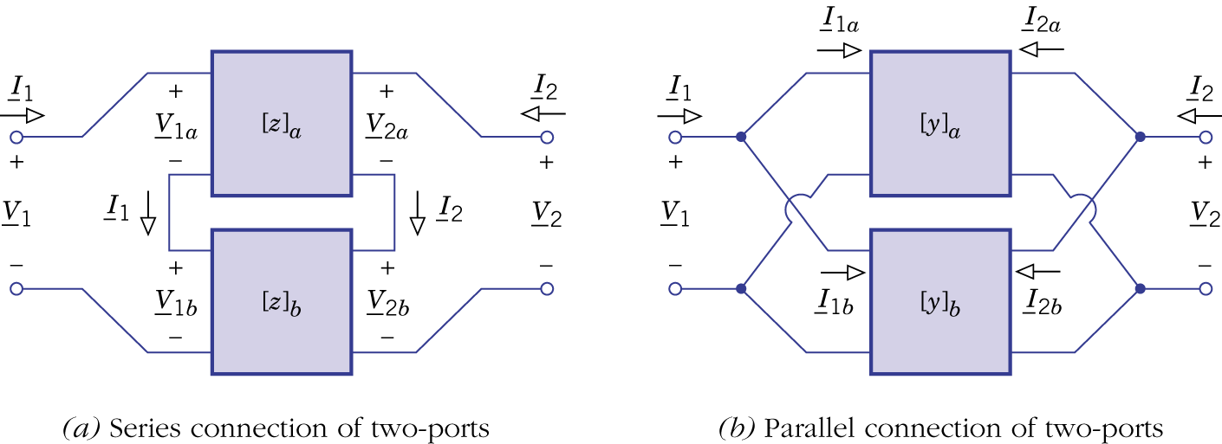
Figure 14.26.
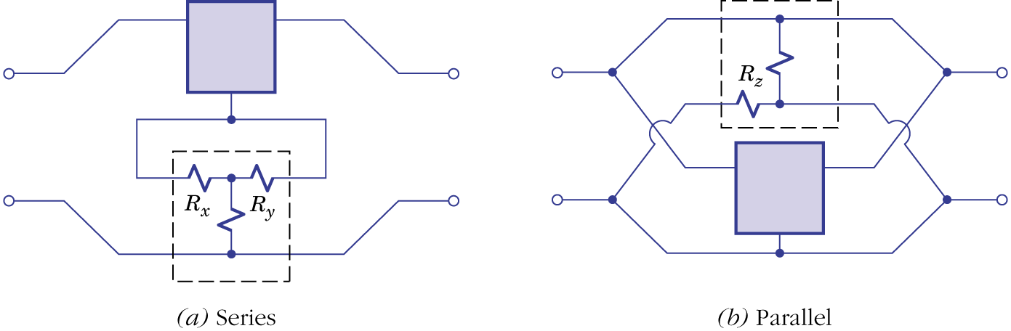Figure 14.27.

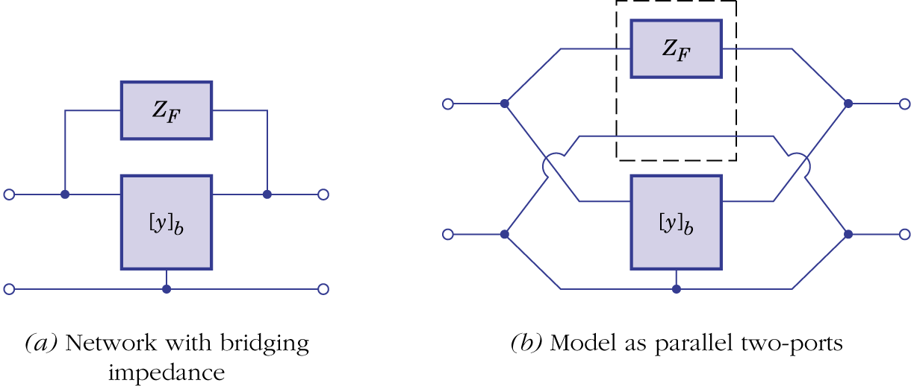Figure 14.28.

Example 14.12 A High-Frequency Amplifier

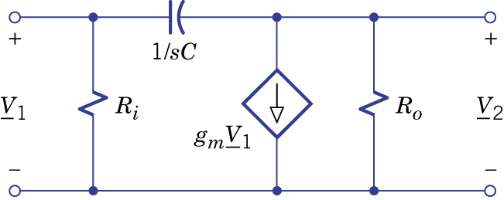Figure 14.29.

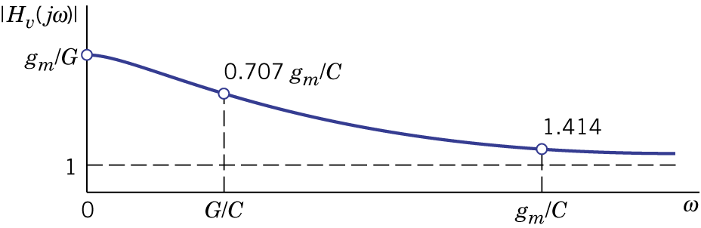Figure 14.30.

