Chapter 13 Laplace Transform Analysis

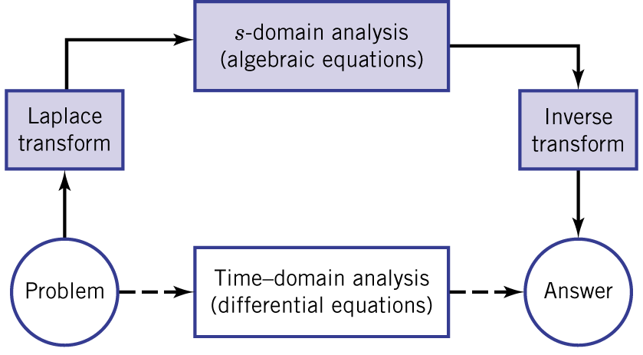Figure 13.1

13.1 Laplace transforms
- s-domain phasor analysis: $x(t)=X_{m}e^{σt}\text{cos}(ωt+φ_{x})$ -> $\underline{X}=X_{m}∠φ_{x}$.
- Laplace transform:
$$F(t)=L[f(t)]≡\int{f(t)e^{−\text{st}}\text{dt}}$$
- Three conditions:
  - Unilateral (one-sided Laplace transform): Laplace transform holds for $t≥0$. Previous effects are included in the initial conditions at $t=0^{−}$.
  - Existence condition: $\underset{t→∞}{\text{lim}}\left|f(t)\right|e^{−σt}=0$, $σ>σ_{c}$.
  - The resulting transform is a function of s.

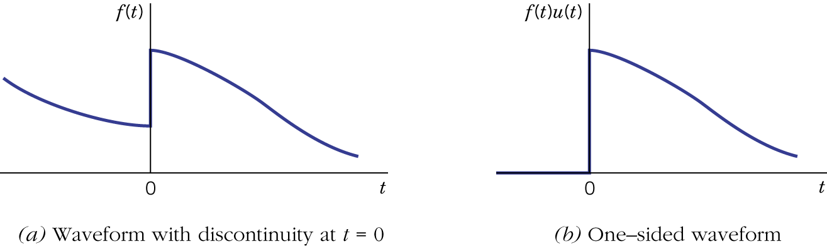Figure 13.2.

- Inverse Laplace transform for $t≥0$:
$f(t)=L^{−1}[F(s)]≡\frac{1}{2πj}\int{F(s)e^{\text{st}}\text{ds}}$, $c>σ_{c}$.
- Inverse Laplace transform is usually done by partial fraction expansion (will be covered in section 13.2).

Example 13.1

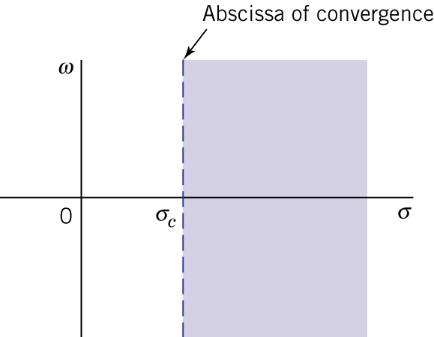Figure 13.3.
Example 13.2

- Transform properties:
  - Linear combination:

  - Multiplication by $e^{−\text{st}}$:

  - Multiplication by t:

  - Time delay:

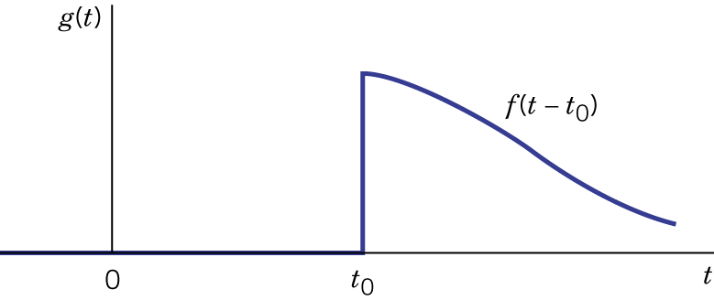Figure 13.4.
  - Differentiation and integration:

Example 13.3

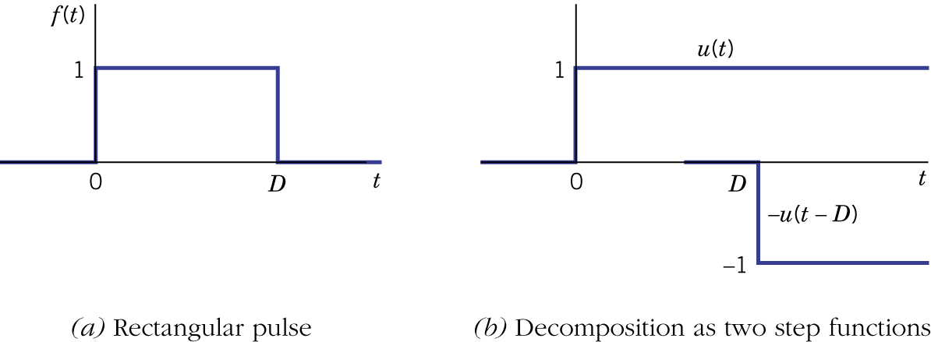Figure 13.5.

Example 13.4

(Please refer to Tables 13.1 and 13.2.)

- Solution of differential equations using Laplace transform:
  - The transformation automatically incorporates the initial conditions.
  - Transformation converts linear differential equations to s-domain algebraic equations.
  - Transformation is similar to the s-domain phasor analysis. Denominator of the s-domain function includes the characteristic polynomial.
  - Inverse transformation is required to obtain the resultant time domain function.

  - First-order example:

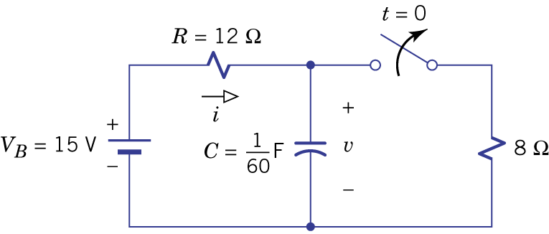Figure 13.6.

  - Second-order example:
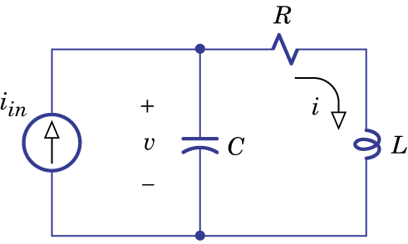Figure 13.7.

13.2 Transform inversion

- Partial-fraction expansion of a strictly proper rational function
$F(s)=\frac{N(s)}{D(s)}=\frac{b_{m}s^{m}+b_{m−1}s^{m−1}+⋯+b_{1}s+b_{0}}{s^{n}+a_{n−1}s^{n−1}+⋯+a_{1}s+a_{0}}$, $m≤n−1$.
- Three cases will be considered: distinct real poles, complex poles and repeated poles.
- Case 1: distinct real poles

(Heaviside's theorem, cover-up rule.)

Example 13.5: Inversion of a Third-Order Function
$$I(s)=\frac{I_{1}s^{2}+(R/L)I_{1}s+{I_{2}}/{\text{LC}}}{s\left[s^{2}+(R/L)s+1/{\text{LC}}\right]}$$

- Case 2: complex poles
$$D(s)=(s^{2}+2αs+ω_{0}^{2})(s−s_{3})⋯(s−s_{n})$$

Example 13.6: Inversion with Complex Poles

(method of the undetermined coefficients)
$$F(s)=\frac{\text{15}s^{2}−\text{16}s−7}{(s+2)(s^{2}+6s+\text{25})}$$

- Case 3: repeated poles
$$\begin{aligned}F(s)=G(s)+\frac{A_{3}}{s−s_{3}}+⋯+\frac{A_{n}}{s−s_{n}} \\ G(s)=\frac{A_{i1}}{s−s_{i}}+\frac{A_{i2}}{(s−s_{i})^{2}}\end{aligned}$$

Example 13.7: Inversion with a Triple Pole
$$F(s)=\frac{−s^{2}−2s+\text{14}}{(s+4)^{3}(s+5)}$$

- Tim delay

Example 13.8: Inversion with Time Delay

- Initial-value theorem

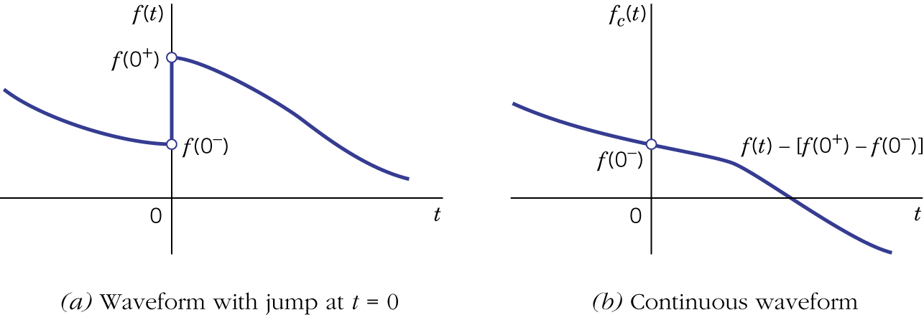Figure 13.8.

- Final-value theorem

Example 13.9: Calculating Initial and Final Values
$f(0^{−})=5$, $F(s)=\frac{N(s)}{D(s)}=\frac{5s^{3}−\text{1600}}{s(s^{3}+\text{18}s^{2}+\text{90}s+\text{800})}$

13.3 Transform circuit analysis

- Given a circuit with some initial state at $t=0^{−}$ and an excitation $x(t)$ starting at $t=0$, find the resulting behavior of any voltage or current $y(t)$ for $t≥0$.
- Zero-state response, natural response, forced response, zero-input response and complete response.
- Zero-state response: a circuit with no stored energy at $t=0^{−}$.

- Step response:
$x(t)=u(t)=1$, $t>0$
$$X(s)=1/s$$
$$Y(s)=H(s)×\frac{1}{s}=\frac{N_{H}(s)}{\text{sP}(s)}$$
Example 13.10: Step Response

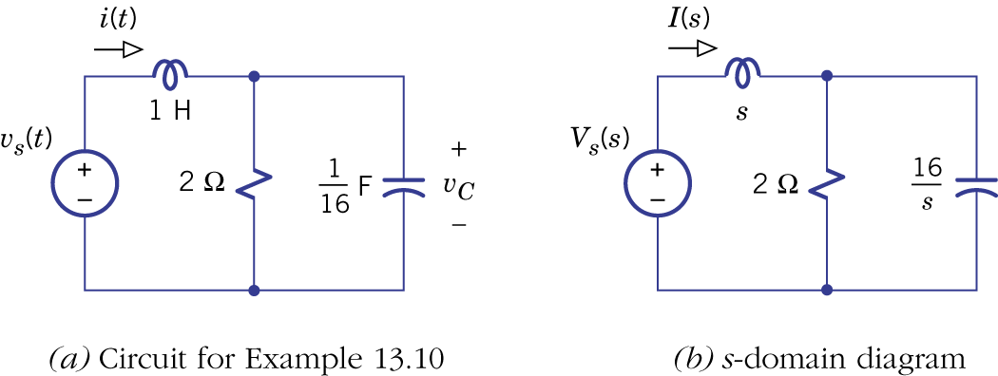Figure 13.9.

- Zero-state AC response:
$$x(t)=X_{m}\text{cos}(βt+φ_{x})$$
$$D_{X}(s)=s^{2}+β^{2}$$

Example 13.11: Zero-State AC Response

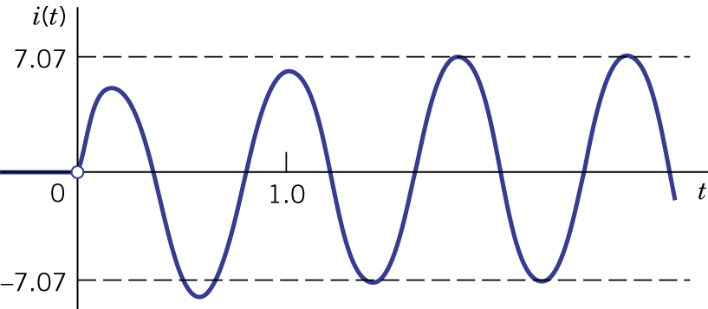Figure 13.10.

- Natural response and forced response:

- Zero-input response: the excitation equals zero for $t≥0$ but the circuit contains stored energy at $t=0^{−}$.

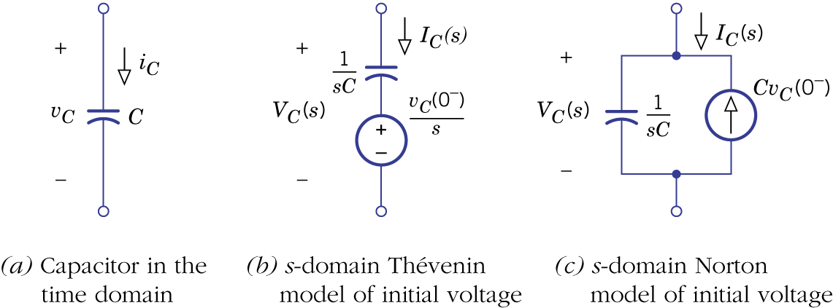Figure 13.11.

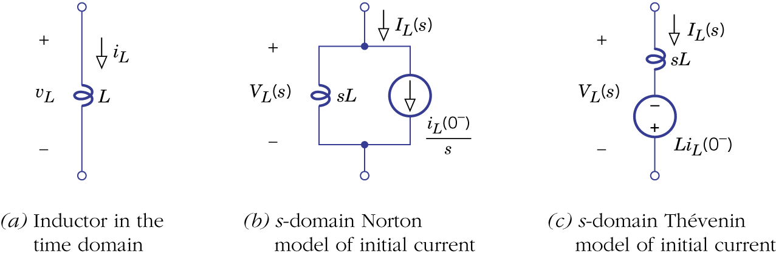Figure 13.12.
Example 13.12: Calculating a Zero-Input Response

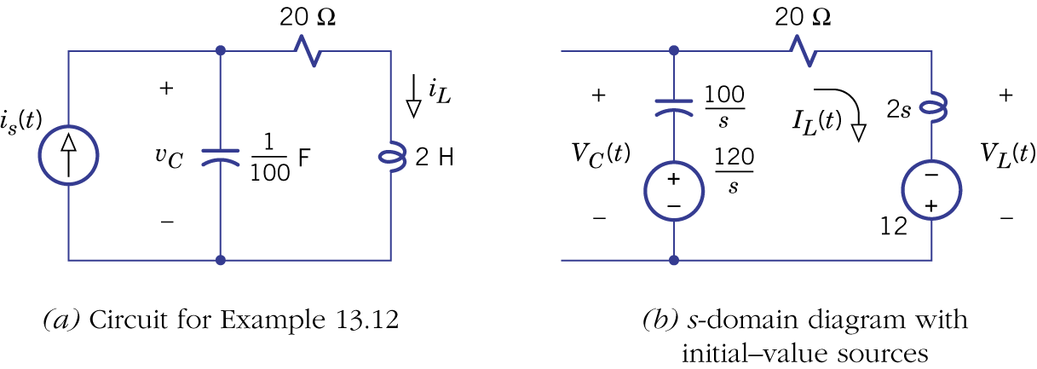Figure 13.13.

- Complete response: complete response=zero-input response + zero-state response.

Example 13.13: Calculating a Complete Response

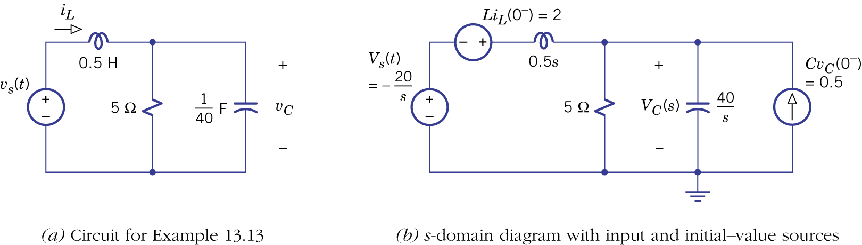
Figure 13.14.

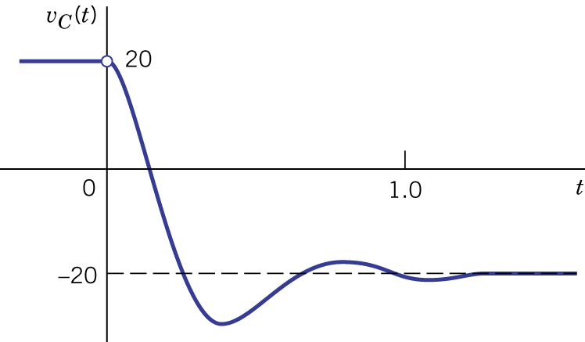Figure 13.15.

13.4 Transform analysis with mutual inductance
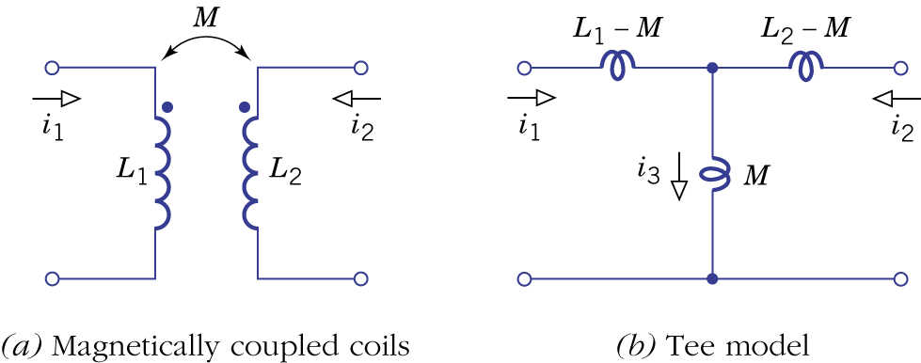Figure 13.16.

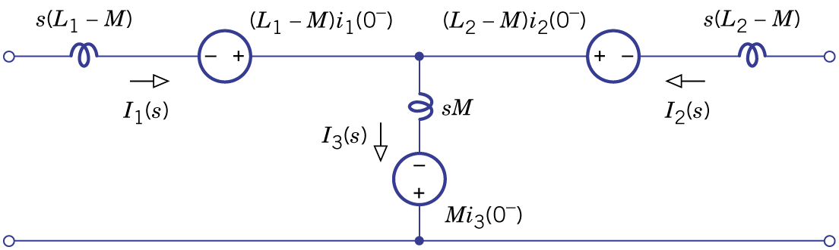Figure 13.17.
Example 13.14: Complete Response of a Transformer Circuit

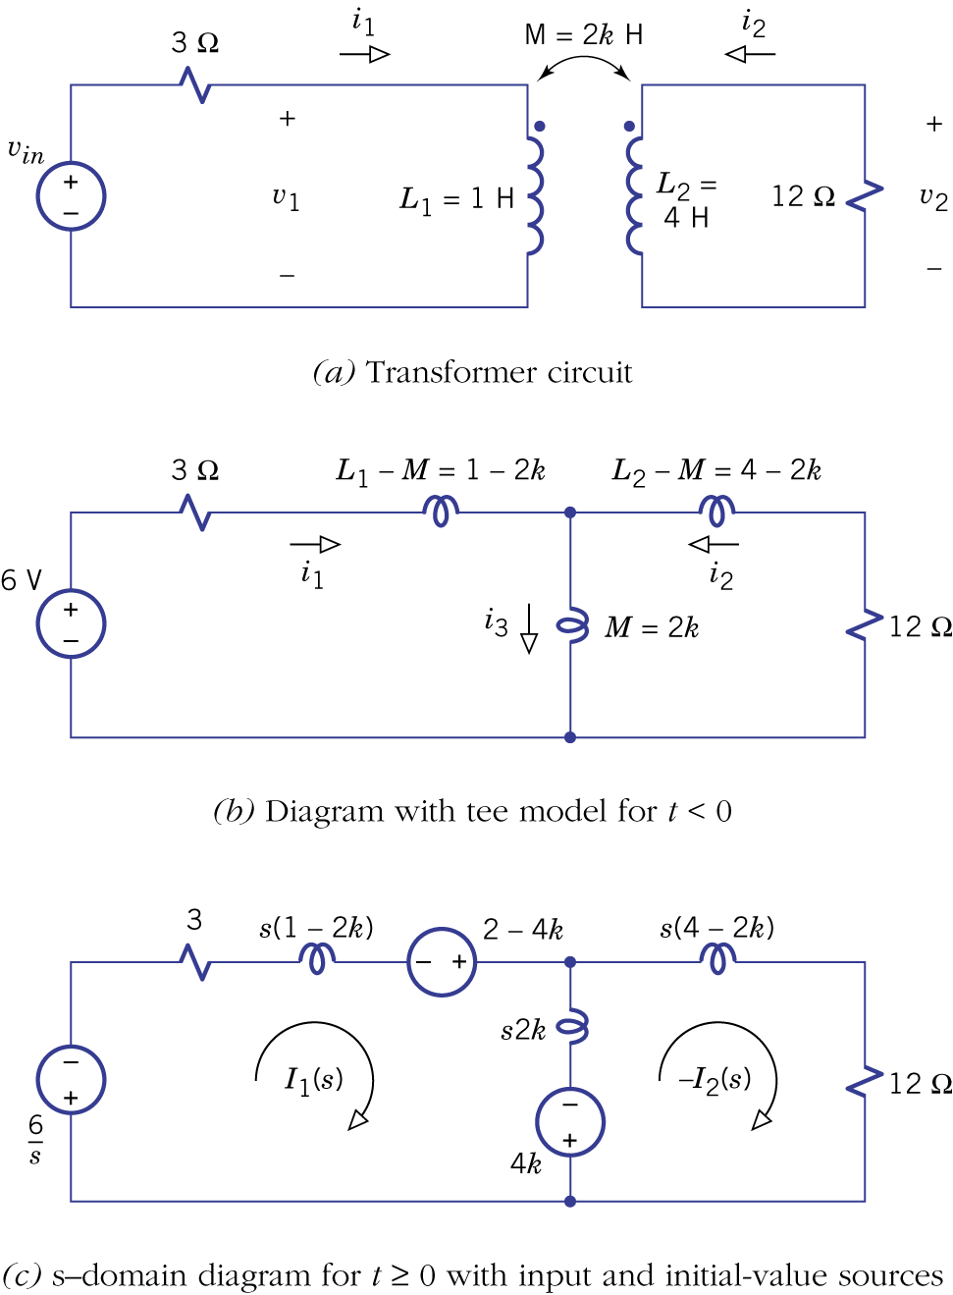Figure 13.18.

13.5 Impulses and convolution

- Impulses:

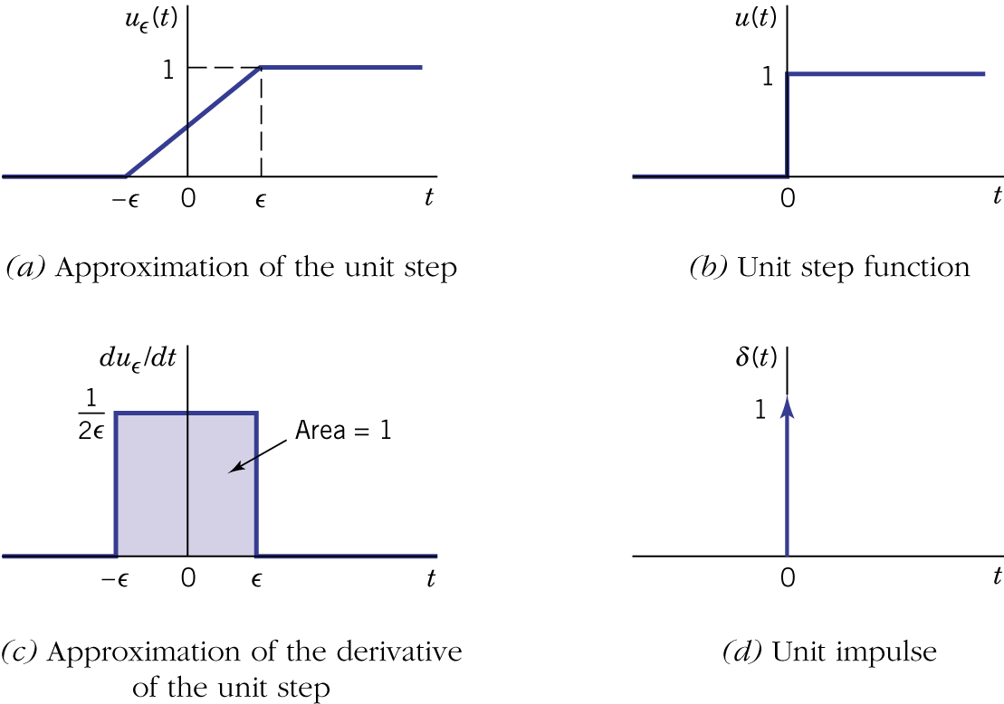Figure 13.18.

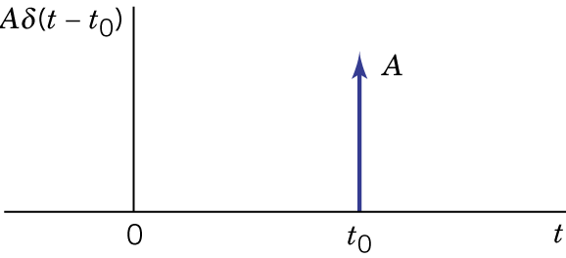Figure 13.20.
- Sampling process:

Example 13.15: Discontinuous Inductor Current

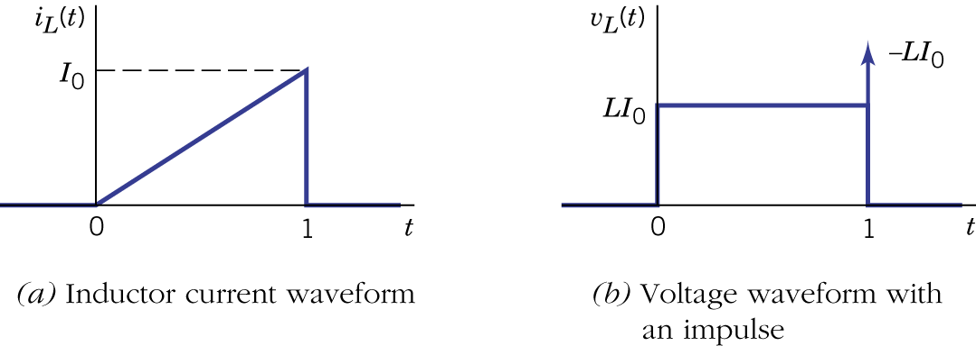Figure 13.21.

- Transform with impulses
$L\left[δ(t)\right]=\int{δ(t)e^{−\text{st}}\text{dt}=e^{−\text{st}}|_{t=0}=1}$.

- As an example, the inverse transform of $\frac{3s}{s+2}$ is

- In general, the inverse of $F(s)$
$$F(s)=\frac{N(s)}{D(s)}=\frac{b_{n}s^{n}+b_{n−1}s^{n−1}+⋯+b_{1}s+b_{0}}{s^{n}+a_{n−1}s^{n−1}+⋯+a_{1}s+a_{0}}$$

Example 13.16: Impulsive Zero-State Response

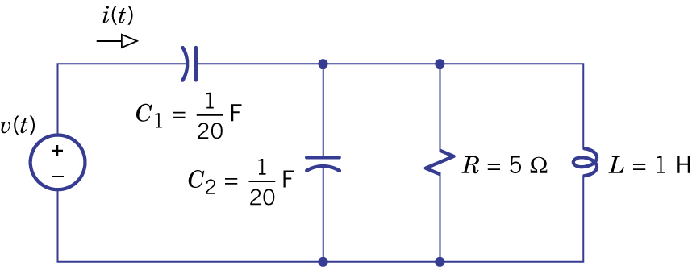Figure 13.22.

- Convolution and impulse response.
- The convolution of $f(t)$ and $g(t)$:
$f(t)∗g(t)≡\int{f(λ)g(t−λ)dλ}$.
- Commutative property ($f(t)∗g(t)≡g(t)∗f(t)$):

- Distributive property ($f(t)∗\left[g_{1}(t)+g_{2}(t)\right]≡\left[f(t)∗g_{1}(t)\right]+\left[f(t)∗g_{2}(t)\right]$):

- Replication property ($f(t)∗δ(t)≡f(t)$):

- Graphical interpretation:

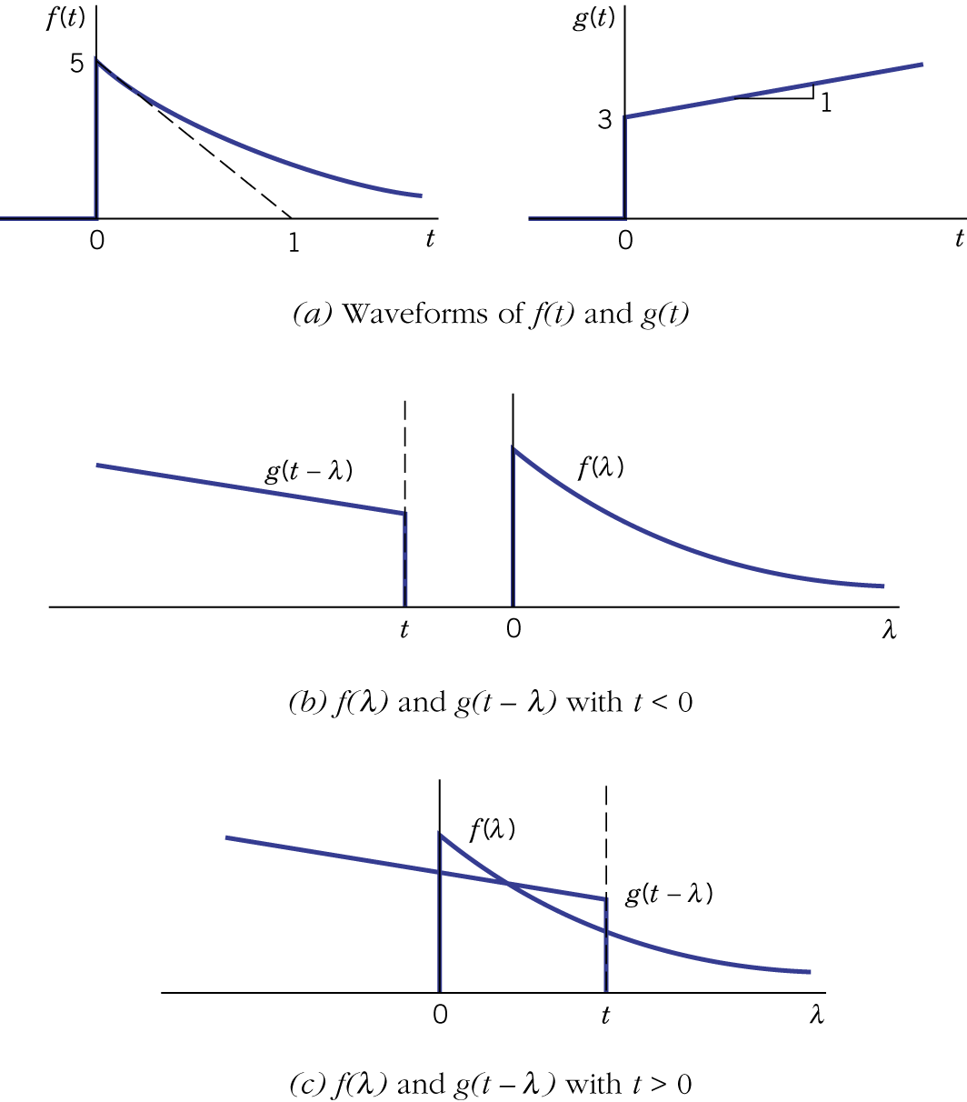Figure 13.23.

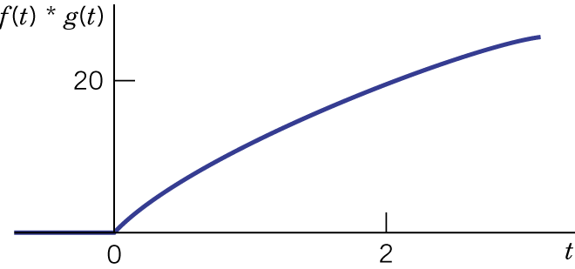Figure 13.24.
- Convolution of two causal functions produces another causal function.

- Laplace transform of the convolution of causal functions:
$$L\left[f(t)∗g(t)\right]=F(s)G(s)$$
$$L^{\text{-1}}\left[F(s)G(s)\right]=f(t)∗g(t)$$

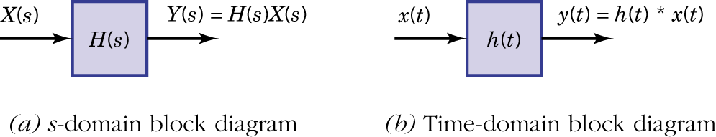Figure 13.25.

Example 13.17: Impulse Response and Pulse Response
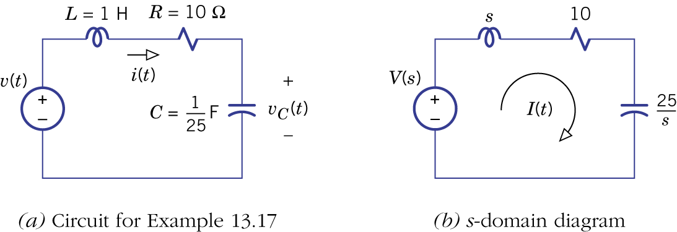Figure 13.26.

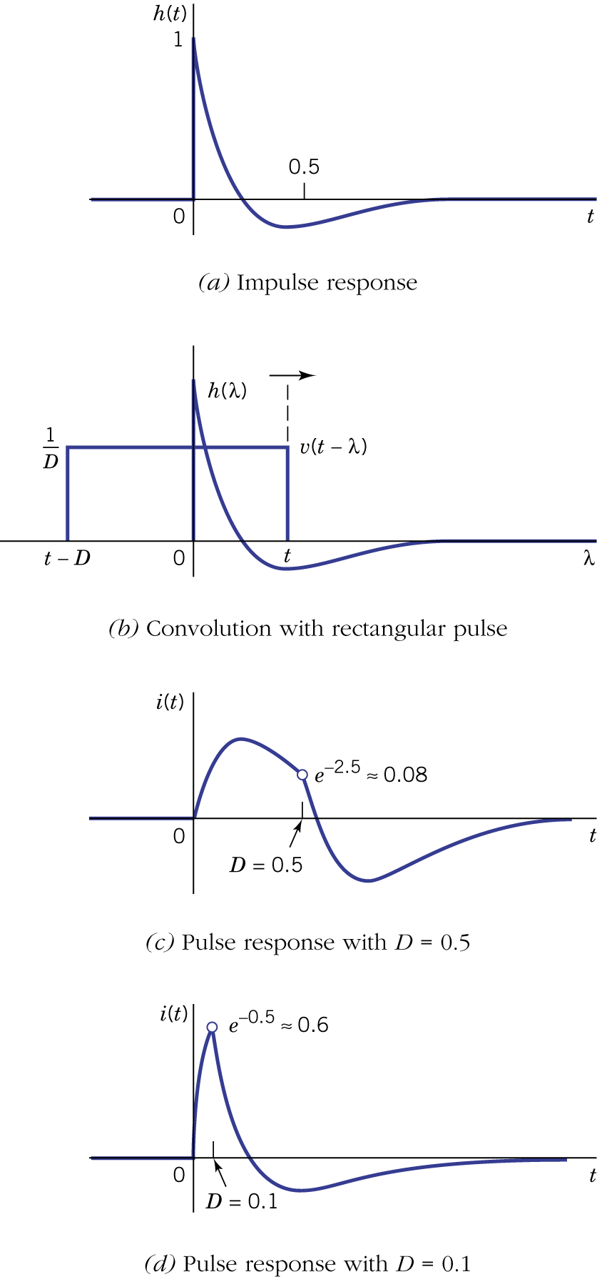Figure 13.27.

