Chapter 12 Fourier Series Analysis

12.1 Periodic waveforms and Fourier series
- A function $f(t)$ is periodic if there exists some repetition interval T such that $f(t−T)=f(t)$.
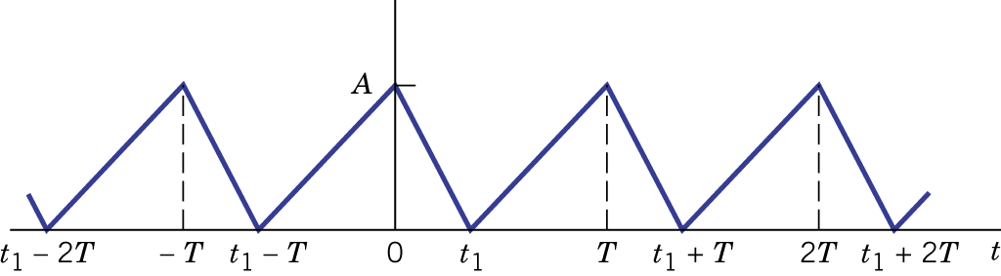Figure 12.1.

- Three properties:
  - Fundamental period T: $f(t+\text{mT})=f(t),m=1,2,3,⋯$.
  - A periodic waveform theoretically continues for all time.
  - $$\int{f(t)\text{dt}=}\int{f(t)\text{dt}}$$
- $\int{f(t)\text{dt}}\int{f(t)\text{dt}}$.
- Fundamental frequency: $Ω≡2π/T$.
- Trigonometric Fourier series:
$f(t)=c_{0}+\sum_{n=1}^{∞}{(a_{n}\text{cos}nΩt+b_{n}\text{sin}nΩt)}$.
- Dirichlet's conditions must be satisfied for a "well-behaved" periodic function being represented by the Fourier series. The conditions are:
  - Single valued.
  - Finite number of maxima, minima and discontinuities per period.
  - The integral $\int{\left|f(t)\right|}$ must be finite.

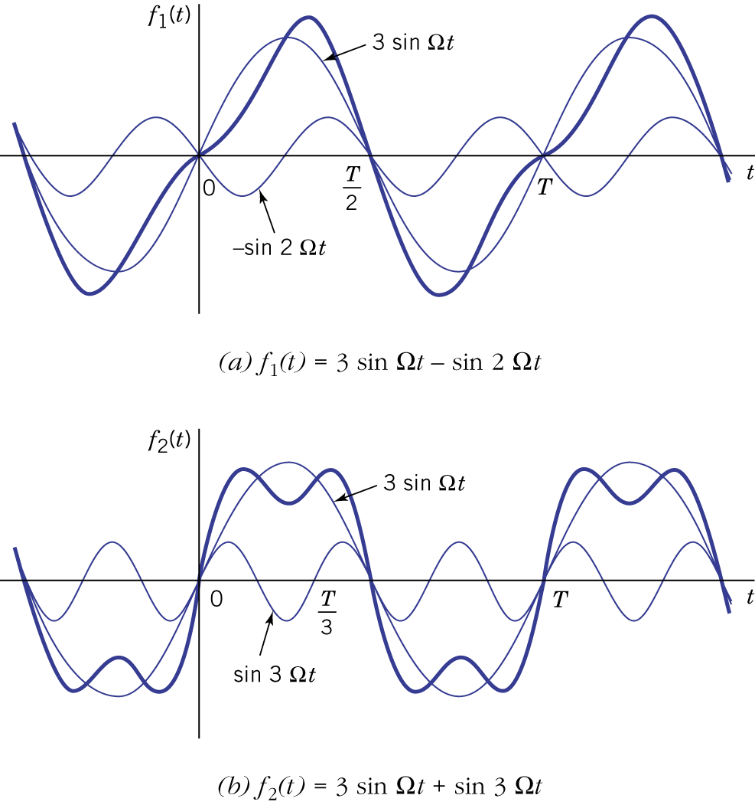Figure 12.2.

- Orthogonality:

- The coefficients can be found based on the following procedures:

Example 12.1: Half-Rectified Sine Wave
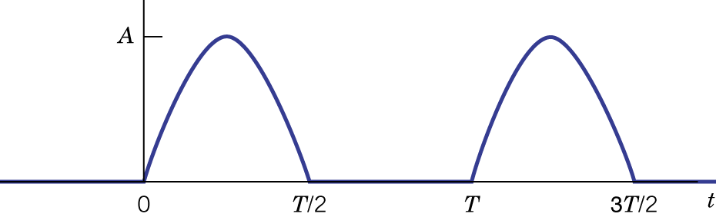Figure 12.3.

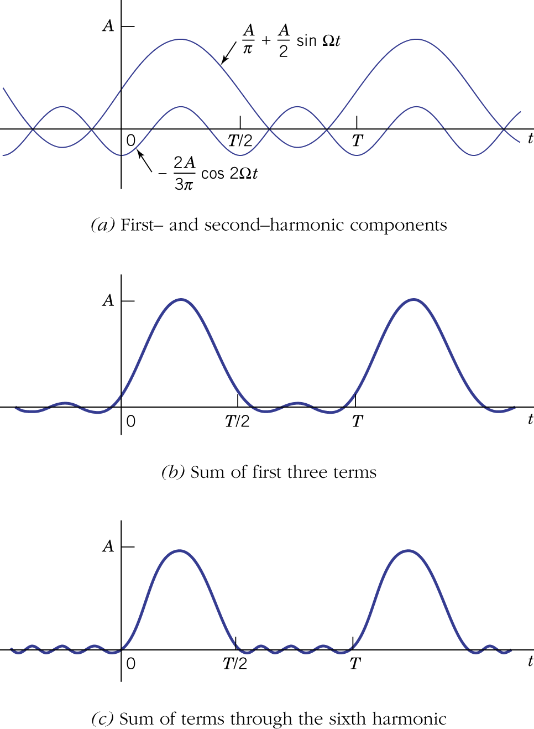Figure 12.4.

- Exponential Fourier series:
$f(t)=c_{0}+\sum_{n=1}^{∞}{(c_{n}e^{\text{jn}Ωt}+c_{−n}e^{−\text{jn}Ωt})}=\sum_{n=−∞}^{∞}{c_{n}e^{\text{jn}Ωt}}$.
- Orthogonality:

- Exponential series vs. trigonometric series ($n≥1$):
$a_{n}=2\text{Re}[c_{n}]$.
$b_{n}=−2\text{Im}[c_{n}]$.
$c_{n}=1/2(a_{n}−{\text{jb}}_{n})$.
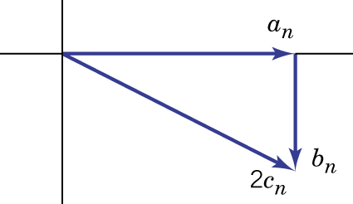Figure 12.6.

Example 12.2: Sinusoidal Waveform

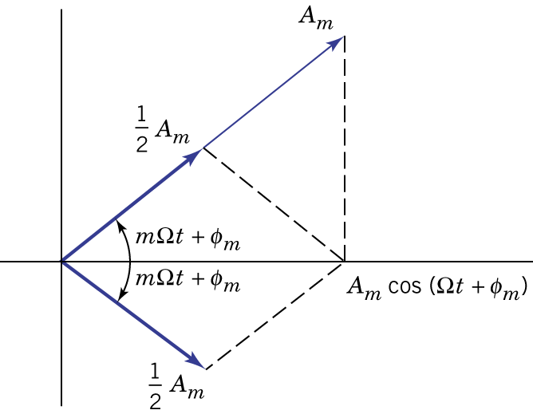Figure 12.7.

Example 12.3: Exponential Series Coefficients

- Even symmetry: $f(−t)=f(t)$.
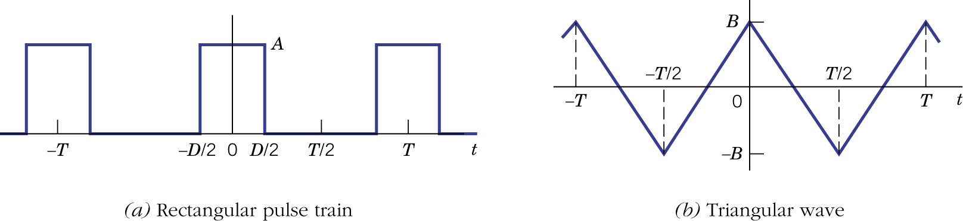Figure 12.8.

- Odd symmetry: $f(−t)=−f(t)$.
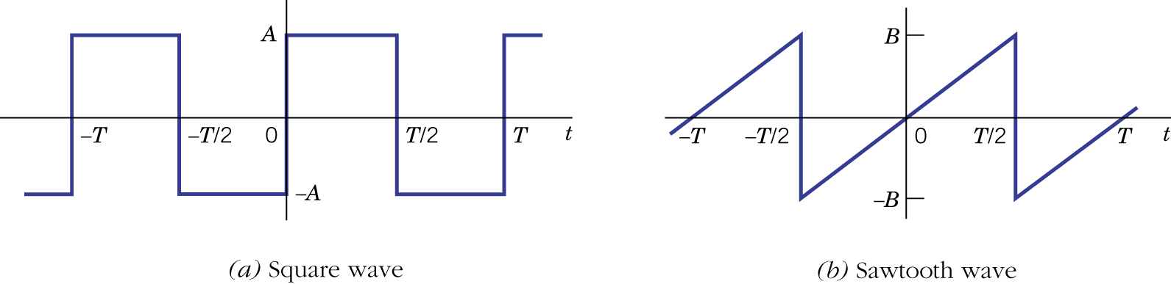Figure 12.9.
- Multiplying two functions having the same symmetry results in a function with even symmetry. Multiplying two functions having opposite symmetry results in a function with odd symmetry.

Example 12.4: Rectangular Pulse Train

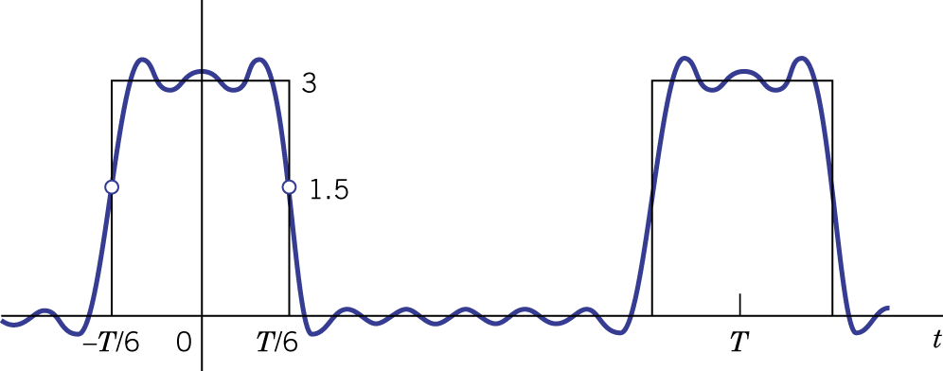Figure 12.10 (Gibb's phenomenon).
12.2 Spectral analysis of periodic waveforms

- Line spectra: frequency, amplitude and phase.

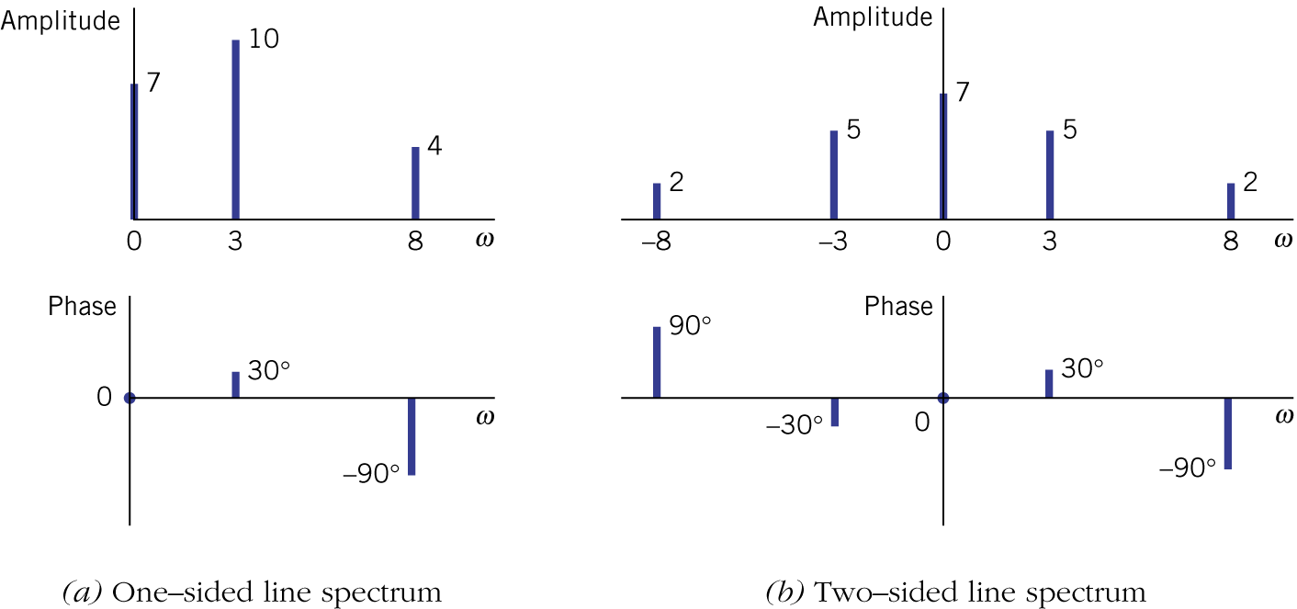Figure 12.11.

Example 12.5: Spectrum of a Rectangular Pulse Train

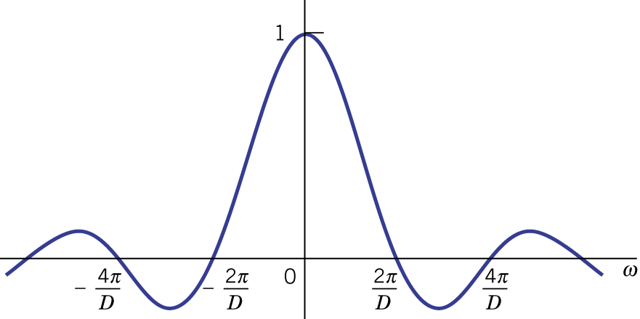Figure 12.12.
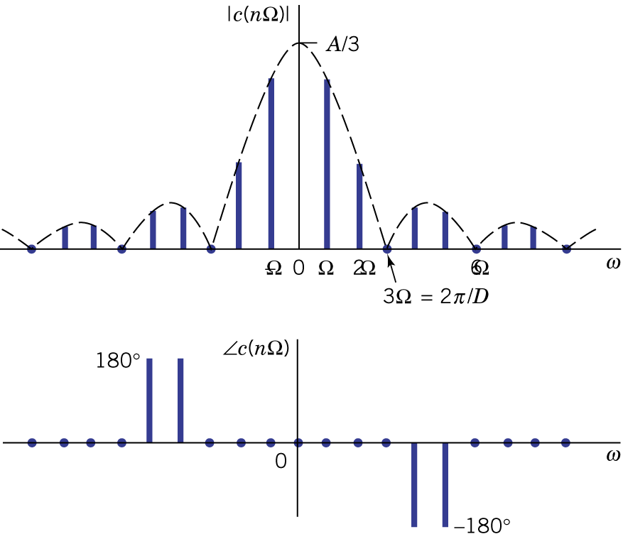Figure 12.13.

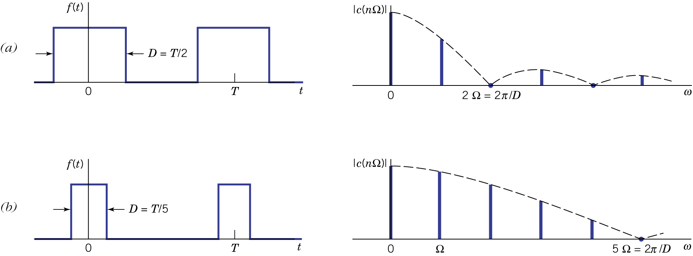
Figure 12.14.

- Time and frequency relations
$f(t)↔c_{f}(nΩ)$, $g(t)↔c_{g}(nΩ)$, $z(t)↔c_{z}(nΩ)$.
  - Linear combination:

  - Time shift:

  - Origin shift:

  - Half-wave symmetry:

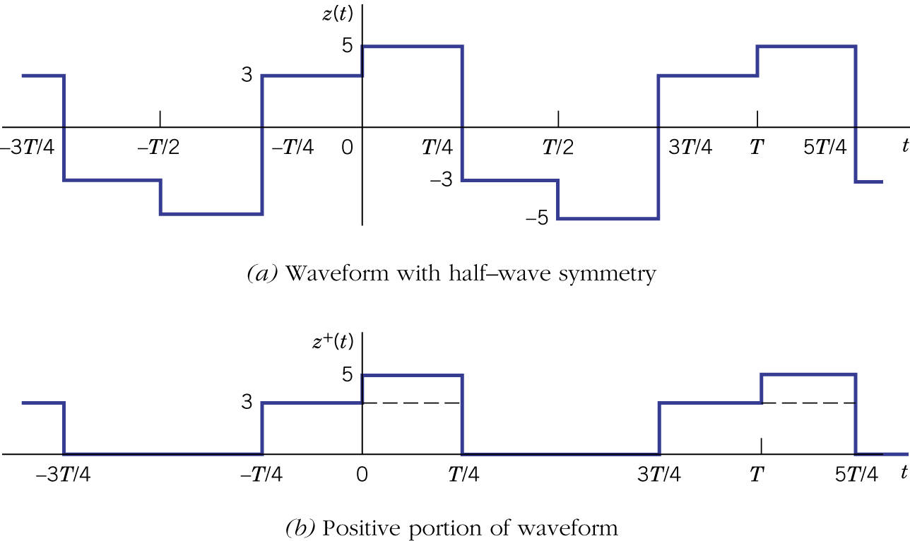Figure 12.15.

Example 12.6: Waveform with Half-Wave Symmetry

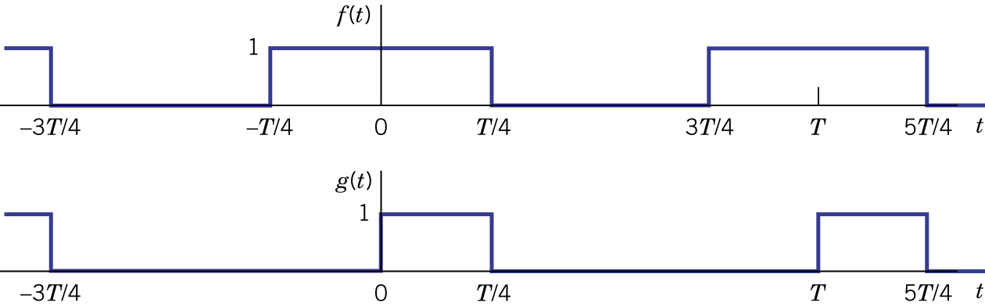Figure 12.16.
- Differentiation and integration:

Example 12.7: Triangular Pulse Train
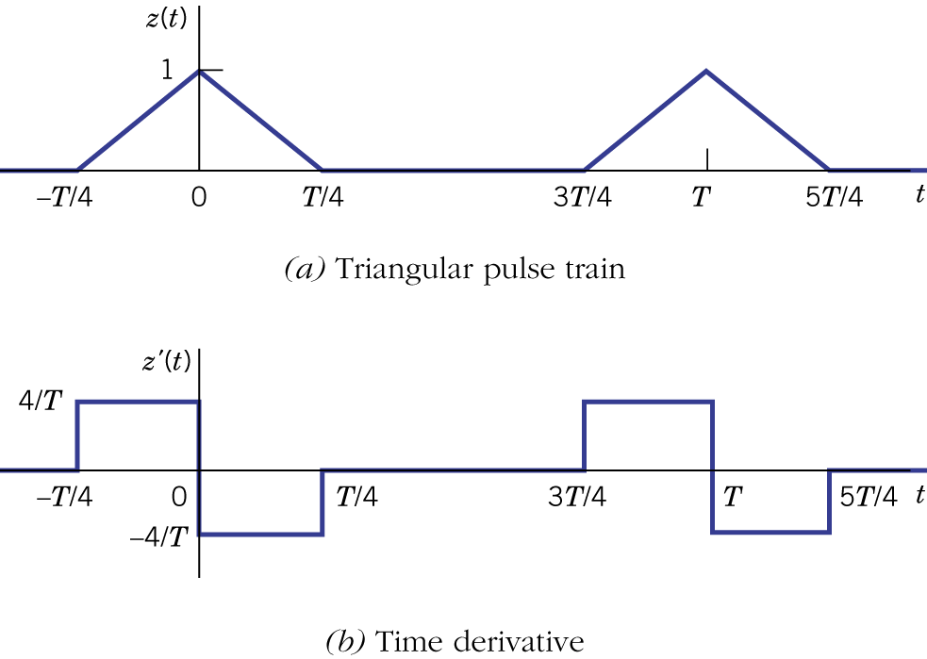Figure 12.17.

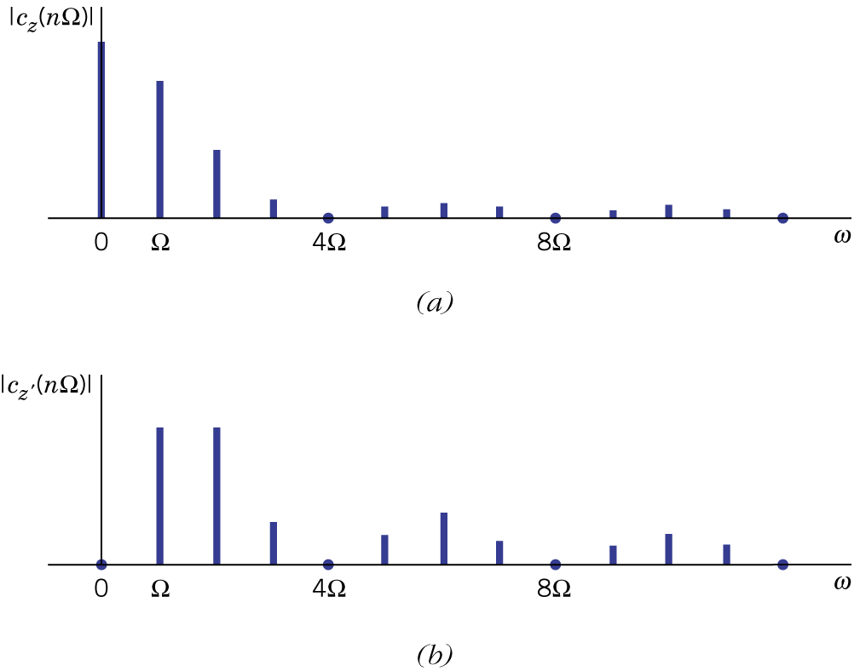Figure 12.18.
12.3 Spectral circuit analysis

- Based on superposition for linear circuits, spectral circuit analysis extends ac steady-state analysis to the more general case of an arbitrary periodic excitation.
- Periodic steady-state response: For a stable network, the steady state response (i.e., after the transients have died away) can be found based on the network's frequency response. Note that the components with amplitude less than 10% of the largest output amplitude can be ignored with the remaining terms constituting a reasonable approximation.

Example 12.8 Harmonic Generator

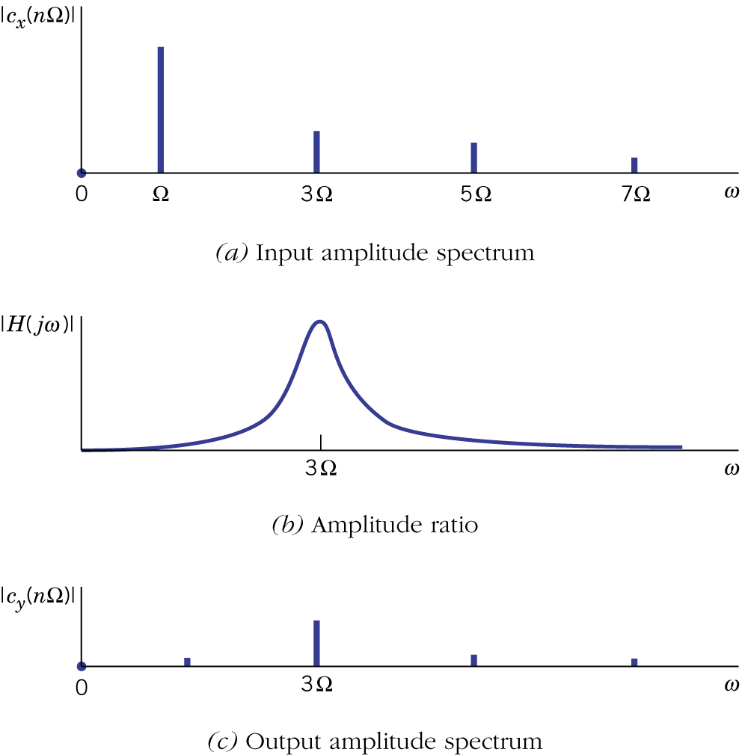Figure 12.19.

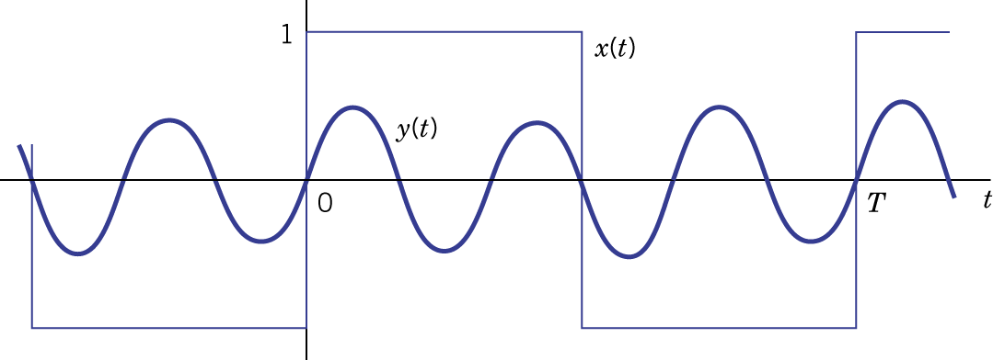Figure 12.10.
Example 12.9: Improved Harmonic Generator

- Waveform distortion: the output waveform may be significantly different from the input waveform due to distortion. Linear distortion includes amplitude distortion (i.e., amplitude of the frequency response is not a constant) and delay distortion (i.e., nonlinear phase). Nonlinear distortion introduces additional harmonics.
- Distortionless reproduction:

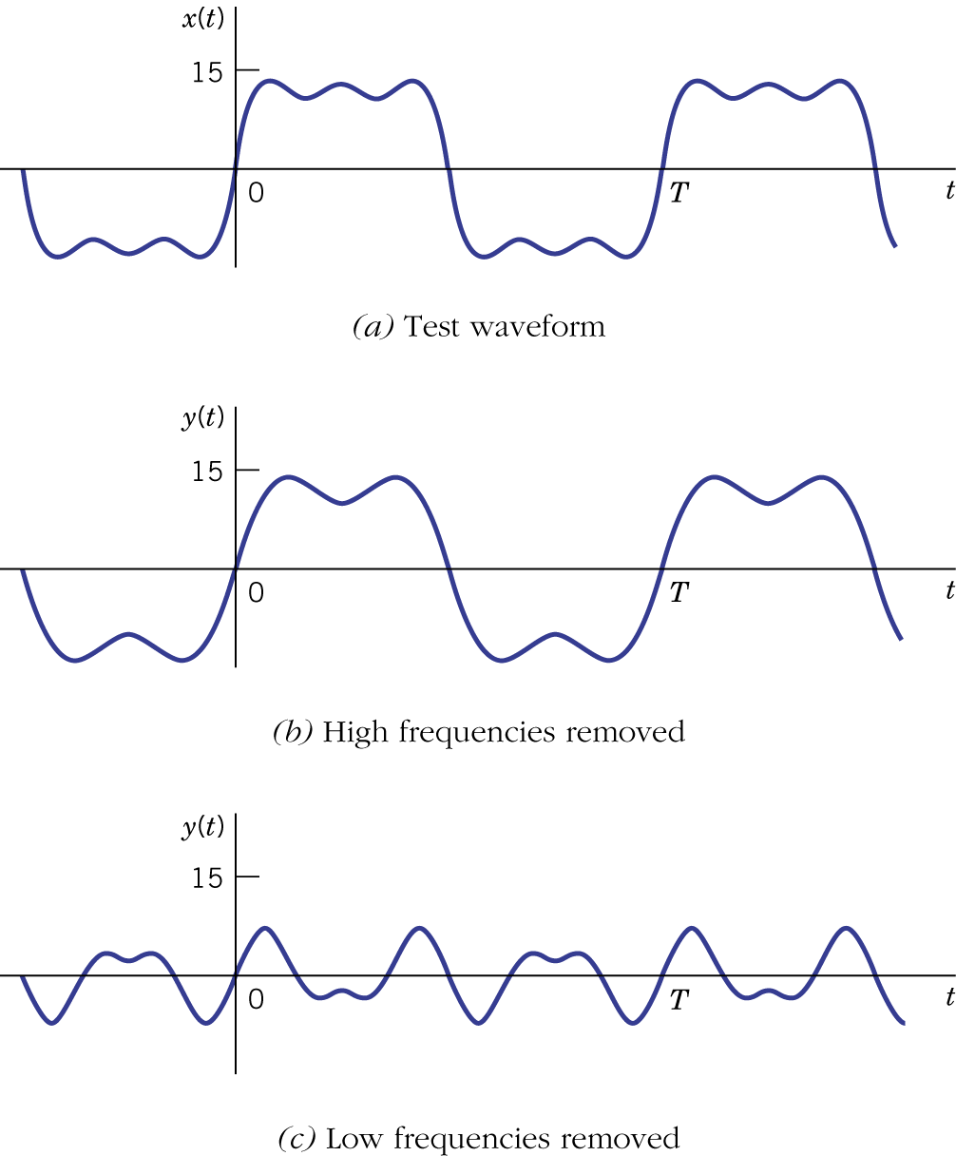Figure 12.21.
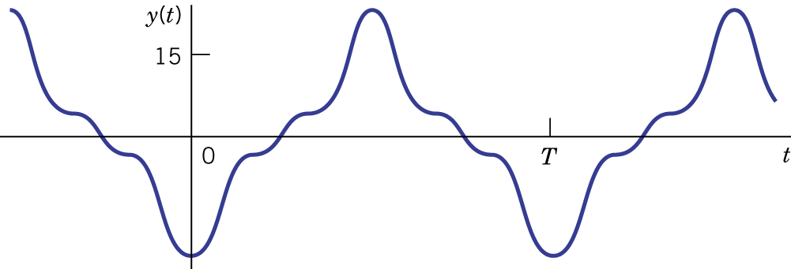Figure 12.22.

Example 12.10: Distortion by a Lowpass Filter

- Equalization: Linear waveform distortion can be reduced by another network called equalizer.
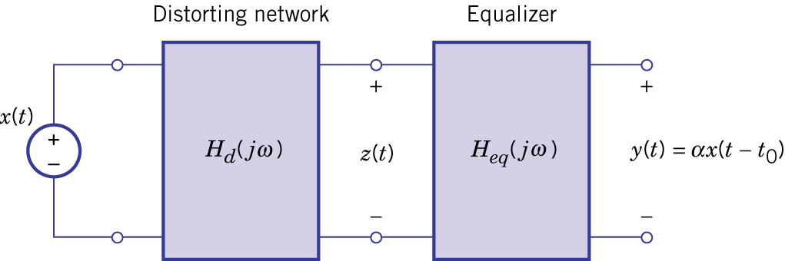Figure 12.23.

Example 12.11: Equalization of a Distorted Pulse Train

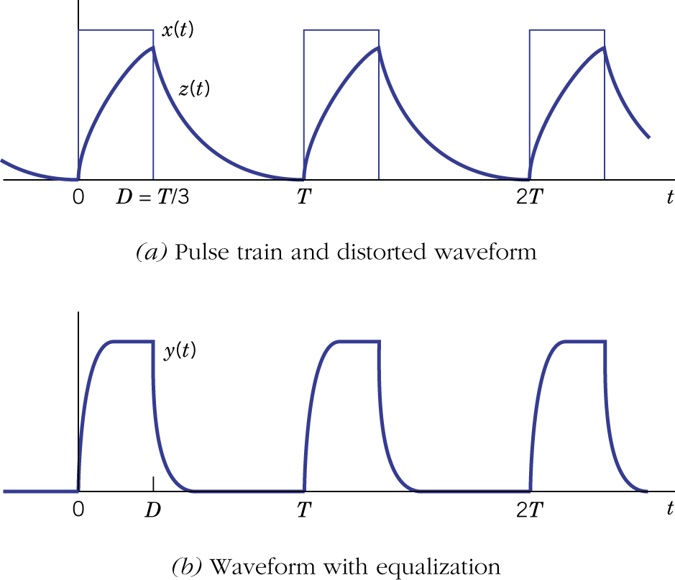Figure 12.24.

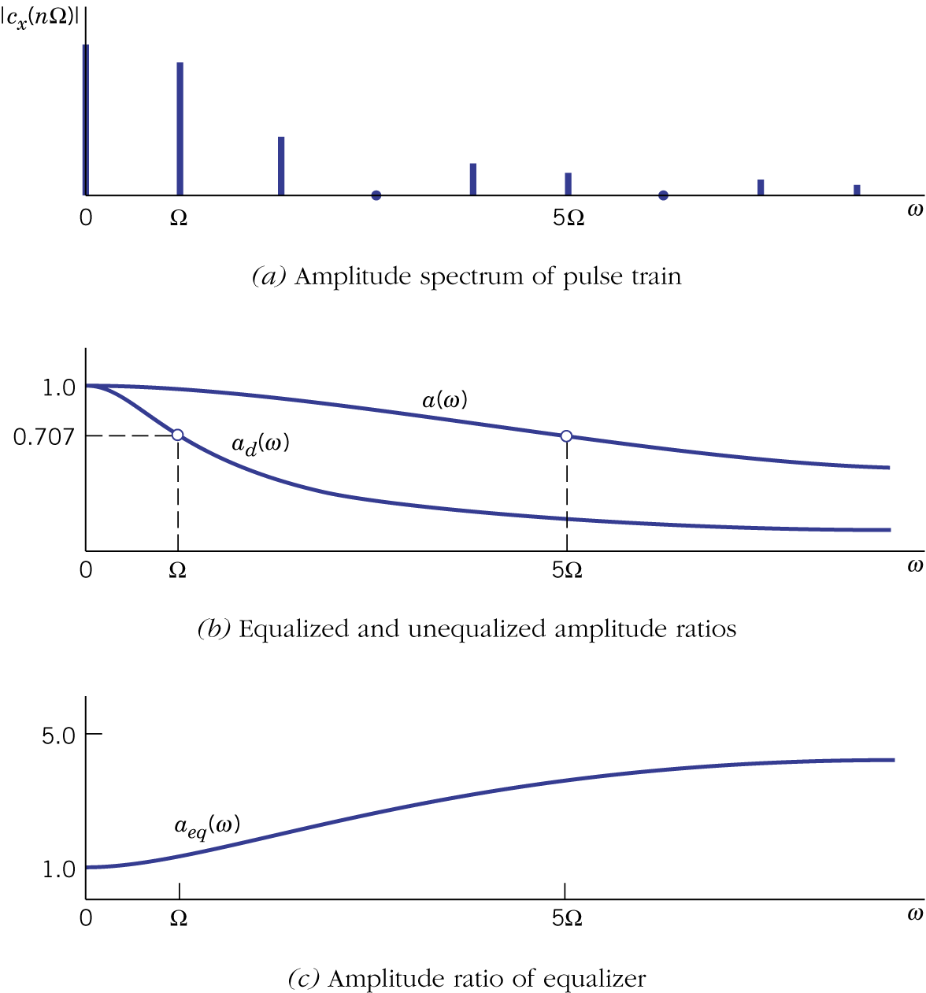Figure 12.25.

