Chapter 11 Frequency Response and Filters

11.1 Frequency response

- Frequency response is the forced response of a circuit to a sinusoid ac waveform of a particular frequency. Amplitude ratio and phase shift are typically used to characterize frequency response.
- Transfer function $H(s)→H(jω)$ (phasor analysis).

- $\underline{Y}=H(jω)\underline{X}$.
- Amplitude ratio: $a(ω)≡\left|H(jω)\right|$.
- Phase shift: $θ(ω)≡∠H(jω)$.
- Superposition for waveforms at different frequencies):

Example 11.1: A frequency-Selective Network
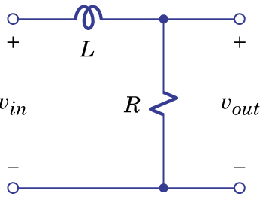Figure 11.1.

- Frequency response curves: plots of amplitude ratio and phase shift vs. frequency. They can be obtained by analytical method or graphical method.

Example 11.2: An All-Pass Network

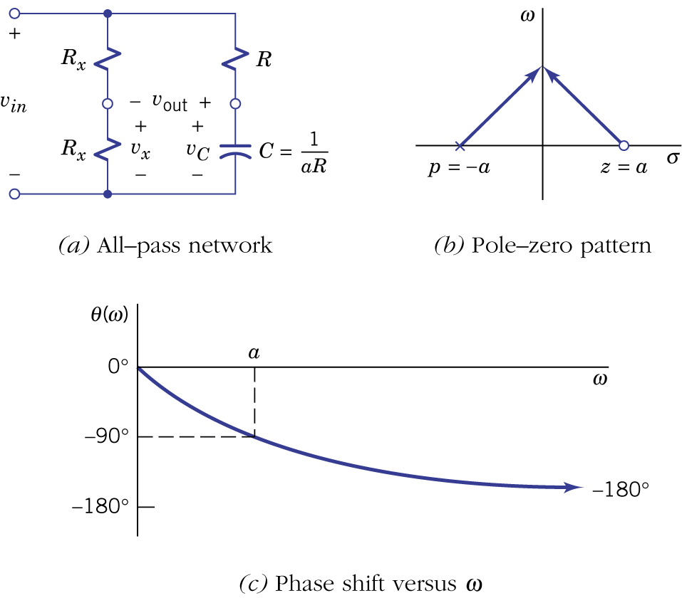Figure 11.2.

Example 11.3: Frequency-Response Calculations

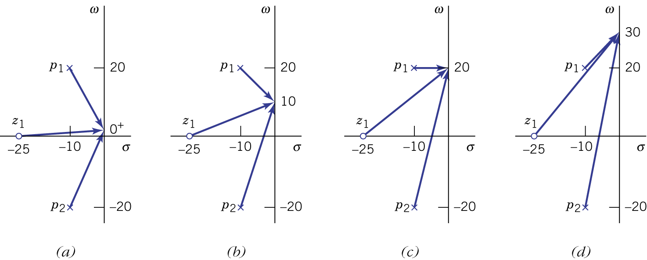Figure 11.3.
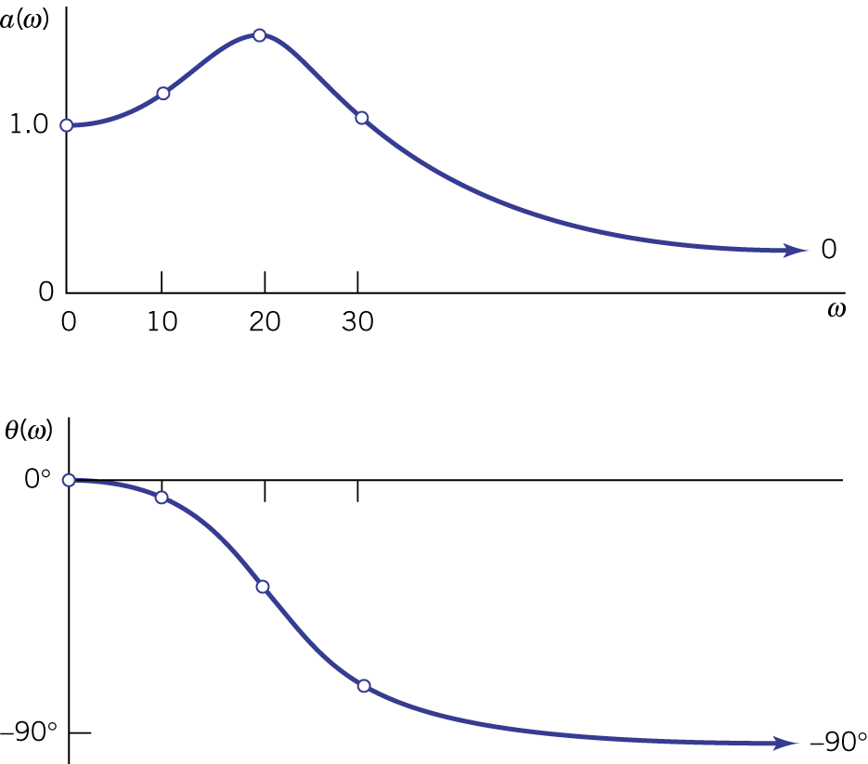Figure 11.4.

11.2 Filters

- Filters are frequency-selective networks that pass certain frequencies but suppress/reject the others.
- Four common categories: lowpass, highpass, bandpass and notch.
- A positive gain constant K is assumed.
- Ideal lowpass filter, ideal highpass filter, cutoff frequency, passband and stop band.

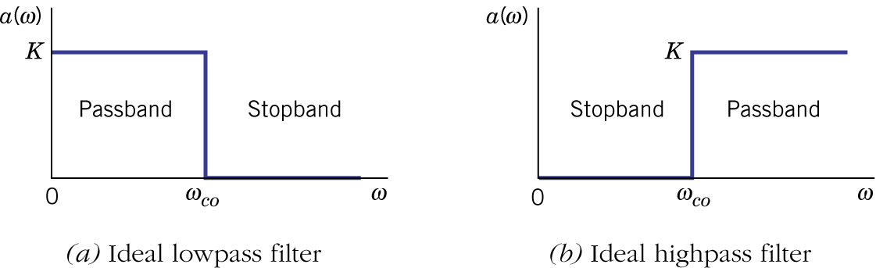Figure 11.5.

- First-order lowpass filter:

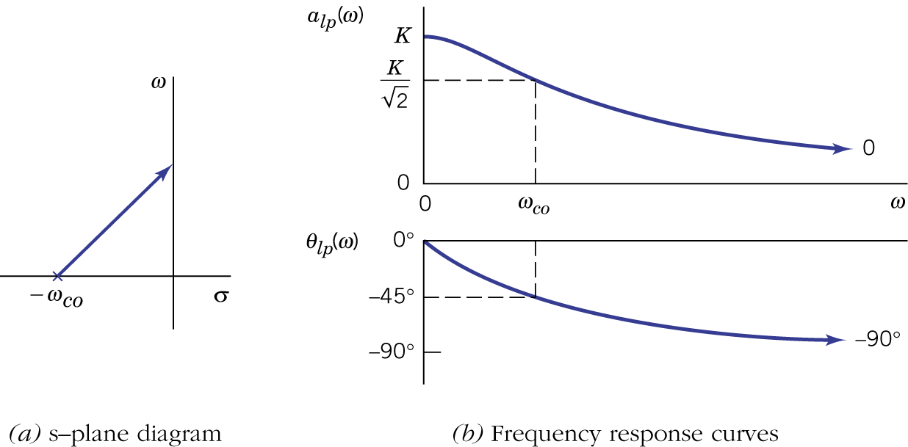Figure 11.6.

- First-order highpass filter:

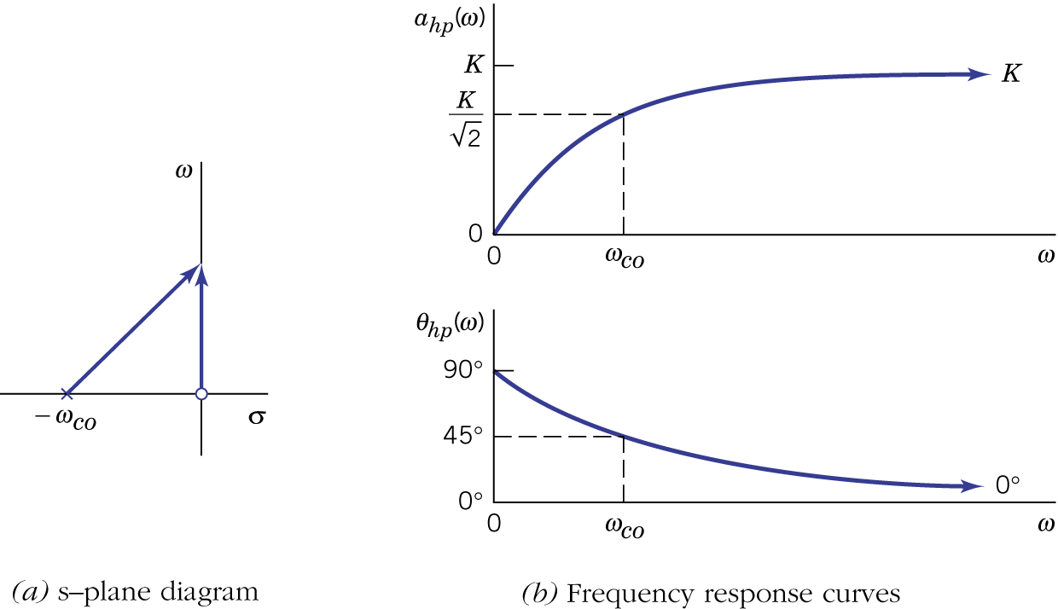Figure 11.7.

- First-order filter networks:
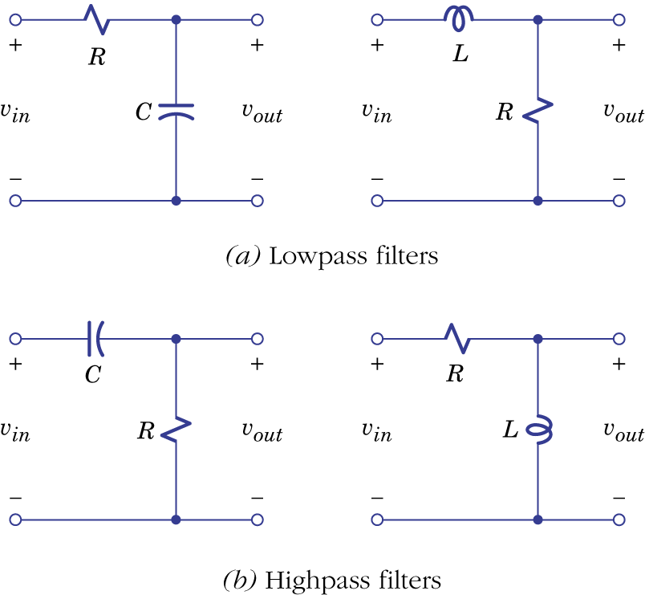Figure 11.8.

Example 11.4: Parallel Filter Network
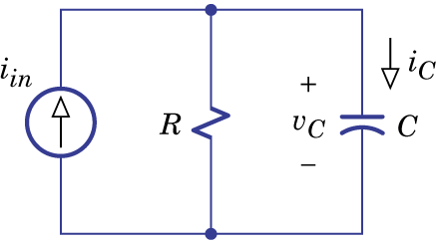Figure 11.9.

Example 11.5: Design of a Lowpass Filter
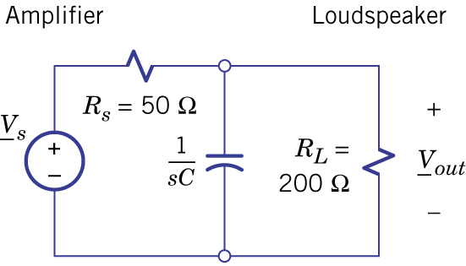Figure 11.10.

- Ideal bandpass filter, ideal notch filter (band-reject filter), lower cutoff frequency, upper cutoff frequency and bandwidth.

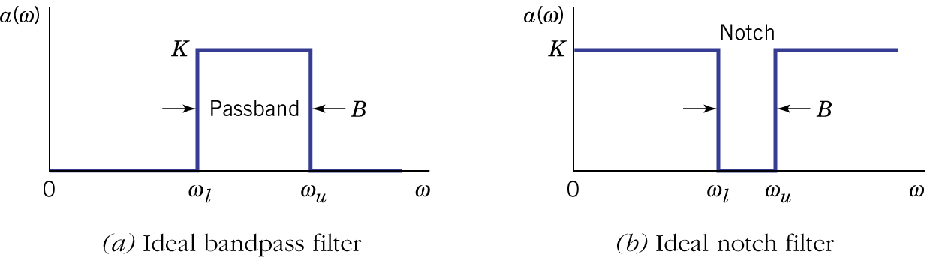Figure 11.11.

- Second order bandpass filter and quality factor.

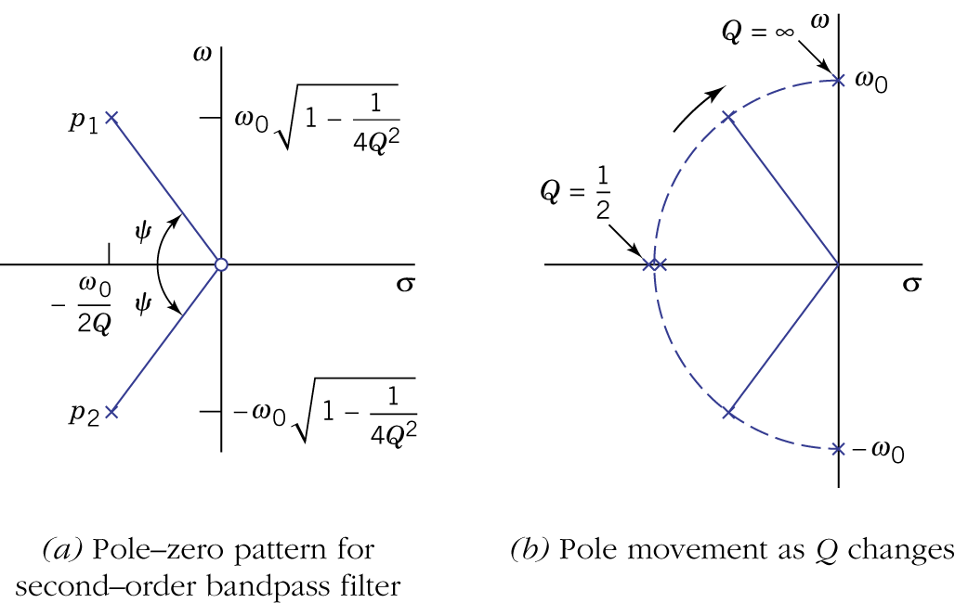Figure 11.12.

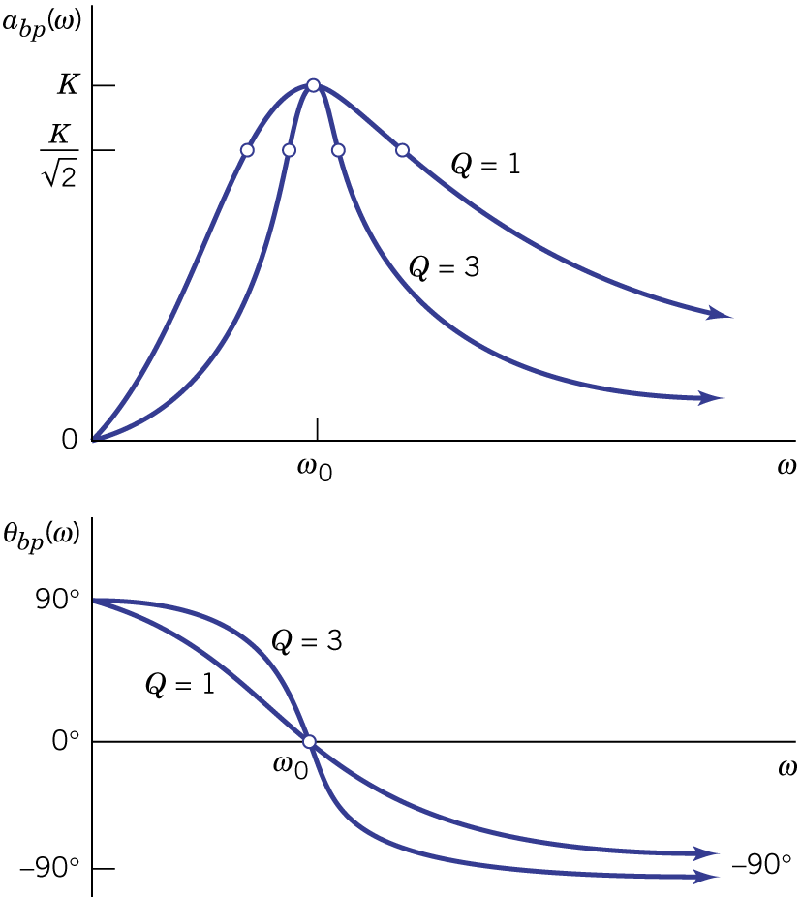Figure 11.13.

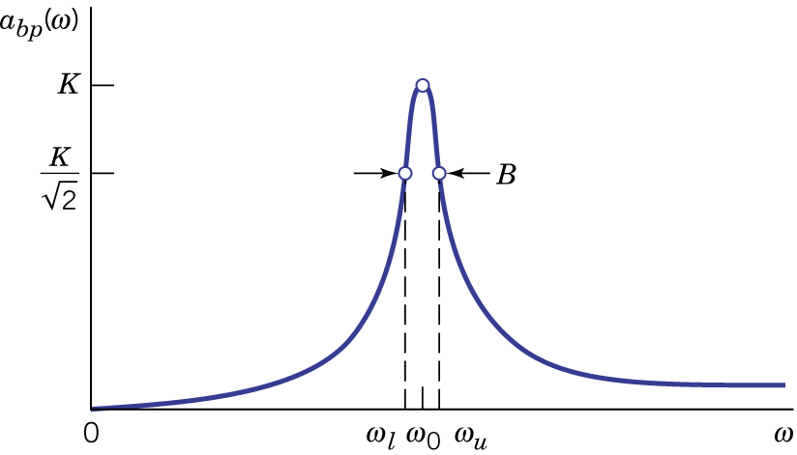Figure 11.14.

- Second-order notch filter.

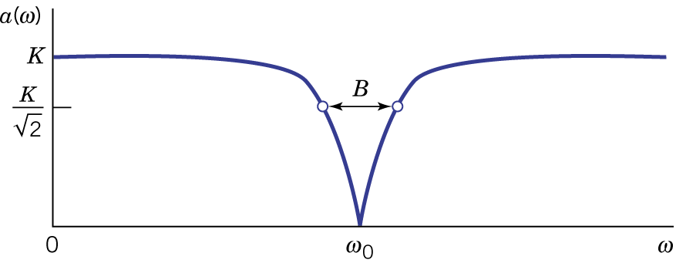Figure 11.16.

- Resonant circuits for bandpass and notch filters.
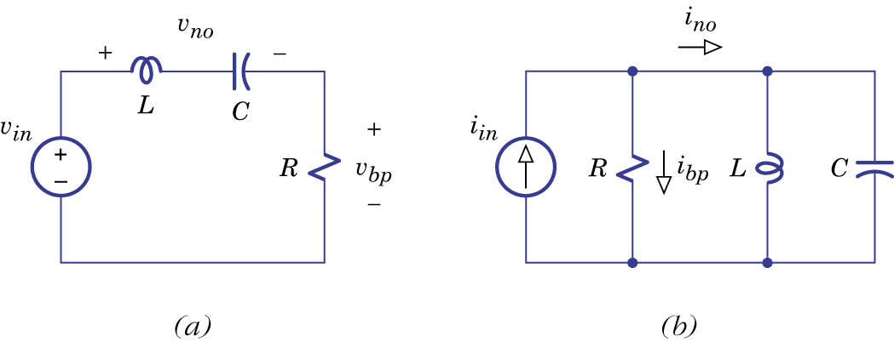Figure 11.17.

- Winding resistance.
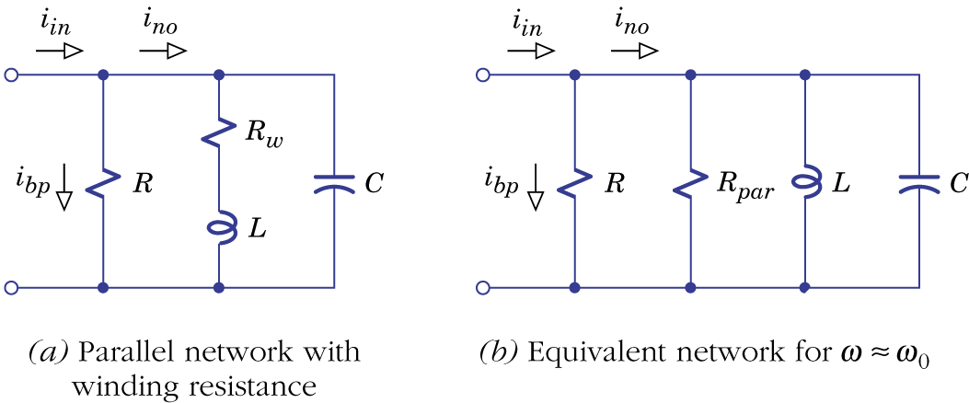Figure 11.18.

Example 11.6: Design of a Bandpass Filter

11.3 Op-Amp filter circuits

- Op-amps are included in filter circuit design to avoid loading effects and to eliminate the need for inductors in bandpass and notch filters.
- Noninverting lowpass and highpass filters:
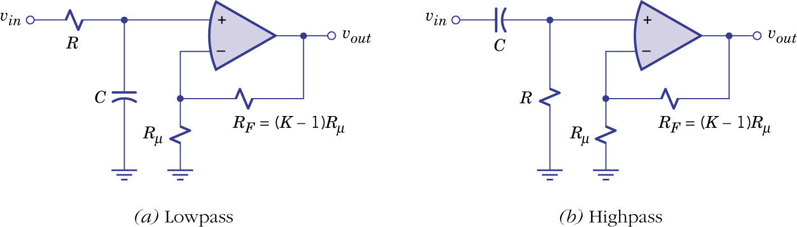Figure 11.19.
- Inverting lowpass and highpass filters:
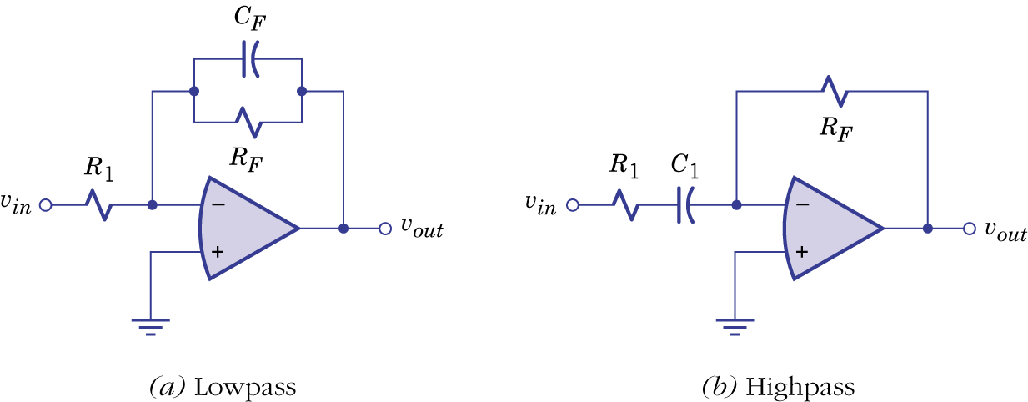Figure 11.20.

- Wideband bandpass filters:
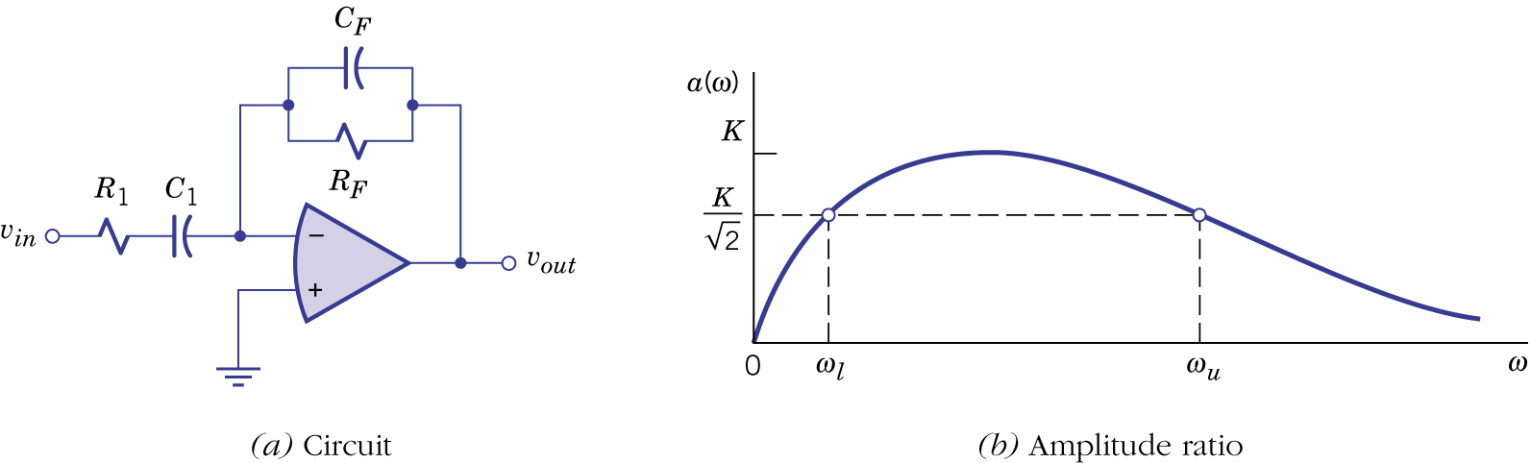Figure 11.21.

- Narrowband bandpass filters:
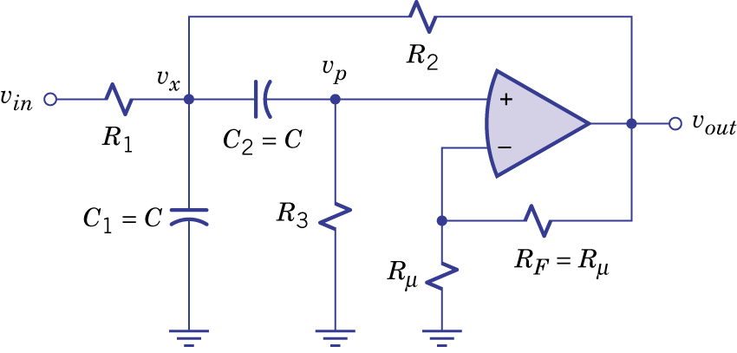Figure 11.22.

- Notch filters:
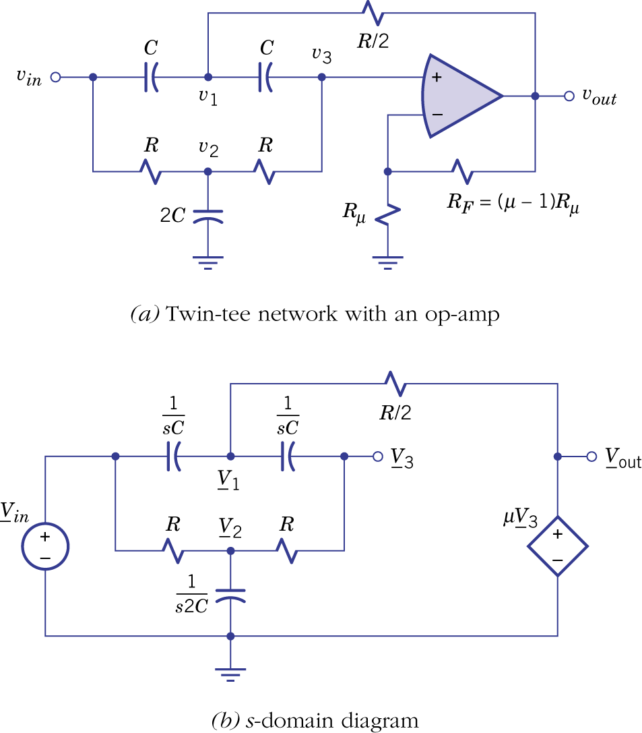(Figure 10.8.)
Example 11.7: Design of an Active Filter

11.4 Bode plots

- Amplitude ratio and frequency are converted to a logarithmic scale.
- Factored functions and decibels:
$$H(s)={\text{KH}}_{1}(s)H_{2}(s)⋯$$
$$a(ω)=\left|H(jω)\right|=\left|K\right|a_{1}(ω)a_{2}(ω)⋯$$
$$\begin{aligned}g(ω)≡\text{20}\text{log}a(ω)=\text{20}\text{log}\left|K\right|+\text{20}\text{log}a_{1}(ω)+\text{20}\text{log}a_{2}(ω)+⋯ \\ K_{\text{dB}}+g_{1}(ω)+g_{1}(ω)+⋯\end{aligned}$$
$$θ(ω)\text{=∠}H(jω)\text{=∠}K+θ_{1}(ω)+θ_{2}(ω)+⋯$$

- First-order factors (ramp function, highpass function and lowpass function).
- Ramp function:

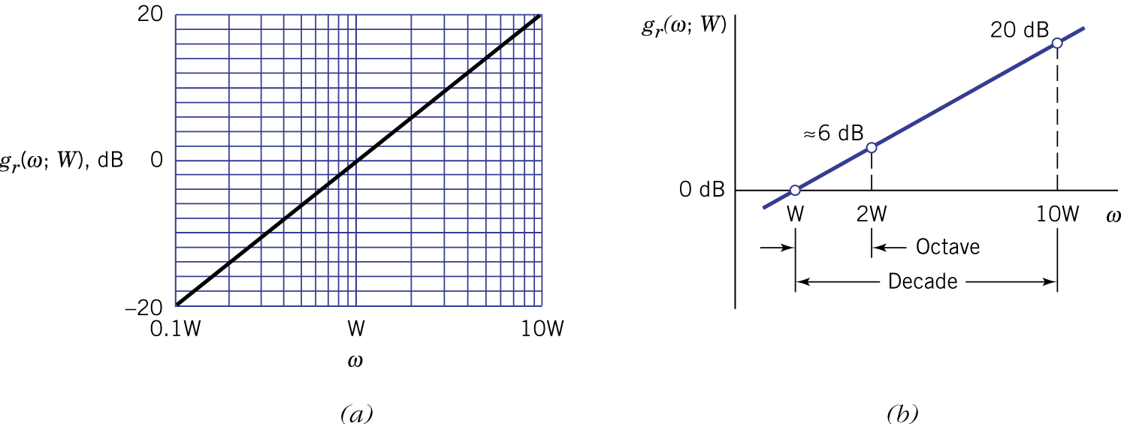Figure 11.23.
- Highpass function:

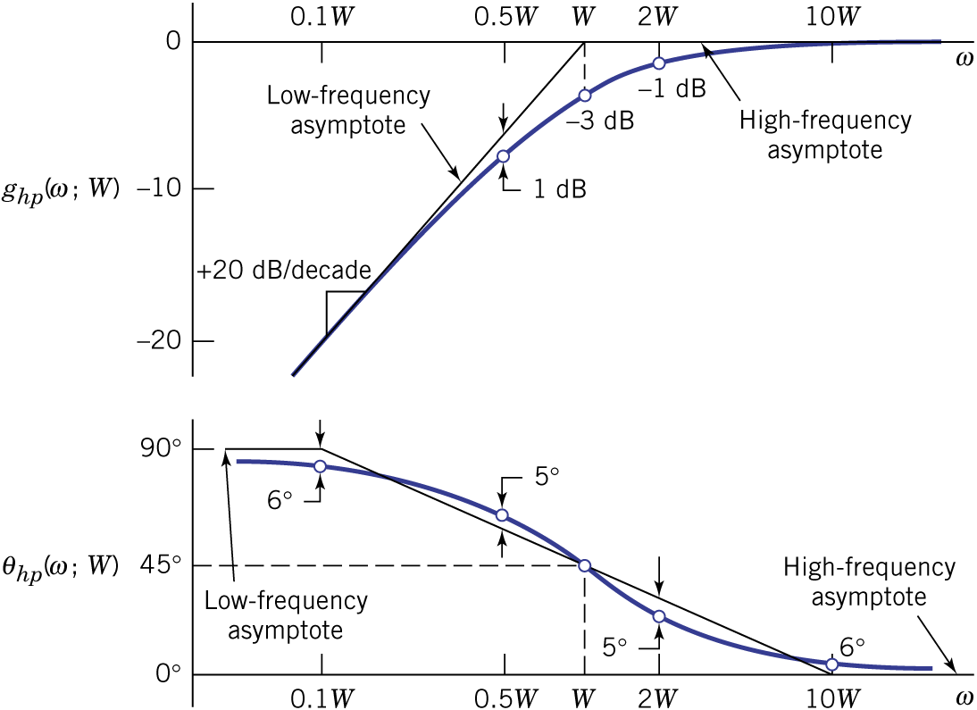Figure 11.24.
- Lowpass function:

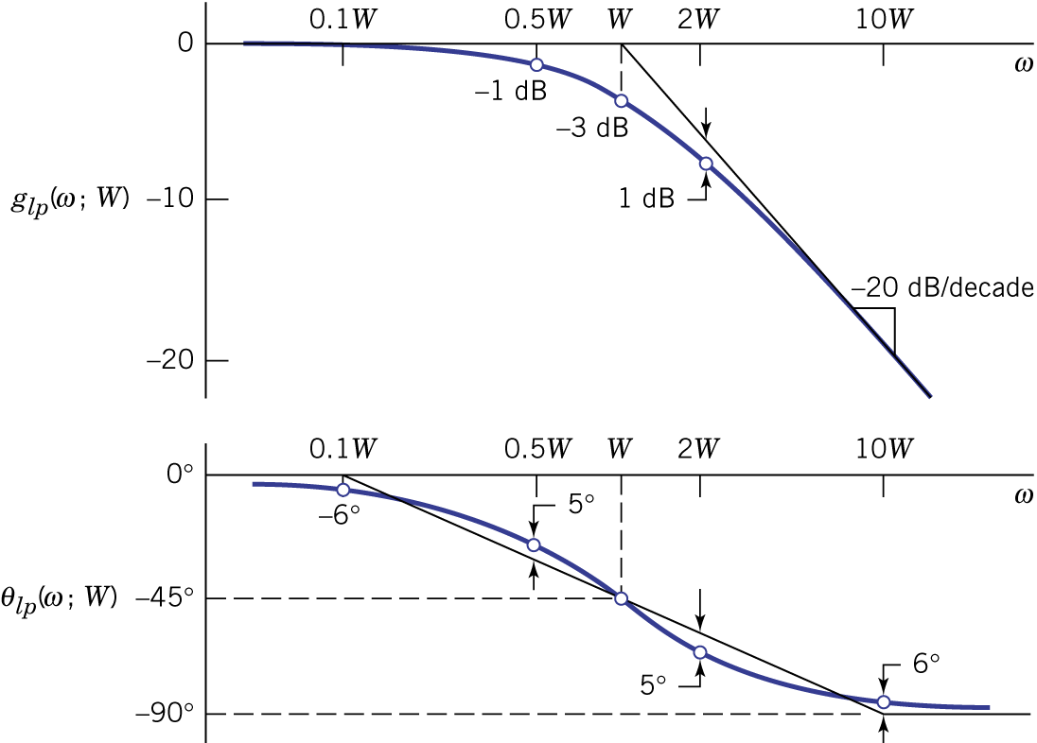Figure 11.25.

Example An Illustrative Bode Plot

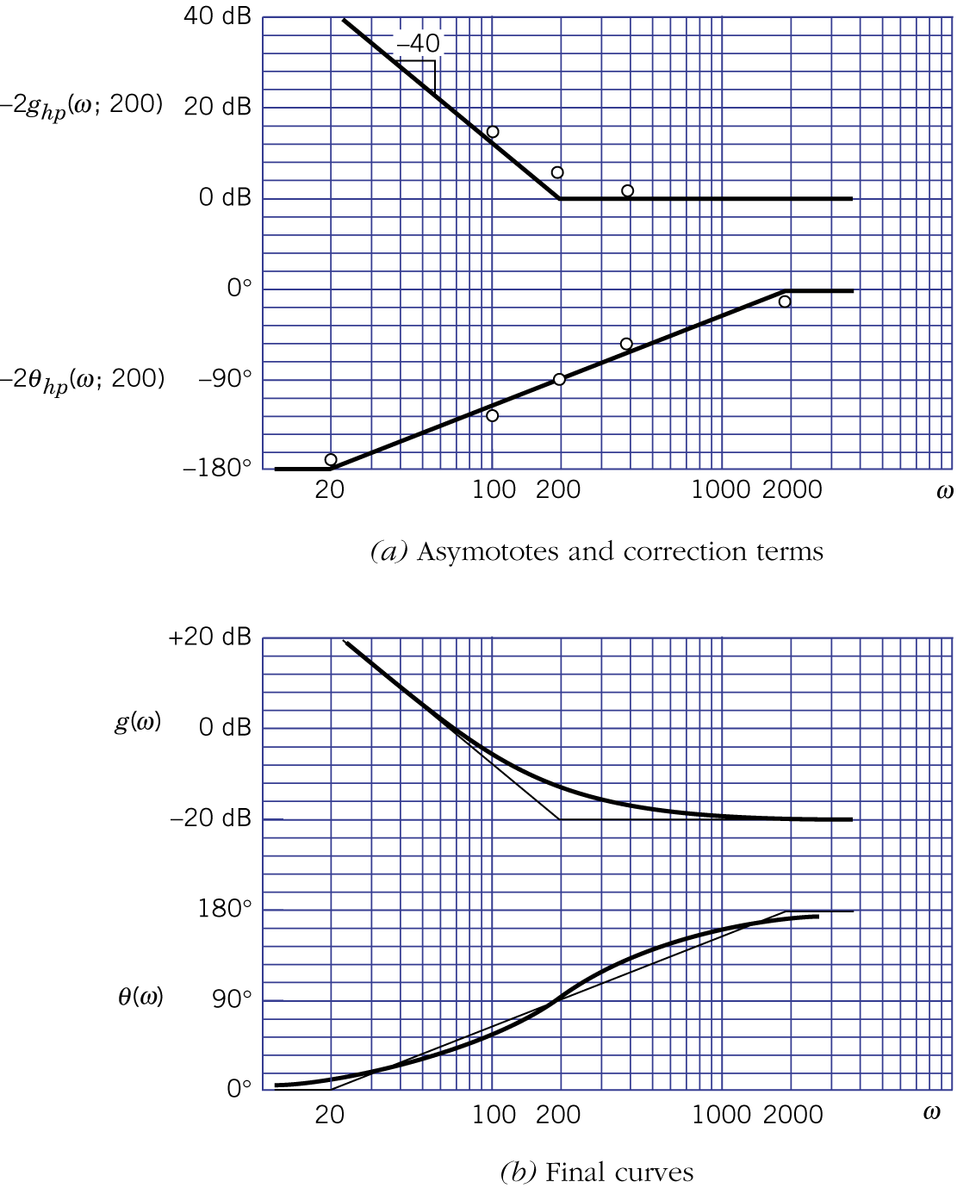Figure 11.26.
- Products of first-order factors: Bode plots of any transfer functions consisting entirely of first-order factors and powers of first-order factors can be constructed using the additive property of gain and phase. The important elements include: break frequencies, asymptotic gain and phase using straight line approximations and constants $K_{\text{dB}}$ and $∠K$.

Example 11.9: Frequency Response of a Bandpass Amplifier

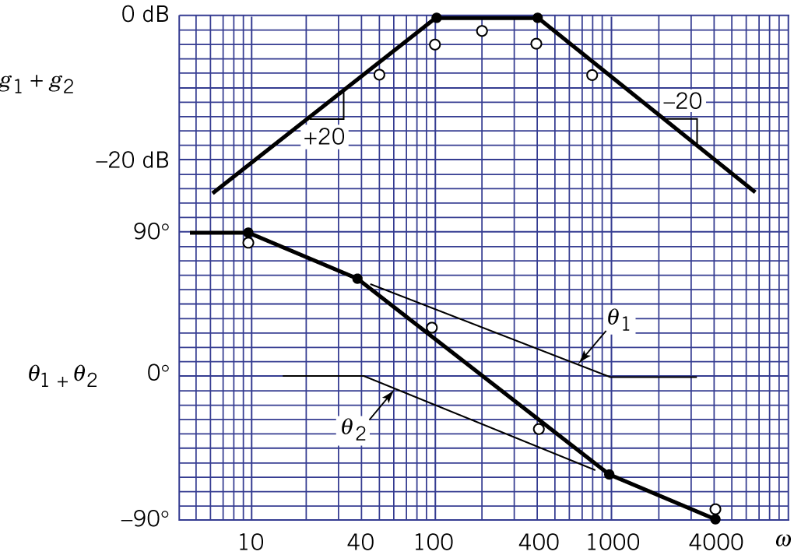Figure 11.27.
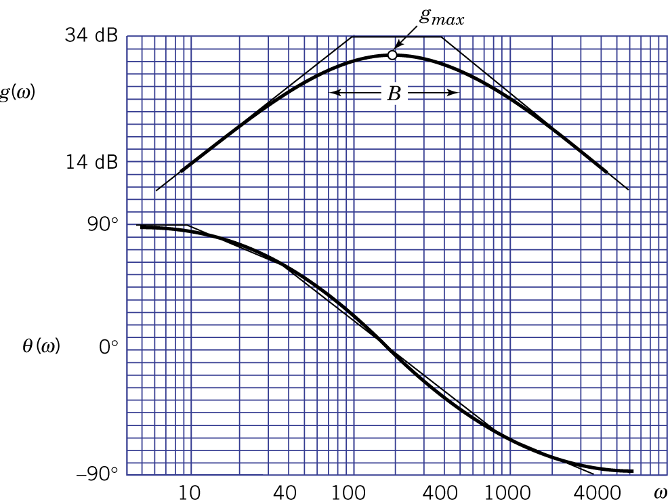Figure 11.28.
- Quadratic factors for complex-conjugate poles:

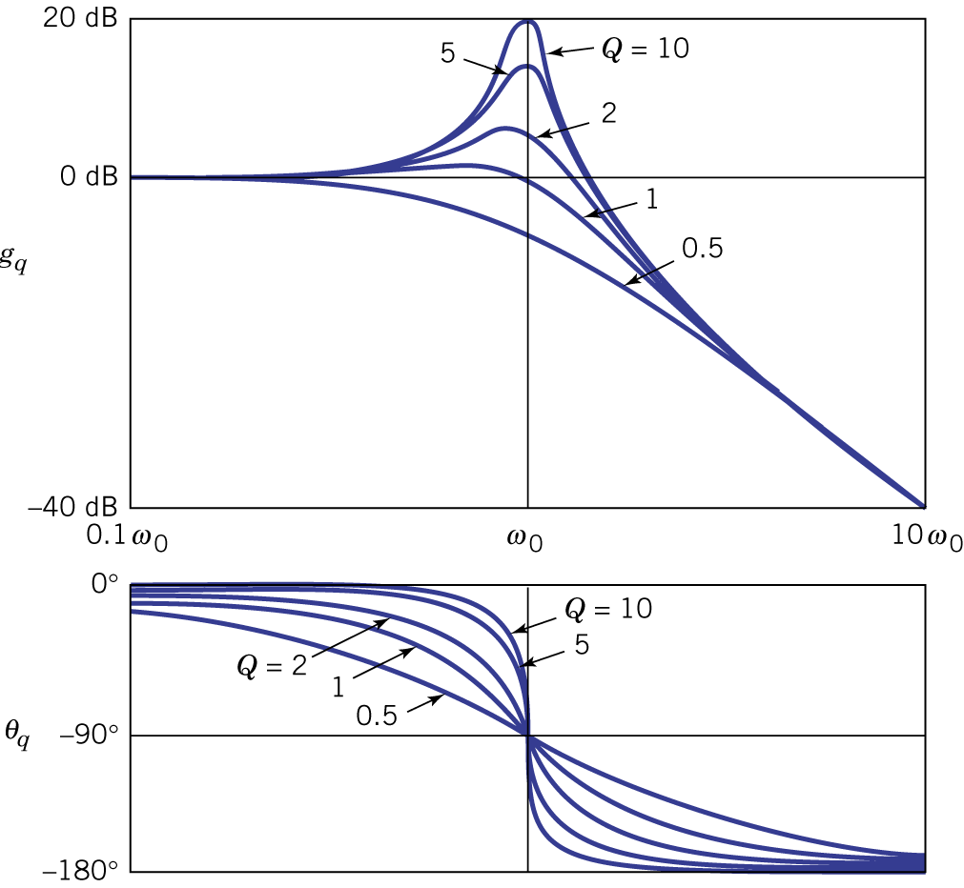Figure 11.29.

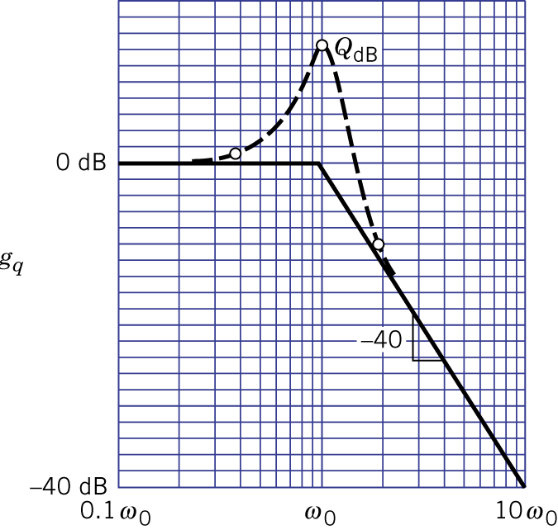Figure 11.30.

Example 11.10: Bode Plot of a Narrowband Filter

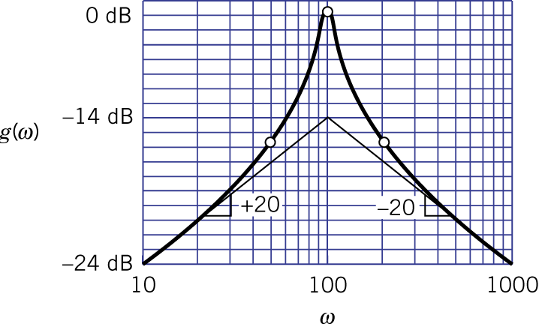Figure 11.31.

11.5 Frequency response design

- Given a required frequency response, the transfer function can be found by starting from the Bode plot. First, a straight line approximation needs to be obtained. Second, the straight line approximation can be decomposed to a constant term and a set of first-order functions (assuming no resonant peaks or peaks are present). Finally, we can apply the basic op-amp networks to realize the transfer function.

Example 11.11: Design of an FM Pre-emphasis Network

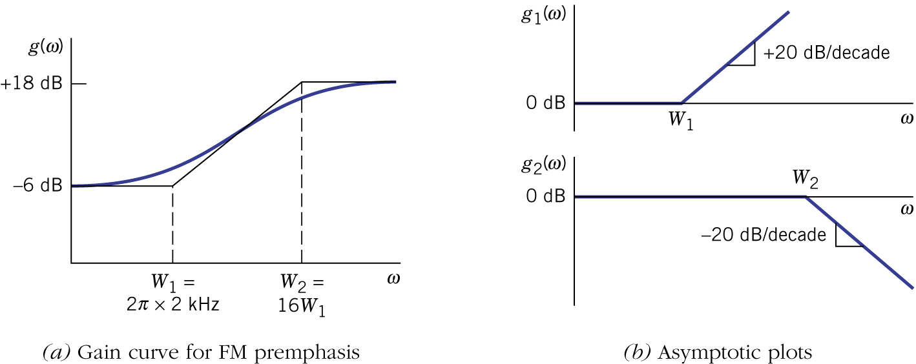Figure 11.33.

11.6 Butterworth filters

- Two trade-offs in filter design: performance vs. complexity and rejection vs. ripple. Will only cover Butterworth lowpass and highpass filters.
- Butterworth lowpass filters: maximally flat, poles are uniformly spaced by angle of 180⁰/n (n is the order), rolloff at 20n dB per decade.

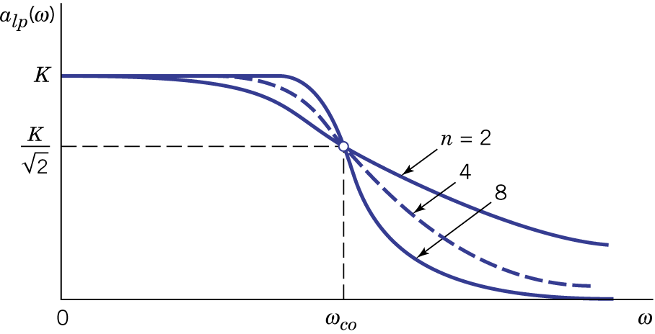Figure 11.36.

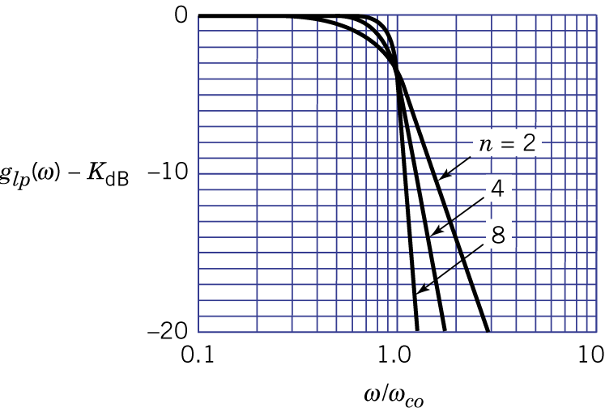Figure 11.37.

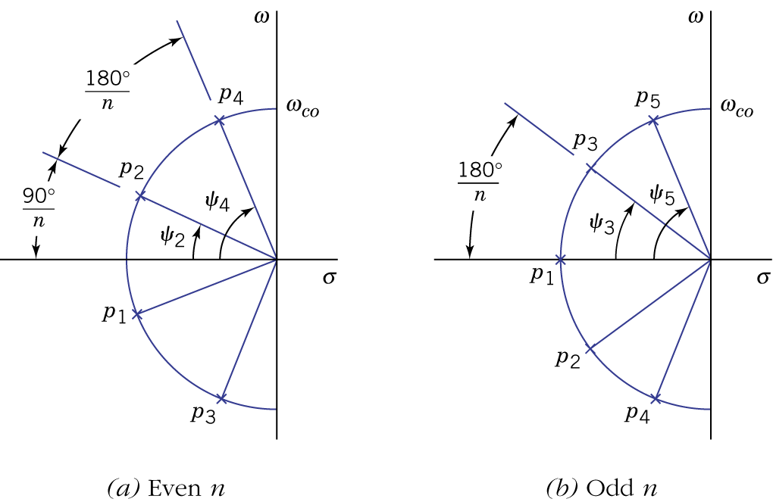Figure 11.38.

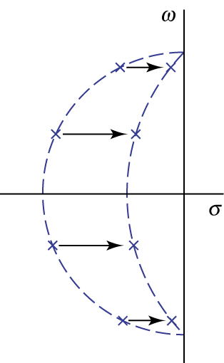
Example 11.12: FM Stereo Separation Filter

- Butterworth highpass filters can be derived from existing lowpass designs via the lowpass-to-highpass transformation: $s→{ω_{\text{co}}^{2}}/s$.

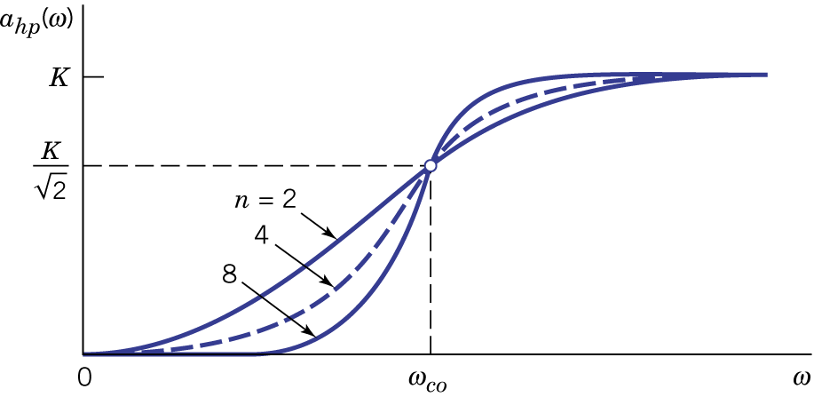Figure 11.40.

- Op-amps can be used to realize Butterworth filters such that inductors and loading effects can be eliminated.
- Op-amp circuits for second-order transfer functions are shown in Figure 11.41.

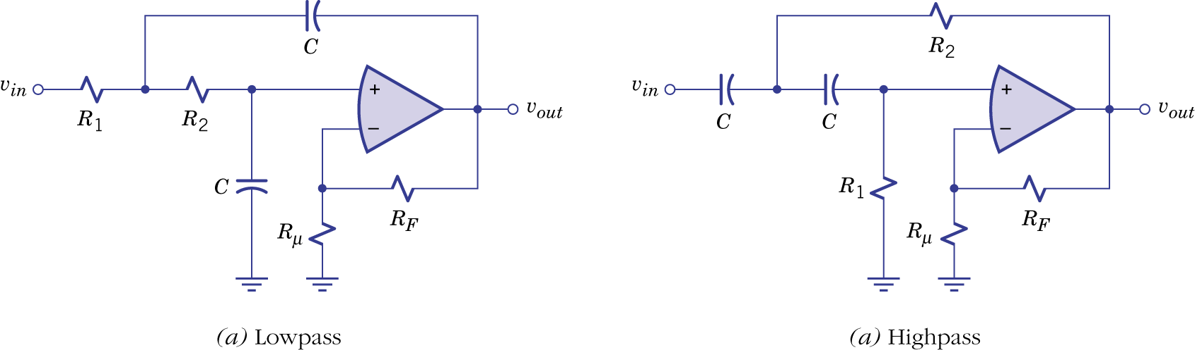
Figure 11.41.

Example 11.13: Op-Amp Circuit for a Lowpass Filter

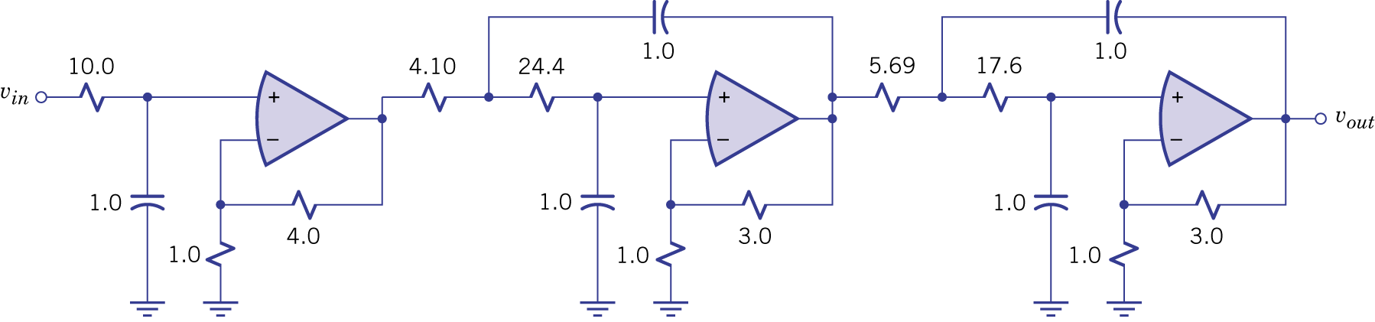
Figure 11.42.

