Chapter 10 Network Functions and s-Domain Analysis

10.1 Complex frequency and generalized impedance

- Complex frequency: oscillating voltages or currents with exponential amplitudes.
- $\begin{aligned}x(t)=X_{m}e^{σt}\text{cos}(ωt+φ_{x})=\text{Re}\left[X_{m}e^{σt}e^{j(ωt+φ_{x})}\right] \\ =\text{Re}\left[(X_{m}e^{{jφ}_{x}})e^{(σ+jω)t}\right]\end{aligned}$.
- Complex frequency: $s≡σ+jω$.
- Phasor: $\underline{X}X_{m}∠φ_{x}=X_{m}e^{{jφ}_{x}}$.

Example 10.1: A Complex-Frequency Waveform

- For a “real” frequency, we have
- $i(t)=I_{m}\text{cos}(ωt+φ_{i})=\text{Re}\left[\underline{I}e^{jωt}\right]$.
- $v(t)=V_{m}\text{cos}(ωt+φ_{v})=\text{Re}\left[\underline{V}e^{jωt}\right]$.
- $\underline{V}=V_{m}∠φ_{v}$, $\underline{I}=I_{m}∠φ_{i}$.
- For a “complex” frequency, we replace $jω$ with s.

- $i(t)=\text{Re}\left[\underline{I}e^{\text{st}}\right]=I_{m}e^{σt}\text{cos}(ωt+φ_{i})$.
- $v(t)=\text{Re}\left[\underline{V}e^{\text{st}}\right]=V_{m}e^{σt}\text{cos}(ωt+φ_{v})$.
- Generalized impedance: $Z(s)≡{\underline{V}}/{\underline{I}}$, or $\underline{V}=Z(s)\underline{I}$.
- Generalized admittance: $Y(s)≡1/Z(s)={\underline{I}}/{\underline{V}}$, or $\underline{I}=Y(s)\underline{V}$.

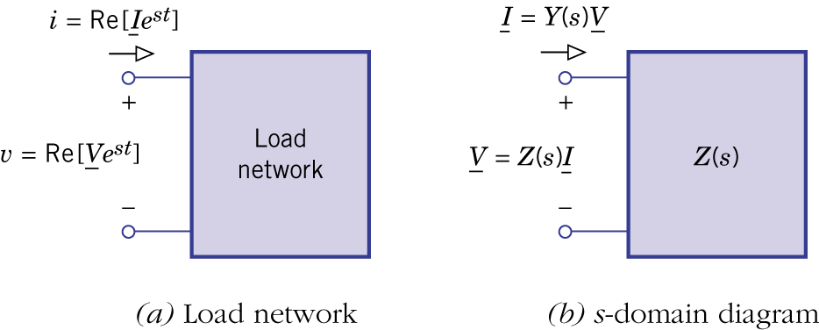Figure 10.1.

- Generalized impedance$Z(s)$ and admittance $Y(s)$ are directly related to the circuit’s behavior given an input signal with a specific complex frequency. This will be covered in more detail in Chapter 13, where we apply Laplace transform to analyze a circuit.

Example 10.2: Calculations with Complex Frequency
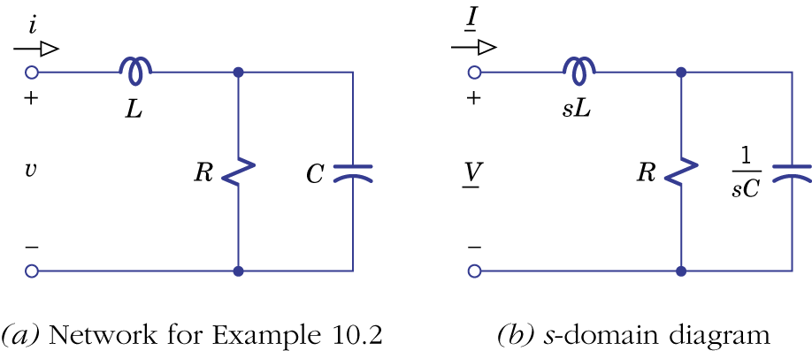Figure 10.2.

- Impedance analysis.

Example 10.3: Miller-Effect Capacitance
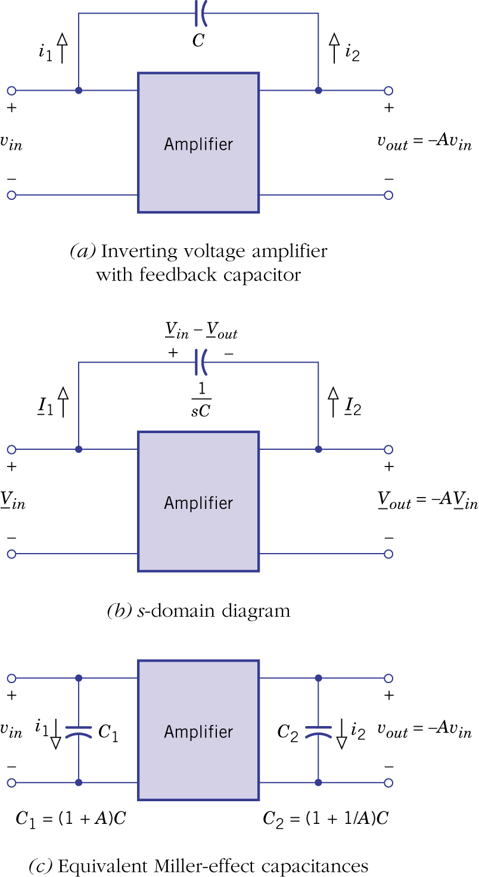Figure 10.3.

Example 10.4: Generalized Impedance Converter
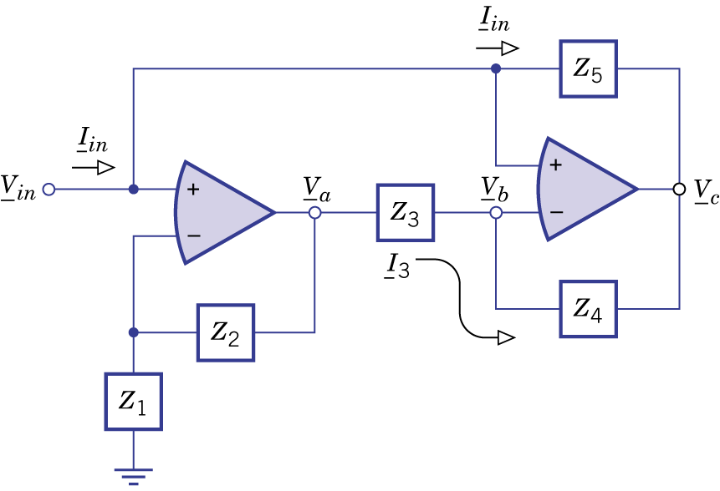Figure 10.4.

10.2 Network functions

- Any response forced by a complex-frequency excitation.
- Input: $x(t)=X_{m}e^{σt}\text{cos}(ωt+φ_{x})=\text{Re}\left[\underline{X}e^{\text{st}}\right]$, $\underline{X}X_{m}∠φ_{x}=X_{m}e^{{jφ}_{x}}$.
- Response: $y(t)=Y_{m}e^{σt}\text{cos}(ωt+φ_{x})=\text{Re}\left[\underline{Y}e^{\text{st}}\right]$, $\underline{Y}Y_{m}∠φ_{Y}=Y_{m}e^{{jφ}_{Y}}$.
- Network function: $H(s)≡{\underline{Y}}/{\underline{X}}$.
- A network function is also known as a driving point function if it relates a network's terminal variables. It can also be a transfer function since $y(t)$ can be any voltage or current within the network.

- A network function is also a rational function. Its numerator is a polynomial obtained from the right hand side of the differential equation with derivatives replaced by powers, the denominator is a polynomial obtained from the left-hand side of the differential equation.

Example 10.5: Series LRC Network Functions
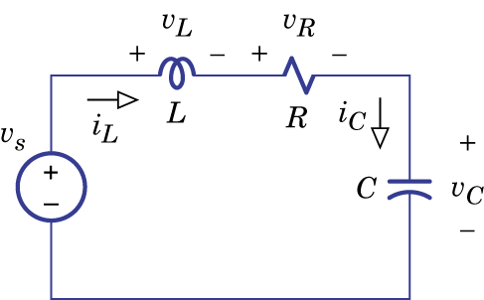Figure 10.6.

- The network function can also be obtained by using s-domain impedances and admittances. Impedance analysis can be done by series-parallel reduction, voltage and current dividers, proportionality, source conversions and node/mesh equations.

Example 10.6: Finding Network Functions
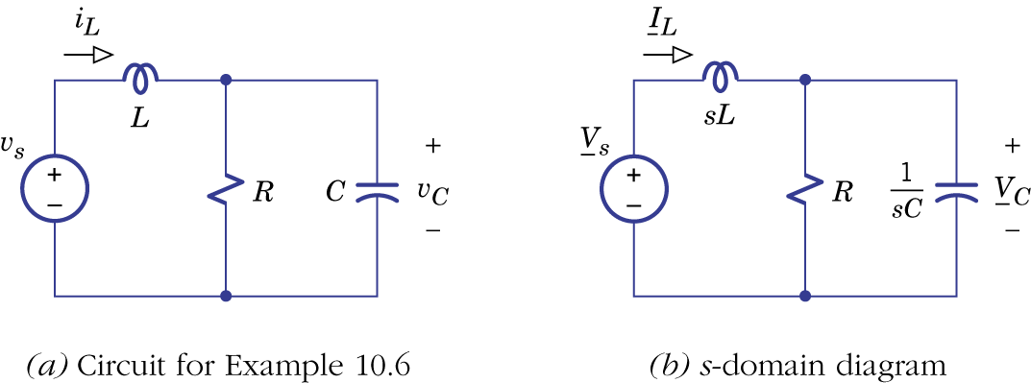Figure 10.7.

Example 10.7: Twin-Tee Network with an Op-Amp
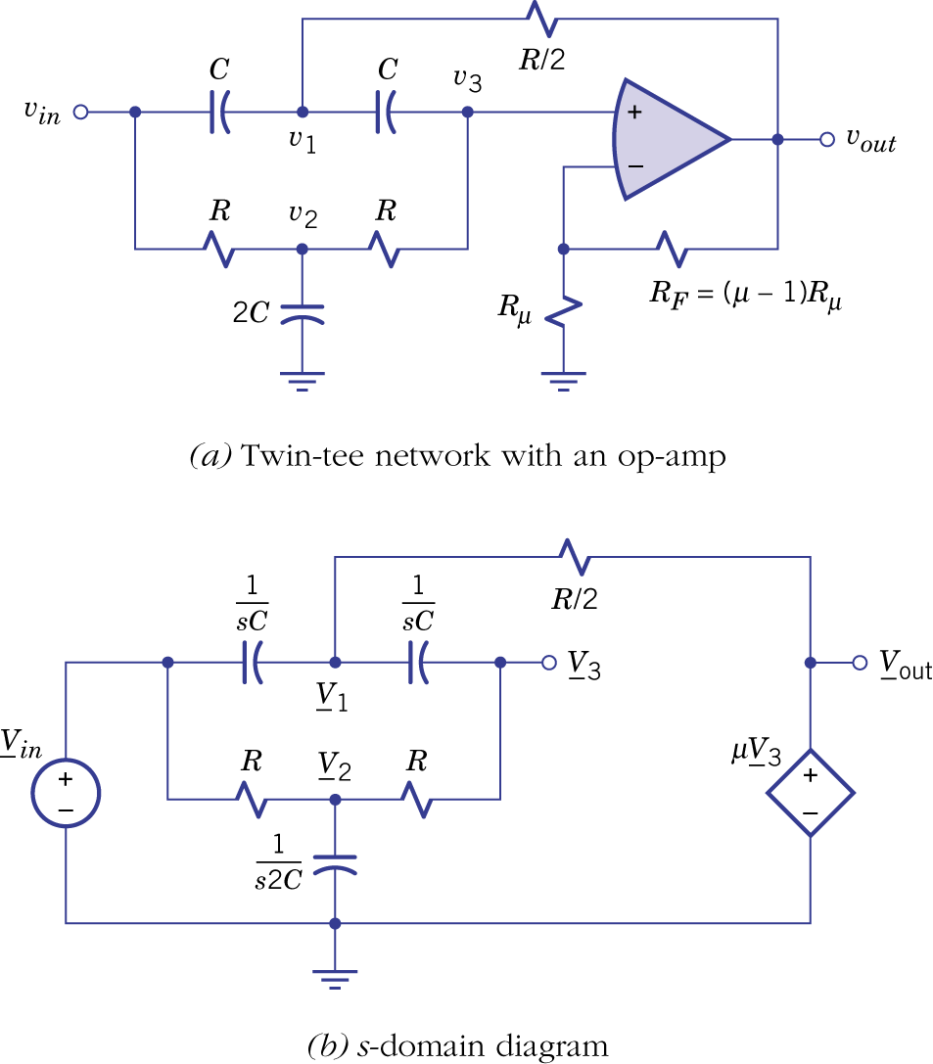Figure 10.8.

10.3 Network functions with mutual inductance
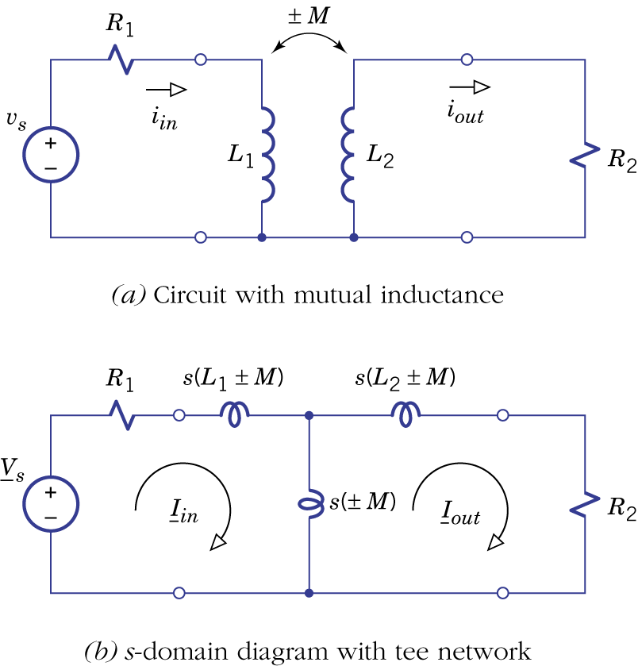Figure 10.10.

10.4 s-domain analysis
- The network function is more easily obtained from impedance analysis than from differential equations.
- Both forced response and natural response can be determined.
- Poles and zeros: poles are roots of the denominator, zeros are roots of the numerator.
- Gain factor corresponds to the dc gain.

- Gain factor K is real. Poles and zeros are either real or in complex conjugate pairs. The number of poles is the order of the circuit (number of independent energy-storage elements in the circuit).

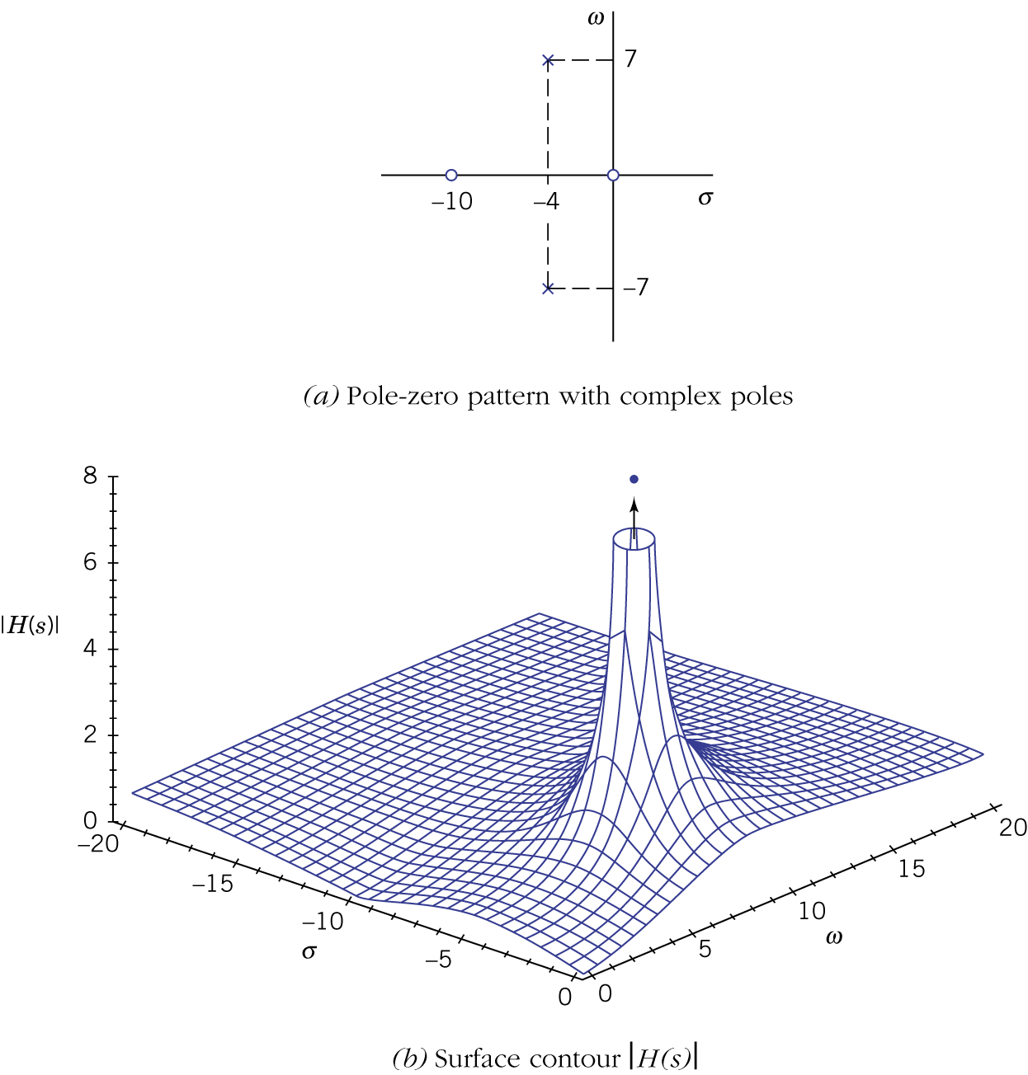Figure 10.11.

Example 10.8: Pole-Zero Pattern of a Fifth-Order Network
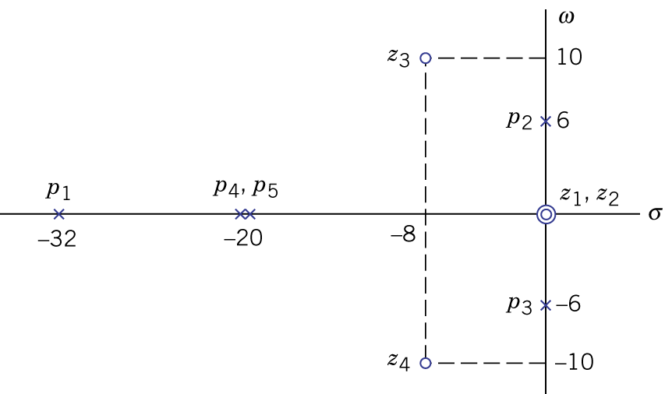Figure 10.12.

- Forced response and s-plane vectors.

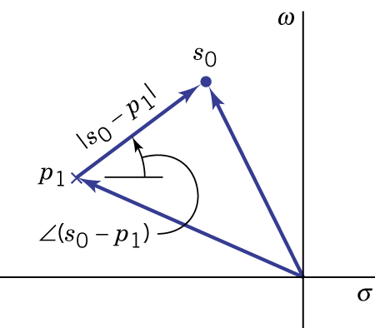Figure 10.13.

Example 10.9: Calculations with s-Plane Vectors

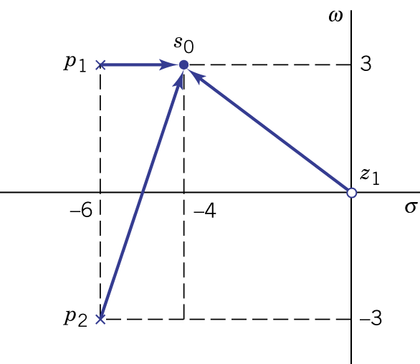Figure 10.14.
- Natural response and stability: poles of the network function are characteristic values of the circuit natural response, each pole corresponds to a mode.

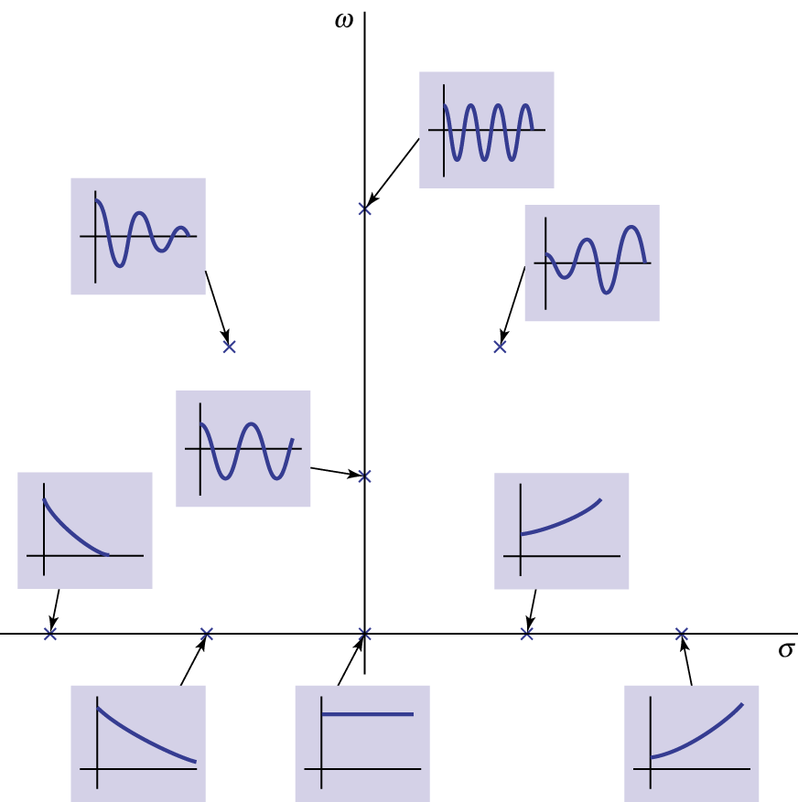Figure 10.15.

- A circuit is stable if all poles are in the left half of the s plane.
- Oscillator and pole-zero cancellation.

Example 10.10: Natural Responses of a Third-Order Circuit

