數位訊號處理概論: Biomedical Signal Processing
李百祺
- Introduction:

- Biomedical signal processing refers to the applications of signal processing methods, such as Fourier transform, spectral estimation and wavelet transform, to biomedical problems, such as the analysis of cardiac signals. A broader aspect of biomedical signal processing also includes biomedical imaging, genomic signal processing,…etc.

1. Bioelectric Signals

- Excitable cells

- A certain class of cells, known as excitable cells, exhibit bioelectrical potentials resulting from their electrochemical activity. Measurements of such electrical activities are typically done using the following set-up.

cell
axon
stimulator
resting potential
action potential

- The resting potential is a steady electrical potential difference between the internal and external environment (i.e., the cell membrane is polarized). The internal potential is typically –50 to –100mV compared to the external environment. The action potential results from an adequate stimulus, which depolarizes the medium and propagates along the membrane of an excitable cell at a constant conduction speed.
- The cell membrane is a thin lipoprotein complex that is essentially impermeable to intracellular protein and other organic anions. However, it is permeable to ions such as Na⁺, K⁺ and Cl⁻. In the resting state, an equilibrium state is reached and the geometry constitutes an electrical capacitor where the two conducting plates are the ionic media and the membrane is the dielectric.

- The action potential results from the membrane permeabilities to certain ions. As the cell is stimulated, depolarization occurs and distribution of ions also changes accordingly. Action potential occurs when the membrane potential exceeds a certain threshold.

- Since axons are responsible for the transmission of information between different points of the nervous system, measurements of the their electrical activity are of great importance.

- Electrocardiogram (ECG)

- The ECG has been used as one of the main methods for assessing heart functions. Many cardiac parameters, such as heart rate and mechanical defects, can be determined using the ECG. Since the ECG is relatively easy to measure, it is often used as an illustration of aspects of biomedical signal processing.
- The electrical events of the heart are initiated and transmitted by five special groups of cells of the heart. They are the sinoatrial (SA) node, the atrioventricular (AV) node, the common bundle, the right bundle branch (RBB) and the left bundle branch (LBB). The SA node initiates the stimulus and its depolarization stimulates the surrounding myocardium and spreads throughout the atria. When the stimulus reaches and passes the AV node, it is then conducted by the common bundle branches to the remainder of the ventricular myocardium. This constitutes ventricular depolarization. The above description reflects normal activation and conduction throughout normal pathways. Any deviation from the normal activation is designated a conduction defect or arrhythmia.
- Atrial depolarization is known as the P wave and ventricular depolarization is known as the QRS complex. Atrial repolarization is too weak to be seen but the ventricular repolarization is known as the T wave. Electrical conduction and a typical electrocardiograph is shown in the following figure.

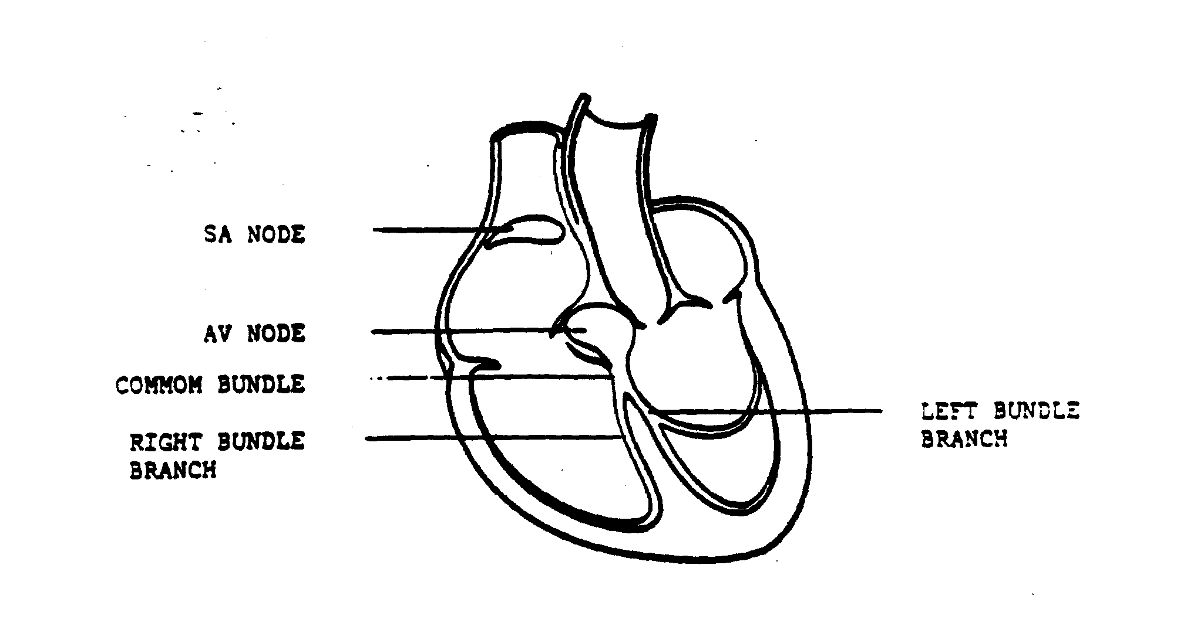
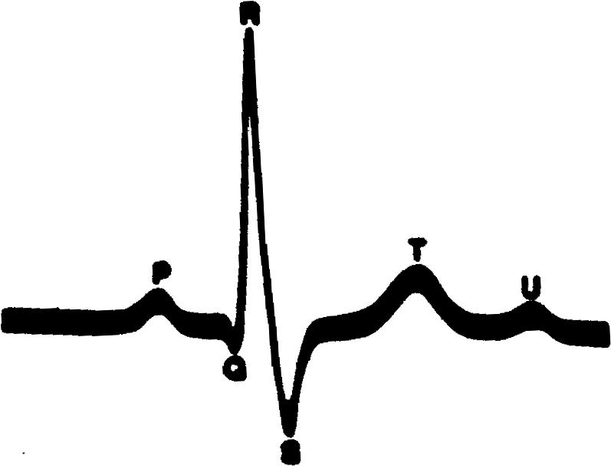

- Cardiac activities can be recorded by placing electrodes on the surface of the body or within the body. From the ECG, many abnormal cardiac functions can be diagnosed. Several examples are illustrated below.
- Premature ventricular contraction: It is a beat initiated by a wrong node (also known as an ectopic ventricular focus). A wide and abnormal QRS complex is typically seen since the stimulus does not conduct through the normal AV conduction pathway. A short RR interval is also typical due to the premature depolarization of the ventricles.
- AV blocked beat (second degree): It is a beat which is delayed or blocked in the AV node or the common bundle and does not conduct to the ventricles.
- Ventricular tachycardia: It is a series of premature ventricular contractions with a rate between 100 to 240 cycles per minute. Ventricular tachycardia beats originate in the ventricles and always exhinit abnormal QRS waveforms.
- Ventricular fibrillation: It is a rapid ventricular firing originating from multiple ventricular ectopic foci with a rate of more than 330 cycles pre minute. The ventricular rate is so high that no blood is effectively pumped to the body. Without immediate treatment loss of consciousness and death will result.

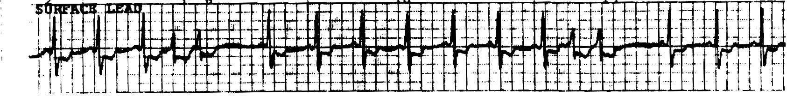
- A typical ECG trace of premature ventricular contraction is shown below.

- Electroencephalogram (EEG)

- EEG records electrical potential fluctuations of the brain. Electrodes can be placed on the scalp, cortex or the neural tissue of the brain. Under normal circumstances, action potentials in axons contribute little to surface recording due to the fact that signals from a large number of axons usually occur asynchronously in time. Therefore, the net influence on the surface potential becomes small. However, if a response is due to simultaneous stimulation of a cortical input, action potentials may project to the surface. In other words, any electrical change at the surface must result from orderly and symmetric arrangement of some type of cells in the cortex.

- Distinct EEG patterns of normal persons may be classified into four groups-alpha, beta, theta and delta, as shown below.
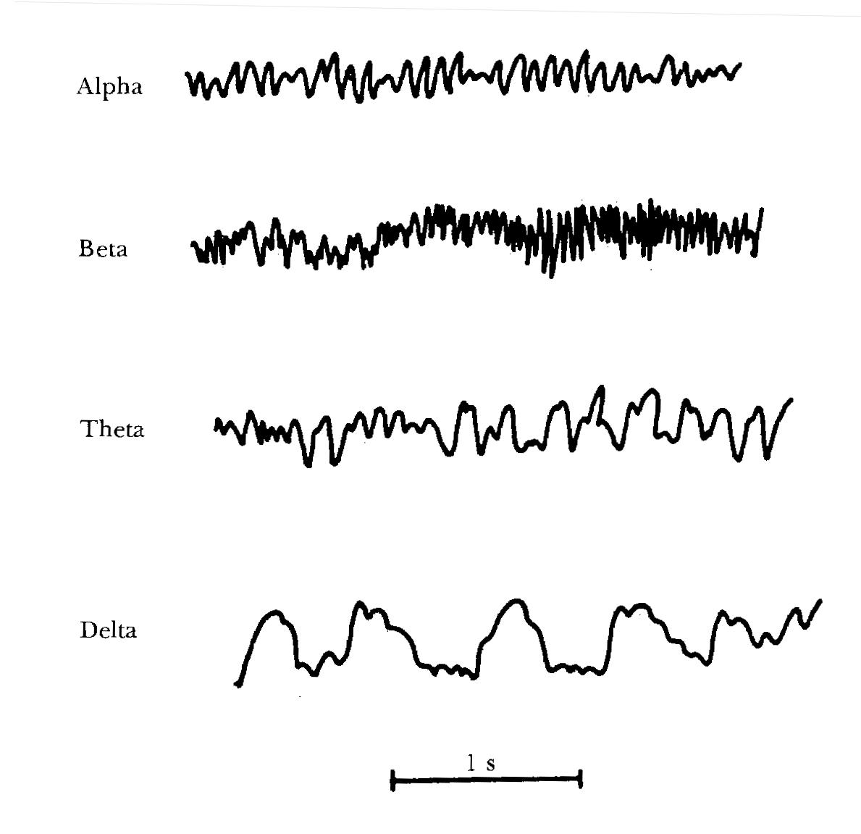
- Alpha waves are rhythmic with a frequency ranging from 8 to 13Hz. These waves occur when normal persons are awake in a resting state. The alpha waves are replaced by asynchronous waves with lower amplitudes and higher frequencies when the person is experiencing some certain type of mental activities. When the person is in sleep, on the other hand, alpha waves disappear.
- Beta waves normally have a frequency range of 14 to 30Hz. However, it may go up to 50Hz in the presence of intense mental activity. The beta waves can be further divided into two sub-groups. The beta I waves have a frequency about twice that of the alpha waves and are influenced in a similar way as the alpha waves. The beta II waves appear during intense activation of the central nervous system and during tension.
- Theta waves occur during emotional stress. The frequency range is between 4 to 7Hz. Finally, delta waves occur in deep sleep or in serious organic brain disease. The frequency of delta waves is below 3.5Hz.
- One main clinical application of EEG is to diagnose various types of epilepsy and the location of the focus in the brain that causes epilepsy. Epilepsy is characterized by uncontrolled excessive activity by either part or all of the central nervous system. Using EEG, proper diagnosis can be made and subsequent surgical treatment can be taken.

- Other biomedical signals
- There are several other physiological signals that can be readily measured and used for clinical diagnosis. They include the electroneurogram (ENG), the electromyogram (EMG), the electroretinogram (ERG) and the electrogastrogram (EGG).
- Some other biomedical signals are not originated from electrical activities of the human body. Although these signals cannot be measured by placing electrodes at particular locations, they can still be detected using alternative methods. Two main categories are the circulatory system and the respiratory system.
- Measurements of the circulatory system include blood pressure, heart sound, blood flow velocity, blood flow volume, …etc. Measurements of the respiratory system include respiratory pressure, gas-flow rate, lung volume and gas concentration.

- Applications of signal processing techniques

- Sampling: With the rapid advancement of modern electronic technologies, the processing, analysis and presentation are often done digitally. The sampling requirements for biomedical signals are basically the same as those for other signals. Generally speaking, biomedical signals typically have low frequencies and the frequency ranges of different physiological signals may be overlapping. Therefore, such signals are not only susceptible to electronic noise, they may also be affected by other physiological signals in the same frequency range. Because amplitudes of some biomedical signals are only at the $μ$V level, design of the pre-amp circuit is often very challenging.
- Filtering: Digital filters are used to keep the in-band signals and to reject out-of-band noise. Characteristics of filters include low-pass, band-pass, high-pass and band-reject. Design principles of digital filters are similar to those of other applications.
- Adaptive noise cancellation: A major problem for biomedical signal processing is noise from power line (also known as the 60Hz noise). Since the frequency of the 60Hz line frequency noise is in the desired frequency range of several biomedical signals (e.g., ECG), rejection of such noise becomes important and challenging. The problem becomes more complicated when considering the fact that the amplitude and exact frequency of the noise may change (i.e., the exact frequency may not be 60Hz). In order not to reject too much signal by using a band-reject filter with a wide bandwidth, adaptive filtering can be employed. A generic noise canceller for suppressing 60-Hz interference in ECG is shown below.

ECG pre-amp output
adaptive filter
attenuator
60Hz outlet
output

- Another application of adaptive filters is for fetal ECG. Fetal ECG can be used to monitor the heartbeat of an unborn child. However, due to its low amplitude, the maternal ECG from the mother presents significant interference. In order to reduce the interference, adaptive filtering can be applied by employing the abdominal ECG as the input and the chest ECG (from the mother) as the reference signal. The output of the adaptive filter should contain mainly the fetal ECG signals.
- Pattern recognition: Abnormal physiological signals tend to have different waveforms from the normal counterparts. Therefore, an efficient way to detect abnormality is to recognize differences in physiological waveforms. Generally, an average of several known normal waveforms can be used as a template. The new waveforms are then detected, segmented and compared to the template. A correlation coefficient can be used to quantify the similarity between the template and the new waveform. If the correlation coefficient is lower than a pre-specified threshold, then the new waveform is considered abnormal and thus may indicate physiological changes. Such a technique has been used in ECG to detect arrhythmia. The correlation coefficient can be calculated based on the following equation

$ρ=\frac{\sum{(T_{i}−μ_{T})(X_{i}−μ_{X})}}{\sqrt{\sum{(T_{i}−μ_{T})^{2}}}\sqrt{\sum{(X_{i}−μ_{X})^{2}}}}$,
where N is the number of points in the template, $T_{i}$ is the template points, $X_{i}$ is the points of the waveform to be analyzed, $μ_{T}$ is the average of the template and $μ_{X}$ is the average of the waveform.
- Data compression: The large amount of data associated with a certain biomedical signal often needs to be transmitted and stored. Therefore, such data need to be compressed for efficient data transmission and storage. Although many data compression schemes have been developed for non-biomedical applications, the use of such general schemes on biomedical data must proceed cautiously. This is due to the fact that any distortion in the signal must alter the physiological meaning and may lead to incorrect diagnosis. Therefore, formal clinical evaluations are often required for such compression schemes for biomedical signals.

- Spectral analysis: Frequency content of biomedical signals may also provide important clinical information. For example, Doppler frequency shifts due to blood motion are often measurements in order to determine blood flow information such as blood flow velocity and volume. Therefore, spectrum of the biomedical signals needs to be estimated. Particularly many physiological signals are not stationary (i.e., the characteristics change with time), time-frequency analysis can also be employed to deal with the time varying nature of such signals.

- Medical imaging

- Medical image processing can be viewed as multi-dimensional biomedical signal processing. Over the last few years, advanced medical imaging systems have revolutionized medical diagnosis. Common imaging modalities include X-ray, magnetic resonance imaging (MRI), ultrasound, Positron Emission Tomography (PET),…etc. Generation, detection, reconstruction and image processing for different modalities are all different to each other. Each modality also assesses particular information of the human body. For example, X-ray depends on electron density, MRI is associated with water content and ultrasound concerns the acoustic mismatch.
- Although they are all different, the goals of medical image processing are similar among different modalities. They include noise reduction, feature enhancement, aesthetics improvement and automatic analysis.
- Examples of the application of signal processing techniques to medical imaging include statistical detection and estimation for PET and array processing for ultrasonic imaging.
- Typical signal processing involved in an ultrasonic imaging system is illustrated as the following.

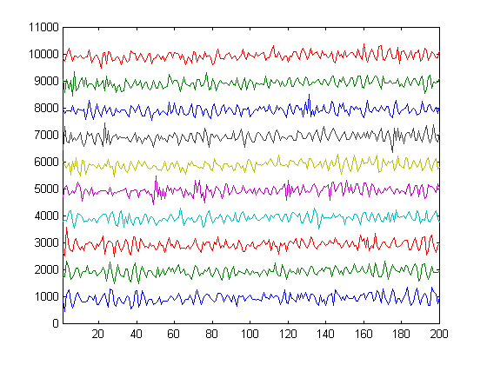
Received High Frequency Sound Wave From a Transducer Array
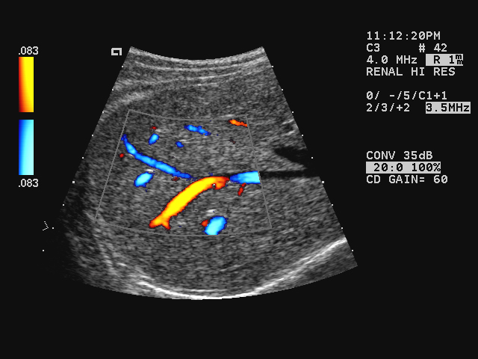
Array Processing (Beamforming), Filtering, Data Re-Sampling, Demodulation, Spectral Estimation, Hilbert Transform, Correlation Analysis, Color Mapping, Coordinate Transformation, Audio Processing, Doppler Processing, Signal and Image Compression, Archiving, Signal and Image Communication, …etc.

- Another example: Signal processing for blood velocity estimation

  - The Doppler principles, which describe the relations between the motion velocity and the frequency change of the interrogating wave, can be used to estimate blood velocity. The basic Doppler principles are shown in the following figure using high frequency sound wave as an example.

receiver
receiver
source
compressed wavelength
elongated wavelength

- When both the source and the receiver are stationary, the frequency experienced by the receiver is simply $f_{s}=c/λ$, where c is the speed of sound and $λ$ is the wavelength.

- The Doppler frequency shift can be described as

$f_{d}=f−f_{s}=f_{s}(v_{r}+v_{s})/(c−v_{s})$.

where v_{r} is the receiver velocity and v_{s} is the source velocity. Assuming the source velocity is much smaller the sound velocity (i.e., $v_{s}\text{<<}c$), the above equation can be simplified as

$f_{d}»f_{s}(v_{r}+v_{s})/c$.

This assumption is true for diagnostic ultrasound since the velocity of typical physiological flows in the body are at most at the order of a few meters per second, whereas sound velocity in blood is around 1500 meters per second.

- In practice, the Doppler angle (i.e., the angle between the flow direction and the wave direction) also needs to be considered. Considering the following drawing, the basic Doppler equation can be written as

v
c
θ

$f_{d}=\left(\frac{2{\text{vf}}_{s}}{c}\right)\text{cos}q,(v\text{<<}c)$,
where v is the flow velocity, c is the propagation velocity of sound waves, $f_{d}$ is the detected Doppler frequency shift, $f_{s}$ is the source frequency and θ is the angle between the flow and the ultrasound beam. Note that the frequency shift is doubled due to round trip propagation and only flows parallel to the ultrasound beam can be detected.

- Flow patterns and their corresponding velocity profiles can be illustrated by the following examples:
velocity or
Doppler shift
0
ultrasound beam

velocity or
Doppler shift
0
ultrasound beam

velocity or
Doppler shift
0
ultrasound beam

- Frequency shifts due to Doppler effects are typically estimated by short-time Fourier transform. A typical time-frequency representation of ultrasonic flow assessment is shown below.

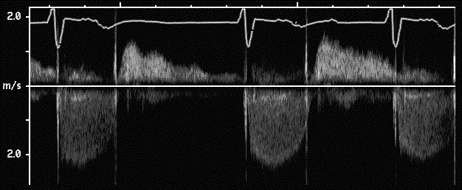

- The above blood velocity estimation method is typically implemented using continuous wave (CW). The major limitation of CW Doppler is that it is sensitive to blood flows along the entire length of the ultrasonic beam and the position of individual flows cannot be localized in range. To overcome this problem, pulsed wave (PW) Doppler was developed. In this case, the Doppler spectrum can be estimated by either Fourier analysis (the same as that for CW) or efficient autocorrelation techniques. The former is usually called Spectral Doppler. The latter only estimates simple flow parameters, such as mean velocity, flow energy and velocity variance, and is capable of displaying two-dimensional flow information in real-time. Since flow parameters (velocity, variance and energy) are mapped to different colors, this is also known as the Color Doppler mode.

- One of the main differences between CW Doppler and PW Doppler is that PW Doppler transmits a short sinusoid burst, instead of a continuous sine wave. By gating the received signals to correspond to the pulse's time of flight to the point of interest, one can interrogate a small sample volume instead of the entire length of the ultrasonic beam.

- Unlike CW Doppler, frequency (i.e., velocity) aliasing may occur in PW Doppler. This is due to the fact that the returned echoes are sampled at a fixed time after the burst is transmitted. This time interval is also known as PRI (pulse repetition interval). According to the Nyquist criterion, the maximum Doppler shift frequency ($f_{\text{max}})$ that can be detected for a given PRI is

$2f_{\text{max}}≤\frac{1}{\text{PRI}}$.

Therefore, the maximum velocity ($v_{\text{max}}$) of the flow projected along the direction of the ultrasonic beam that can be detected without aliasing is

$$2f_{\text{max}}=\frac{4v_{\text{max}}f_{s}}{c}≤\frac{1}{\text{PRI}}$$
$$v_{\text{max}}≤\frac{λ}{4⋅\text{PRI}}$$

where $λ$ is the wavelength at the carrier frequency (i.e., without Doppler shift).

- Due to the sampling requirement, a trade-off exists between the maximum sample depth and maximum un-aliased blood velocity. When aliasing occurs, the high velocity components (higher than $v_{\text{max}}$) show up in the other side of the spectrum. This is illustrated as follows.
no aliasing
aliasing

v_{max}
v_{max}
-v_{max}

- In addition to spectral aliasing, PW Doppler is also susceptible to range ambiguity. In other words, signals from sample volumes which correspond to an integer multiple of ${c⋅\text{PRI}}/2$ away from the main sample volume may also contribute to the real Doppler signal.

- The PW principles can be illustrated using the following figures.
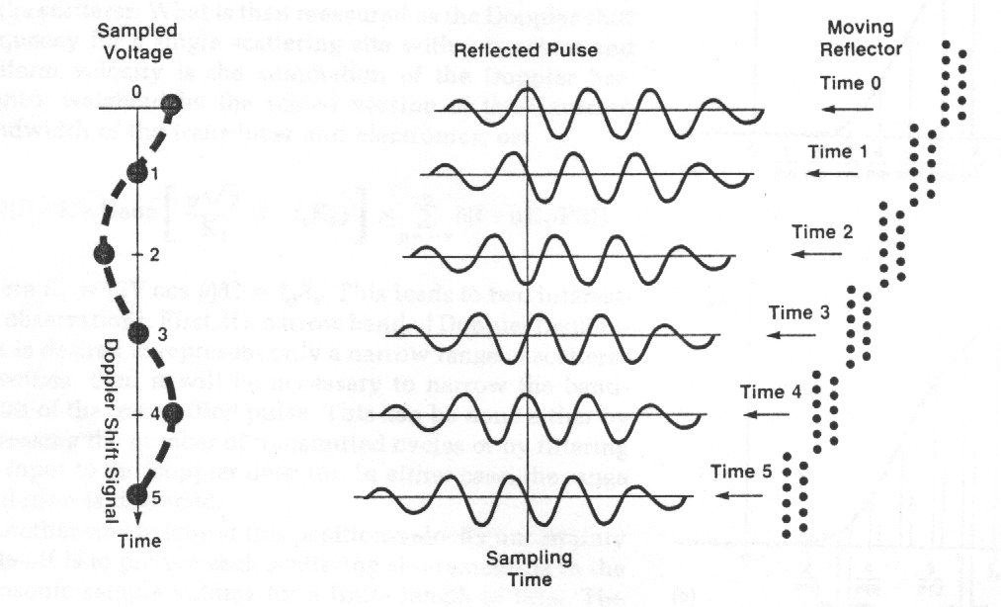
(a). No aliasing
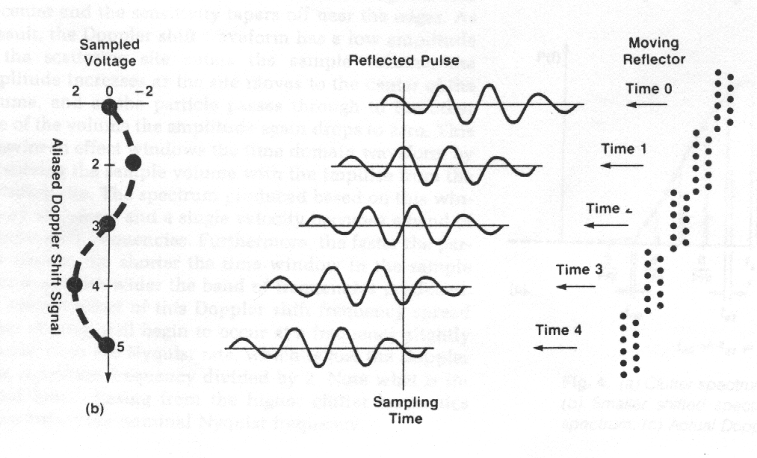
(b). With aliasing

